helpful rules and guidelines

- Make sure to type your First and Last name in the highlighted area and fill out all information about your degree type.

- Open Academic Transcript (myuca self-registration student academic transcript submit)
  - Fill in transfer classes in the Transfer Credit box at the end of the PCP.
  - Put your grades in as well.

- Do not include classes that have been withdrawn (W), failed (F), or are a remedial course (UNIV). Only include classes that will count toward your degree plan.

- If you have a Minor, list every class for the minor in the separate Minor box at the end of the PCP.
  - Do not include the minor class the semester you plan to take it.

- Use Academic Transcript to fill in box labeled Year 1. Fill in with the classes you took your 1st semester at UCA. Change highlighted portions accordingly (Spring, Fall, Summer 1, Etc.).
  - If this is your first semester to get college credits ignore academic transcript

- Open DegreeWorks (myuca degreeworks). This tool will allow you to see all of the classes you have taken and still need to take in order to earn your degree.
  - Ensure the major/minor listed are correct.
  - If they are not, process a what-if (click what-if button on top of left side of your degreeworks screen choose major/minor process)

- Use DegreeWorks to fill in remaining semesters until you graduate.
  - Only include classes that are needed in order to complete your degree.
  - You do not get open electives and any classes you take that are not needed for your degree will not be paid for by the VA

- Add or delete rows/boxes that are not needed or blank.

- Label Upper Division Core Classes next to the class that satisfies that requirement
  - Example [UD: C] for Upper Division Communication

- Once finished, SAVE your PCP. You WILL have to make changes.

- Send a copy to yourself over email, save it to Google Docs, or both

- Come to the office and pull it up on one of the computers
  - Have a student worker look it over and give you the okay to print it
  - Sign and date the back and ensure the student worker does too

- Don’t leave until it has been checked and signed by a student worker!

STEP 3
- Click the first link. Open the document and select enable editing to begin your PCP.
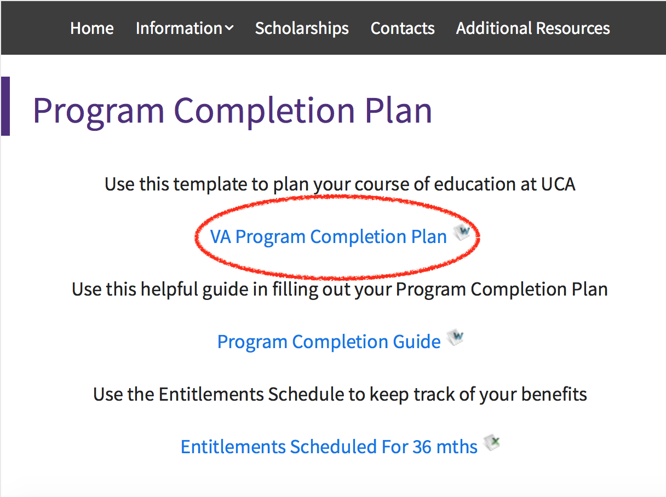

STEP 4
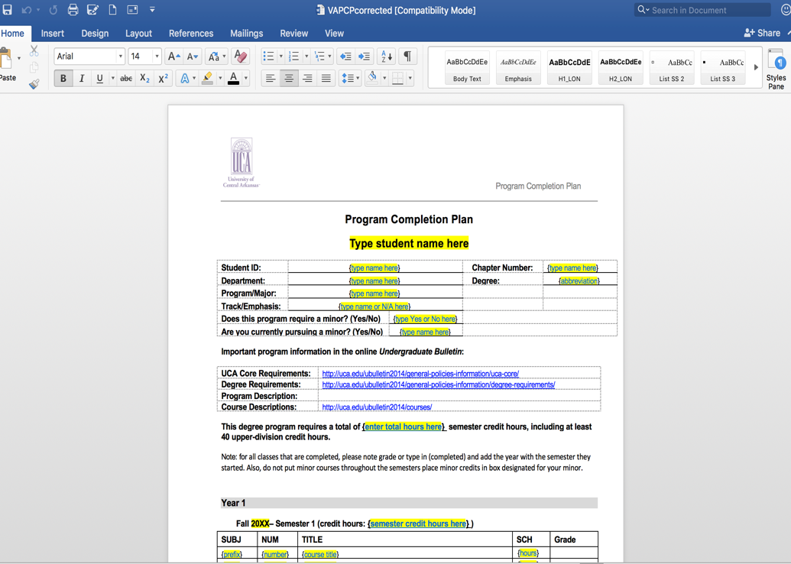
- Your screen should look like this. If so, begin filling out your PCP with the necessary information. If not, please repeat the steps.
UCA VA P.C.P  veteranservices@uca.edu  (501) 852-2999  201 Donaghey Ave, Conway, AR 72035-0001 |  | HOW TO BUILD YOUR PROGRAM COMPLETION PLAN  Step 1  - http://uca.edu/veteranservices  STEP 2  - Scroll down to “Good to Know Info” and Click the highlighted Program

