Submit Assignment in Anthology/Chalk & Wire

Step 1: Select the Portfolio/Assignment Page
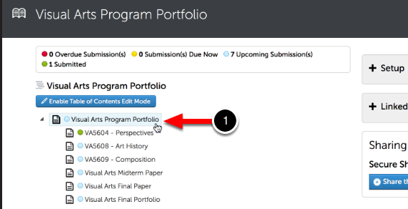

Using the Table of Contents on the left side of your screen, click to select the appropriate page for your course/assignment.

Step 2: Click on the Add Content Menu
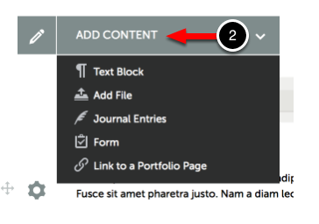
In order to submit your work, you must first add content to the portfolio page. To begin adding content:
Use the Add Content drop-down menu to select the appropriate method for adding content.

Step 3: Select your Method for Adding Content
If you have been using Google Docs, you must first save your document as a PDF or docx file.
Simply adding content to your portfolio or assignment does not grant your instructor access to it for assessment. In order to complete this process, you must actually submit your work. In this lesson you will learn how to submit your work, and how to select the instructor to whom it should be submitted.

Step 4: Submit your Work
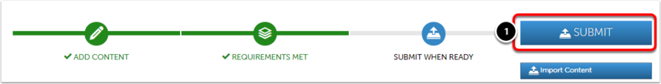
Once you have added all required work to the portfolio page, then a Submit When Ready tag will appear on your submission page. If the Submit When Ready tag is not shown on your page after adding your content, then please make sure that all required content has been added to the portfolio page and that all add content windows have been closed.
(1) Click on the Submit button.

Step 5: Enter Name of Assessor(s)
If you are making a submission as part of a Resubmission Request, you will not need to enter the name of your Assessor. The submission will be automatically sent to the original Assessor.
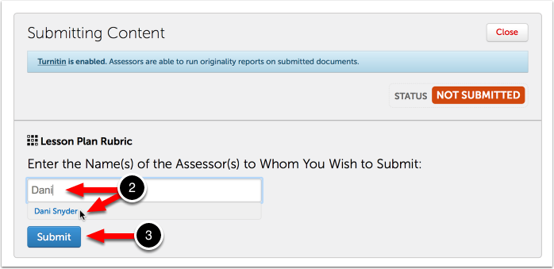
A submission window will drop down on the screen. (2) Begin typing the Name(s) of the Assessor(s) to whom you wish to submit. As you type, matches in the system will appear. Do NOT include “dr” or other prefixes. When the correct name appears, click on it to select it. The name will appear next to a checkmark to indicate that it has been selected. (3) Click Submit.

Step 6: Review Submission
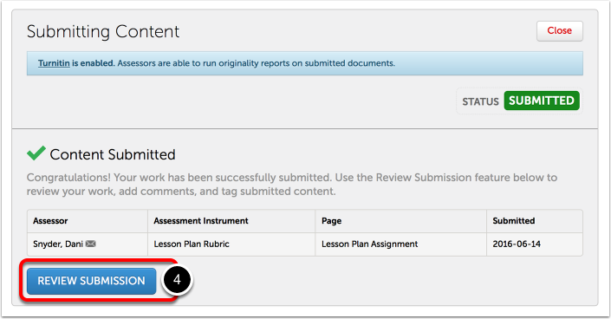
A message will appear to indicate that your content has been submitted.
(4) Click on the Review Submission button if you would like to review the submission that you just made.
If you do not see the "Content Submitted" message, or the "Status: Submitted" flag, your content has not been submitted.

