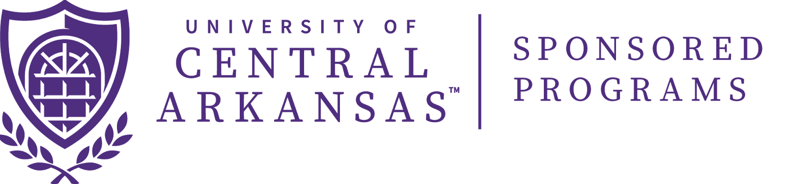

Request for Pre-Award Spending

Under limited circumstances, Principal Investigator may request authorization to spend funds in support of a sponsored project in advance of receiving an award from a sponsor. Authorization of pre-award spending may be granted under the following circumstances:

- Pre-award costs up to 90 days prior to the effective date of a new award. (Not allowable on fixed price or sole source awards.)
- A single no-cost extension of time up to 12 months. The request must be submitted to Sponsored Programs 45 days prior to the expiration date of the project. The agency must be notified within 10 days of the extension and prior to the expiration date of the project.
- Acquisition of special purpose equipment below $5,000.

Instructions: The PI should fill in the form fields (grey-shaded boxes), print this form, sign, request signatures from the appropriate chair and dean, and deliver the form to Sponsored Programs. We request that forms be hand delivered rather than sent through campus mail.

Certification
The Principal Investigator requesting pre-award spending from Sponsored Programs certifies that the agency named below will issue UCA a grant award in the sum indicated on the stated date. The Principal Investigator, Chair, and Dean are requesting pre-award spending beginning on the date specified and certify that any costs incurred will be allowable under the award’s Terms and Conditions and all applicable federal regulations.

Although we have every indication that the award will come through, the Department and College will take full responsibility for the expenses incurred by the university in the event that the award is not made.

Agency Issuing Award:
Award Amount:
Expected Date of Award:
Amount Requesting:
Date Needed:

Principal Investigator, Print Name | PI, Signature | Date

Chair, Print Name | Chair, Signature | Date

Dean, Print Name | Dean, Signature | Date

Dean of Graduate School & Director of Sponsored Programs, Print Name | Signature | Date

Thank you for taking the time to complete this form. Sponsored Programs will respond to your request within five (5) business days.

