CITI INSTRUCTIONS FOR FIRST TIME USERS

- https://www.citiprogram.org/

- 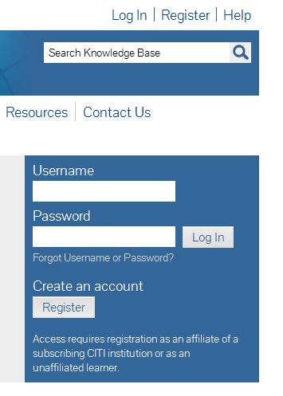Welcome page, click on Register

- Complete Steps 1-7

  - Select an Institution: Choose University of Central Arkansas under participating institutions
  - Personal Information: Enter name and e-mail address
  - Create your username and password.
  - Enter your Gender, Ethnicity, and Race (“I would rather not disclose” is an option)
  - Answer CEU credits and surveys as you wish. CEU credits are not required by the UCA IRB or IACUC.
  - Answer demographic information requested by UCA.

- Choose your course path:

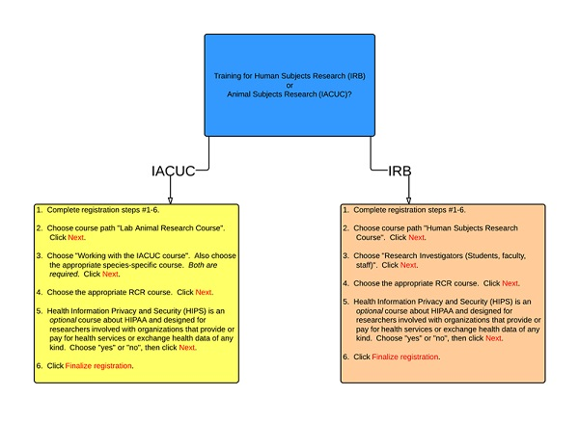
  - Category of Responsible Conduct of Research (RCR) –
REQUIRED for all NSF and some NIH award recipients

- Select Finalize registration unless you are collaborating with another institution. If you have previously taken CITI trainings at another institution, these trainings can be viewed by the UCA CITI administrator if you choose to Affiliate with another institution.

- On the Main Menu page, you can view the instruction page under My Learner Tools or click on enter to start a course.

Remember, you can login several times and use multiple sessions. You can also look at the coursework you have completed.

- Completion reports do not have to be printed and submitted with your IRB or IACUC application UNLESS they are from an institution other than UCA and you have not affiliated that institution to your UCA CITI profile. We may ask you for a hard copy of your completion report if we have trouble accessing it in the CITI database.

HAPPY RESEARCHING!

