MBA Program Admission Essay | 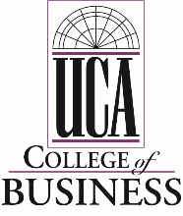
Please complete the required essay question below. Your response should be limited to no more than 750 words. E-mail your essay to the Graduate School directly (colleene@uca.edu) as a MS Word attachment.

Explain how your past accomplishments have prepared you for the MBA Program and how the UCA MBA Program will help you achieve your personal and professional goals.

