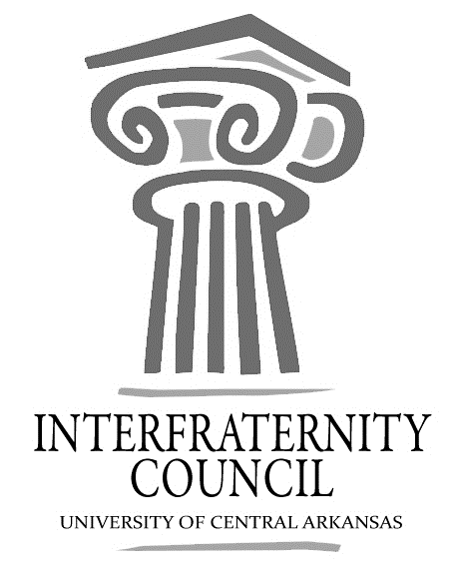
Interfraternity Council
Official minutes available immediately after meeting online: https://orgsync.com/54961/files
All IFC Public Documents: http://23277uca.edu/ifc/forms-and-policies/
General Meeting
University of Central Arkansas
Tuesday, September 4, 2018
ucaifcexec@gmail.com

Interfraternity Council Contact Information
President | Drew Himstedt | jhimstedt1@cub.uca.edu
VP Communications | Lamon Wade | lwade3@cub.uca.edu
VP Judicial Affairs | Colton Rowe | crowe3@cub.uca.edu
VP Recruitment | Chase Bicanovsky | cbicanovsky1@cub.uca.edu
VP Development | Lance Cook | lcook8@cub.uca.edu
Advisor | Katie Frazier | kfrazier6@uca.edu

Agenda
- Commence Meeting:
- Delegate Roll Call
- Guest speakers
- Executive Discussion
  - VP of Development – Lance Cook
    - Strike out hunger
      - Phi Sig sign up
      - Strike out is thursday
      - No alcohol at tailgate
  - VP of Recruitment – Chase Bicanovsky
    - Tailgates Must Follow Recruitment Rules
    - Recruitment Roundtables:
      - Sept 6 1:30PM Hall of Fame Room
      - Sept 13 1:30PM SC 214
      - Sept 20 1:30PM SC 223 (Recruitment Evaluation Meeting)
  - VP of Judicial Affairs – Colton Rowe
  - VP of Communications – Lamon Wade
  - President – Drew Himstedt
    - Vigil at 6PM SC Amphitheater
    - RSO Training/Social Events Training Sept. 5 at 4:00pm and 6:00pm SC Ballroom
    - Strike Out is Thursday!
- Advisors’ Report
  - Rain Plan for Recruitment Events
  - Party Supplies-make sure they don’t disappear
- Old Business
- New Business
- Chapter Reports
  - Alpha Sigma Phi- No Report
  - Beta Upsilon Chi – No Report
  - Kappa Sigma – No Report
  - Phi Gamma Delta – No Report
  - Phi Sigma Kappa – No Report
  - Pi Kappa Alpha – No Report
  - Sigma Nu – No Report
  - Sigma Phi Epsilon – No Report
  - Sigma Tau Gamma – No Report
- End Meeting:

