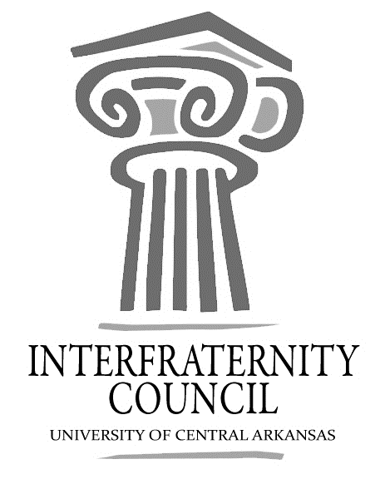
Interfraternity Council
Official minutes available immediately after meeting online: https://orgsync.com/54961/files
All IFC Public Documents: http://23277uca.edu/ifc/forms-and-policies/
General Meeting
University of Central Arkansas
Tuesday, September 11, 2018
ucaifcexec@gmail.com

Interfraternity Council Contact Information
President | Drew Himstedt | jhimstedt1@cub.uca.edu
VP Communications | Lamon Wade | lwade3@cub.uca.edu
VP Judicial Affairs | Colton Rowe | crowe3@cub.uca.edu
VP Recruitment | Chase Bicanovsky | cbicanovsky1@cub.uca.edu
VP Development | Lance Cook | lcook8@cub.uca.edu
Advisor | Katie Frazier | kfrazier6@uca.edu

Agenda
- Commence Meeting:
- Delegate Roll Call
- Guest speakers
- Executive Discussion
  - VP of Development – Lance Cook
    - Strike Out reschedule possibly Sept. 27
  - VP of Recruitment – Chase Bicanovsky
    - Sept 13 1:30PM SC 214
    - Sept 20 1:30PM SC 223 (Recruitment Evaluation Meeting)
  - VP of Judicial Affairs – Colton Rowe
  - VP of Communications – Lamon Wade
    - #MyFraternity campaign starts tomorrow
  - President – Drew Himstedt
- Advisors’ Report
  - Very important that you have reps at the recruitment roundtable
  - #MyFraternity Campaign starts tomorrow
  - Sept 22 Greek 101-Ida Waldran
9am - ASA, AST , Sigma Nu, SigEp, Sig Tau, Alpha Sigma Phi, BUCs
2:30pm - DZ, SK, SSS, Kappa Sigma, FIJI, Phi Sig, PIKE, Phi Lamb
  - Sept 23 Greek Convocation - (80% of chapter in attendance) Reynolds Auditorium
5pm - ASA, AST, Sigma Nu, SigEp, Sig Tau, Alpha Sigma Phi, BUCs, Delta, Omega, Sigma, Zeta, Phiota, SIA
7pm - DZ, SK, SSS, Kappa Sigma, FIJI, Phi Sig, PIKE, Phi Lamb, AKA, Alpha, Kappa, SGRho
- Old Business
- New Business
- Chapter Reports
  - Alpha Sigma Phi- No Report
  - Beta Upsilon Chi – No Report
  - Kappa Sigma – No Report
  - Phi Gamma Delta – No Report
  - Phi Sigma Kappa – No Report
  - Pi Kappa Alpha – No Report
  - Sigma Nu – No Report
  - Sigma Phi Epsilon – No Report
  - Sigma Tau Gamma – No Report
- End Meeting:

