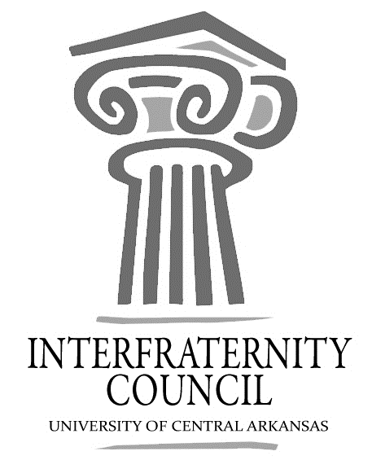
Interfraternity Council
Official minutes available immediately after meeting online: https://orgsync.com/54961/files
All IFC Public Documents: http://23277uca.edu/ifc/forms-and-policies/
General Meeting
University of Central Arkansas
Tuesday, August 29, 2017

Action Items
What needs to be turned in by delegates, completed by exec board members, etc

Decisions Made
What concrete decisions were made at this meeting?

Upcoming Dates
What important events and deadlines should you be looking out for?

- Commence Meeting:
- Delegate Roll Call
- Guest speakers
- Executive Discussion
  - VP of Development – Lance Cook
    - Walk a mile t-shirts - April 20th (community open)
  - VP of Recruitment – Chase Bic
  - VP of Judicial Affairs – Colton Rowe
    - delegate for judicial committee
  - VP of Communications – Lamon Wade
  - President – Drew Hemstedt
    - 6% recruitment increase from last Spring. Possibly keep week and a half for fall, push spring recruitment back
    - Greek 101 - new members required to go. This Saturday, 9 a.m., Ida Waldron
    - Constitution changes
- Advisors’ Report
  - Open Bids- Have PNM fill out recruitment registration and send Katie an email with the name of potential.
  - All Greek Council - 1/31/18 5 pm SC 214
  - Send Katie fraternity updated rosters in excel format by next Wednesday. 5 star forms must be sent as well. uca.edu/greeks
- Old Business
- New Business
  - Fall “row” style concert - fraternities can have tables, use it as recruitment.. SAFA funded. More details.
- Chapter Reports
  - Alpha Sigma Phi- No Report
  - Beta Upsilon Chi – chili cook off for second chance ranch (foster home for families). $25 entry fee, no set date.
  - Kappa Sigma – No Report
  - Phi Gamma Delta – No Report
  - Phi Sigma Kappa – No Report
  - Pi Kappa Alpha – No Report
  - Sigma Nu – No Report
  - Sigma Phi Epsilon – No Report
  - Sigma Tau Gamma – No Report
- End Meeting:

Interfraternity Council Contact Information
President | Drew Himstedt | jhimstedt1@cub.uca.edu
VP Communications | Lamon Wade | lwade3@cub.uca.edu
VP Judicial Affairs | Colton Rowe | crowe3@cub.uca.edu
VP Recruitment | Chase Bicanovsky | cestes1@cub.uca.edu
VP Development | Lance Cook | lcook8@cub.uca.edu
 |  | ucaifcexec@gmail.com

