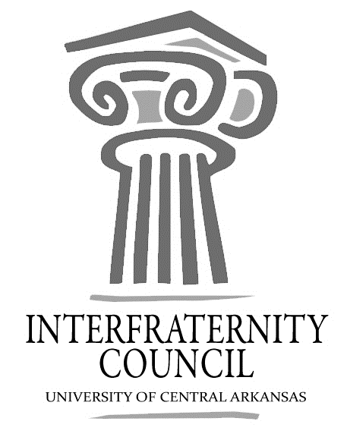
Interfraternity Council
Official minutes available immediately after meeting online: https://orgsync.com/54961/files
All IFC Public Documents: http://23277uca.edu/ifc/forms-and-policies/
General Meeting
University of Central Arkansas
Tuesday, August 29, 2017

Action Items
What needs to be turned in by delegates, completed by exec board members, etc

Decisions Made
What concrete decisions were made at this meeting?

Upcoming Dates
What important events and deadlines should you be looking out for?

- Commence Meeting:
- Delegate Roll Call
- Guest speakers
  - Camp War Eagle
    - handout packet - paid summer staff positions (not all summer).
- Executive Discussion
  - VP of Development – Lance Cook lcook8@cub.uca.edu
  - VP of Recruitment – Chase Bic
  - VP of Judicial Affairs – Colton Rowe
  - VP of Communications – Lamon Wade
    - register by 4:30 Thursday
  - President – Drew Hemstedt
- Advisors’ Report
  - recruitment number: 27 registrations
  - Bid day - be there by 3:30 Friday
  - make up for missing sexual assault 1-23-18 - most likely online module
  - RSO training- president, social chair, two exec members must go
  - Bid day locations - Sig Tau (5), Pike (4), Phi Sig (6), Kappa Sig (3), Alpha Sig (7), Sig Ep (2), Bux (8), Sig Nu (9), Fiji (1)
- Old Business
- New Business
- Chapter Reports
  - Alpha Sigma Phi- No Report
  - Beta Upsilon Chi – No Report
  - Kappa Sigma – No Report
  - Phi Gamma Delta – No Report
  - Phi Sigma Kappa – No Report
  - Pi Kappa Alpha – No Report
  - Sigma Nu – No Report
  - Sigma Phi Epsilon – No Report
  - Sigma Tau Gamma – No Report
- End Meeting:

Interfraternity Council Contact Information
President | Drew Himstedt | jhimstedt1@cub.uca.edu
VP Communications | Lamon Wade | lwade3@cub.uca.edu
VP Judicial Affairs | Colton Rowe
VP Recruitment | Chase Bicanovsky | cestes1@cub.uca.edu
VP Development | Lance Cook | lcook8@cub.uca.edu
 |  | ucaifcexec@gmail.com

