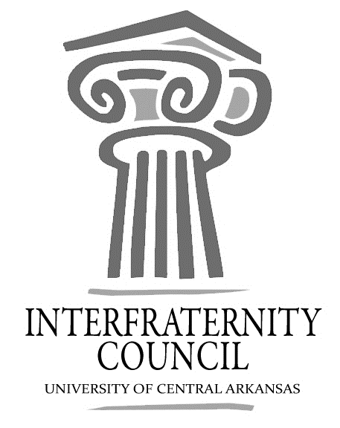
Interfraternity Council
Official minutes available immediately after meeting online: https://orgsync.com/54961/files
All IFC Public Documents: http://uca.edu/ifc/forms-and-policies/
Key:
Times New Roman: pre-submitted agenda
Times New Roman italicized: meeting notes
General Meeting
University of Central Arkansas
Tuesday, February 16, 2016

Action Items
What needs to be turned in by delegates, completed by exec board members, etc
All delegates: Dues

Action Items
What should have been turned in by delegates, completed by exec board members, etc

Decisions Made
What concrete decisions were made at this meeting?

Upcoming Dates
What important events and deadlines should you be looking out for?
- Spring Dues
  - Due: By IFC Meeting Time February 16th.
- Margaritaville
  - Friday, February 19, 2016 At the Kappa Sigma House
- Sig Ep Happy Hour
  - Every Tuesday in February 4-6 pm.
- All Greek Basketball Game
  - February 24th, 7 pm
- International Badge Day
  - March 7th
- New Member King Sponsored by Alpha Sigma Alpha
  - March 8th
- Spring Queen Sponsored by Kappa Sigma
  - March 10th
- Walk a Mile in her Shoes
  - March 13th, 2-4
- Outstanding Greek/ Rookie of the Year Application Due
  - March 18th
- Pike Crawfish
  - April 16th
- UCA Leadership Summit
  - April 16th, 9:30-2:30
  - $10 (2 meals included)
- Commence Meeting:
- Delegate Roll Call
  - All here besides Alpha Sigma Phi
- Guest speakers
- Executive Discussion
  - VP of Development – Nathan Parker
    - Tutor times
    - Thursday, Scholarship round table
  - VP of Recruitment – Matt Lawrence
    - Recruitment Roundtable
    - Thursday X period, Room 207E
  - VP of Judicial Affairs – Seth Hunter
    - Academic info.
    - Contacting chapters who did not make grades
  - VP of Communications – Reid McKenzie
    - Spring Invoices
    - Sigma Nu, Phi Lambda Chi, Pike, Sigma Nu, and Sigma Tau Gamma has not paid
  - President – Corbin Block
    - Presidents Roundtable
    - March 3rd, X-period

- Advisors’ Report
  - HP hiring
  - 2016 Leadership Summit
    - April 16th, 2016
  - Greek Basketball Game
    - February 24th, 2016
  - International Badge day
    - March 7th, 2016
  - Greek Man/ Rookie of the year applications are now out
    - Due March 18th
- Old Business
- New Business
  - NPHC/ Panhellenic Representation
  - Walk a mile in her shoes, March 13th
- Chapter Reports
  - Alpha Sigma Phi – No Report
  - Beta Upsilon Chi – No Report
  - Kappa Sigma
    - Margaritaville, February 19th
  - Phi Gamma Delta
    - Phi gams and hot cakes;
    - Oak Grove Community Service Project
  - Phi Lambda Chi –No Report
  - Phi Sigma Kappa
    - Electric Wonderland 10-2
  - Pi Kappa Alpha –No Report
    - Fresh Pikes of Bel Air, February 26th 10-2
  - Sigma Nu
    - Charity event.
  - Sigma Phi Epsilon
    - Happy Hour, 4-6;
  - Sigma Tau Gamma – No Report
- End Meeting:

Interfraternity Council Contact Information
President | Corbin Block | Cblock0@gmail.com
VP Communications | Reid McKenzie | dmckenzie1@cub.uca.edu
VP Judicial Affairs | Seth Hunter | Sethhunter95@yahoo.com
VP Recruitment | Matt Lawrence | mlawrence6@cub.uca.edu
VP Development | Nathan Parker | nparker3@cub.uca.edu

