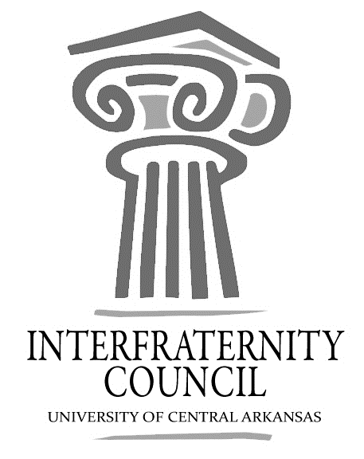
Interfraternity Council
Official minutes available immediately after meeting online: https://orgsync.com/54961/files
All IFC Public Documents: http://uca.edu/ifc/forms-and-policies/
Key:
Times New Roman: pre-submitted agenda
Times New Roman italicized: meeting notes
General Meeting
University of Central Arkansas
Tuesday, January 17, 2017

Action Items
What needs to be turned in by delegates, completed by exec board members, etc
All delegates:
- Rho Chi Contact Information
  - Meeting Friday, 3 PM, SC 213
- Recruitment Events Registered on Orgsync
  - By Midnight Tonight

Action Items

What should have been turned in by delegates, completed by exec board members, etc

Decisions Made
What concrete decisions were made at this meeting?

Upcoming Dates
What important events and deadlines should you be looking out for?
- January 18, 3:00 pm, SC 223
  - Greek 101
- January 19, 3:x-period, SC 214
  - Greek 101
- January 21, 2017, 10am-3pm, SC Ballroom
  - UCA Leadership Summit
- January 25, 7:00 pm, SC 213
  - Greek 101
- January 26, x-period, SC 223
  - Greek 101
- January 27, 2017, 4 pm, Old Main Steps
  - IFC Bid Day
- Commence Meeting:
- Delegate Roll Call
- Guest speakers
  - Di’Anka Moton
    - Choosing To Excel
- Executive Discussion
  - VP of Development – Steve Moorhead
  - VP of Recruitment – Drew Estes
    - Rho Chi Information Needed by end of meeting
      - Rho Chi Meeting Friday
    - Greek 101 Times
    - Recruitment Rules
  - VP of Judicial Affairs – Drew Himstedt
  - VP of Communications – Hayden Murry
    - Reports due 24 hours before meeting time.
  - President – Matt Lawrence
    - Beta Upsilon Chi now recognized as full members of IFC
- Advisors’ Report
  - UCA Leadership Summit
  - Drop form on Orgsync
  - Grades
    - Fall 14: 2.67
    - Fall 15: 2.69
    - Fall 16: 2.94
  - Recruitment
    - Need Events Registered by end of today
    - Registration Form
      - 8 Total currently
- Old Business
- New Business
- Chapter Reports
  - Alpha Sigma Phi- No Report
  - Beta Upsilon Chi – No Report
  - Kappa Sigma – No Report
  - Phi Gamma Delta – No Report
  - Phi Sigma Kappa – No Report
  - Pi Kappa Alpha – No Report
  - Sigma Nu – No Report
  - Sigma Phi Epsilon – No Report
  - Sigma Tau Gamma – No Report
- End Meeting:

Interfraternity Council Contact Information
President | Matt Lawrence | Mlawrenc6@cub.uca.edu
VP Communications | Hayden Murry | Hayden.murry@ucaphigam.com
VP Judicial Affairs | Drew Himstedt | jhimstedt1@cub.uca.edu
VP Recruitment | Drew Estes | cestes1@cub.uca.edu
VP Development | Steve Moorhead | Smoorhead1@cub.uca.edu

