HLTH 4600 The Health Sciences Internship
Congratulations! You are very close to completing the final requirements for your Health Sciences degree. As you may know, all UCA students are required to have a capstone experience as part of their degree program. For Health Promotion and Health Services Administration majors, the capstone is HLTH 4600 – the Health Sciences Internship. This internship experience requires 200 hours of service and should be completed during your last semester at UCA. It is highly recommended that you only take two additional courses while
doing your internship, and preferably these should be online courses. If additional arrangements
need to be made, you must meet with your internship coordinator for advising and approval. Both internships require an overall 2.5 GPA for admission. Along with that you must have a C average in all of your professional courses (this does not include science courses) in order to enroll in the internship. You are encouraged to meet with one of your Health Science instructors or your academic advisor during your junior year to discuss your career goals and the internship options.
Health Promotion majors
If you are a Health Promotion major you have two internship options - the traditional Health Promotion internship and the Health Coaching internship. Cindy Shelton (cshel@uca.edu) is the coordinator for the traditional Health Promotion internship. Duston Morris (dustonm@uca.edu) is the coordinator for the Health Coaching internship.
If you choose the traditional internship experience, you will follow the standard path lined out on the Health Promotion check sheet. If you are interested in the Health Coaching option, you must complete the Health Coaching Internship prerequisite courses. These include HLTH 1320 or EXSS 1320 (Essentials of Lifetime Health and Wellness), HLTH 2201 (First Aid), HLTH 3325 (Disease Management), HLTH 4398 (Health Coaching I) and HLTH 4399 (Health Coaching II). PRIOR to enrolling in HLTH 4600, you must also meet with Dr. Morris to discuss the internship to make sure it is the right option for you.

Health Services Administration majors
There are also 2 options for the Health Services Administration capstone. Option 1 involves enrolling in HLTH 4600 and completing a 200-hour internship at a health facility or company. Cindy Shelton (cshel@uca.edu) is the coordinator for this traditional internship/capstone course.
In certain circumstances, for example, if your family/work schedule does not permit the traditional internship, Health Services Administration students may be offered the option of completing the business capstone course MGMT 4347 (Managing Policy and Strategy). If you are eligible to go this route, there is one additional prerequisite course you must take - MGMT 3344 (Operations and Supply Chain Management). Anyone who chooses this route must complete all the required business courses with a C average or better.

For all the traditional internships, both Health Promotion and Health Services Administration, you must have your application submitted, meet with Cindy Shelton, and have your site selected and confirmed before the last 3 weeks of the semester prior to internship semester.
If you want more information or have any questions, please email Cindy Shelton at cshel@uca.edu.

The Health Sciences Internship is an important and final piece of your undergraduate
education in the Department of Health Sciences. Please do not wait until last minute to
begin preparing for your internship. If you have any questions about the Health Sciences
internship, please contact either of the following internship coordinators:

Cindy Shelton, MSE
Health Sciences Internship Coordinator
Email: cshel@uca.edu

Duston Morris, PhD, MS, CHES, ACE-HWC
Health Coaching Internship Coordinator
Email: dustonm@uca.edu
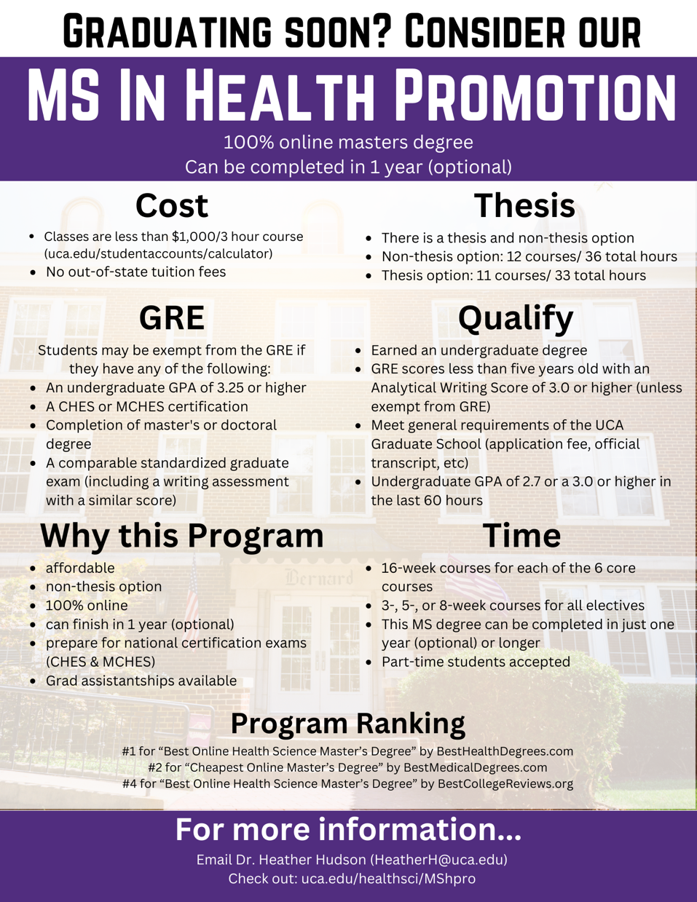
Phone/Text: (501) 504-5250

