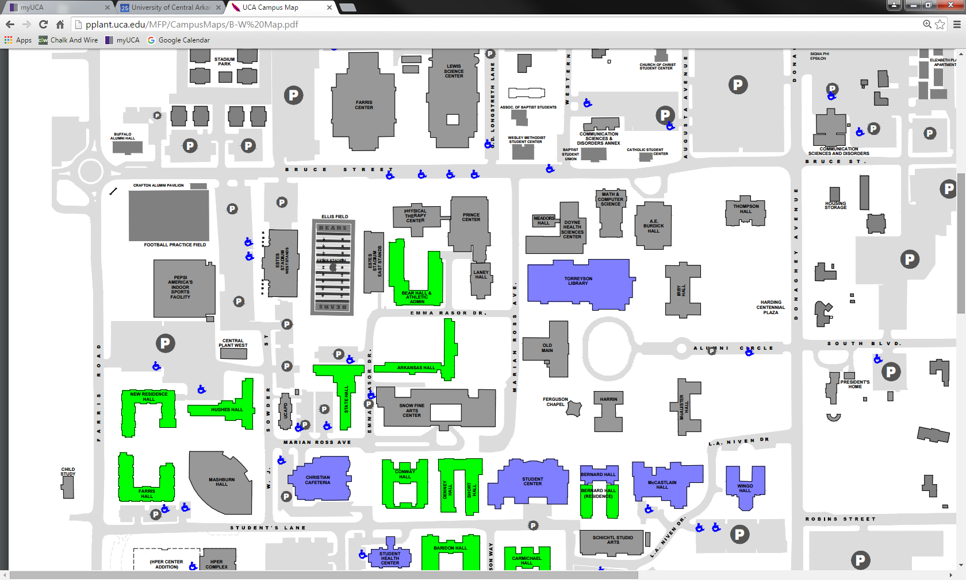

One table proposed for area between Irby & Thompson Hall to service both buildings (If funding permits).

Two tables proposed for Farris Center to service Farris Center and Lewis Science Center.

One Table proposed for Mashburn Hall at entrance to service Mashburn, Hyper Center, and Farris Halls.