Learn 9.1 Q4 2016 Updated Features

1. New icon set
In this release, there is a new icon set for use in courses and organizations, cancel/submit buttons will always pin to the bottom of the page regardless of device.
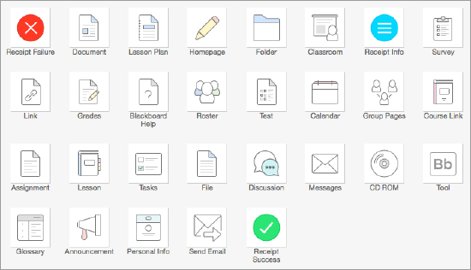

2. Drag and drop files
When instructors create content items, assignments, and web links, they can drag files from their computers to the "hot spot" in the Attach Files area. Students can also drag files to upload when they submit assignments.
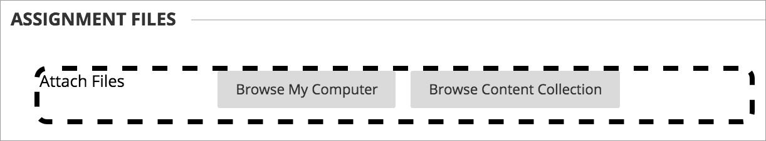

3. Dropbox Education integration
Users can attach files and submit assignments from their personal Dropbox accounts using this cloud service integration.

4. Submission receipts
Instructors can keep track of all student submissions, regardless of whether the attempt or the assignment is deleted or the submission history has changed. A submission receipt is captured at the time of submission and includes information such as attached file information, date, time, etc. This feature provides evidence for academic disputes, giving students assurance about their work.

A receipt is generated for each group member when a student submits on behalf of the group, and the anonymous state of an assignment is respected. For assignments with multiple attempts, students receive a different number for each submission.

5. Reminders
Instructors can send email reminders from Grade Center columns to students and members of groups who have missing coursework. Students receive a system-generated email that lists the course, coursework, and the due date if included.

6. Fewer Needs Grading items
When multiple-attempt assignments are set to calculate using the first attempt, there are potentially numerous other attempts that will never be used for the grade calculation. This can be particularly problematic in anonymous or delegated grading scenarios where it can be difficult to determine which attempts are associated with students and therefore require grading. A new filter is now available both in the Needs Grading workflow as well as within the Grade Center to show or hide these attempts. Attempts that won’t calculate towards the assessment grade are now indicated with an icon.

7. Improved behavior for Self and Peer Assessments
Non-participants during the submission period are excluded from the evaluation process. Submitters with partial or complete submissions will be distributed to peers for evaluations. By pairing an assessment with Adaptive Release, it’s possible to configure Self and Peer Assessments for individual groups.

8. Course activity reports
The Course Activity Overview report has been updated to improve the experience for larger enrollment courses. Instructors can filter the report and break down the calculations of student activity by course groups.

Note from Tonya McKinney for consideration:
Taine,
This is the website with the new features.

https://help.blackboard.com/Learn/Administrator/Hosting/Release_Notes/Release_Notes_All_91_Releases/Release_Notes_9.1_2016_Q4

The top things that I feel faculty will be interested in are attached. I have not had a chance to actually test these new features, but the Q4 2016 version is installed on the test server at https://uca-test.blackboard.com and if faculty cannot login with their myUCA login credentials, I am happy to get them added and give them a course to test in.

The other item I would like feedback on is if Dec. 20 is acceptable as a first date to offer managed hosting in performing the ugraded.

