INTRODUCTION

A recent USA Today report ranked 231 United States collegiate athletic programs based on the subsidy they receive from their host university to cover expenses. In this report, UCA was ranked as the 68th most subsidized school in the nation, with 74.81% of athletic revenue from University subsidy - a total subsidy of $9,308,495.

This is the highest subsidy percentage of any Arkansas school listed in the USA Today report. In contrast:

UAPB = 72.58% subsidy
UALR = 67.90% subsidy
ASU = 48.06% subsidy
UA-F = 0% subsidy

Essentially, UCA spends more on athletics and earns less from it than any other school in the State, which cannot persist. Recent disagreements over a $160M stadium expansion at UAF highlight the extent to which the general public is disgusted with the athletic cart leading the academic horse.

Public perception drives public opinion, which drives public policy. The public perceives that higher education costs too much. This leads to a public and legislative search for waste in higher education. Athletics is viewed as a subsidiary function of higher education yet many schools, including UCA, spend more money on athletics than athletics Return on Investment (ROI) potentially justifies. Legislators already seem to hold a less than favorable opinion of higher education’s ability to efficiently allocate resources. Budget pressures resulting from the Lakeview case, prison overcrowding, Arkansas Works, highway construction, etc. will eventually force legislators to make difficult funding decisions. Higher education becomes an easy target for cuts when money is spent in ways it ostensibly should not. UCA has recently been the target of legislative pressure to merge with another system to save taxpayer money.

I believe we are all proud of our University, our student athletes, and their athletic accomplishments. Athletics is a key component of college life and a way to maintain alumni engagement. The purpose of voicing this concern is not to "kill" UCA athletics. Alternatively, the purpose of voicing this concern is to save UCA athletics. We can either choose to live more within our means or someone else will force us to do so, perhaps as part of another university system. It is time for athletics to either "spend less" or "make more" so UCA is not the Statewide posterchild for athletic overspending.

This report will attempt to provide perspective on UCA athletic spending as compared to academic spending and then examine football’s role as a driver of athletic spending. Finally, a request is made for faculty senate to charge a committee with studying a preliminary set of questions found at the end of this document.

DATA

State funding is stagnant and the University’s academic side fights to remain afloat (reference the removal of adjunct funding for the 16-17 AY). Commiserate with flat state funding, information derived from the Knight Commission presented in Figure A illustrates that UCA’s inflation adjusted academic and instructional spending per FTE student changed little if any from 2007 to 2014. Academic spending rose 3% from 2007 to 2014 whereas instructional spending rose 0%. Further, both are underfunded relative to Football Championship Subdivision (FCS) peers. FCS peer median inflation adjusted academic spending increased 8% and instructional spending increased 5% during the same time period.

FIGURE A
ACADEMIC AND INSTRUCTIONAL SPENDING PER FTE STUDENT

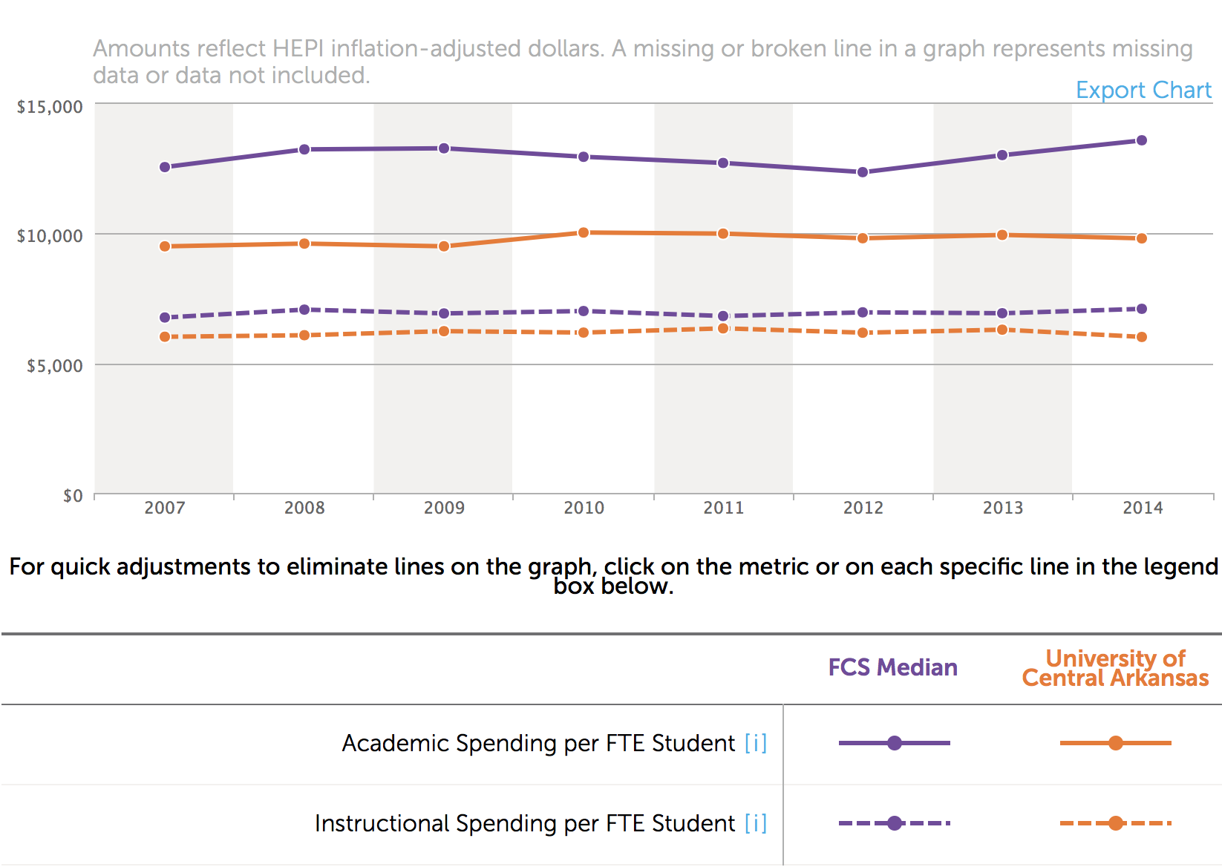
Source: Knight Commission

How does academic/instructional spending per FTE student compare with athletic spending per athlete? Figure B details UCA’s inflation adjusted athletic spending per student athlete from 2007 – 2014. According to the Knight Commission, UCA spending per athlete rose from $23,223 in 2007 to $28,690 in 2014, a 24% increase. It should be noted that spending marginally decreased between 2010 and 2014 and also that UCA spends less than its FCS peers, whose spending continues to rise. However, as illustrated in Figure A, academic and instructional spending per FTE student was essentially flat from 2007 to 2014, whereas Figure B shows athletic spending per athlete increased 24%.

FIGURE B
ATHLETIC SPENDING PER ATHLETE

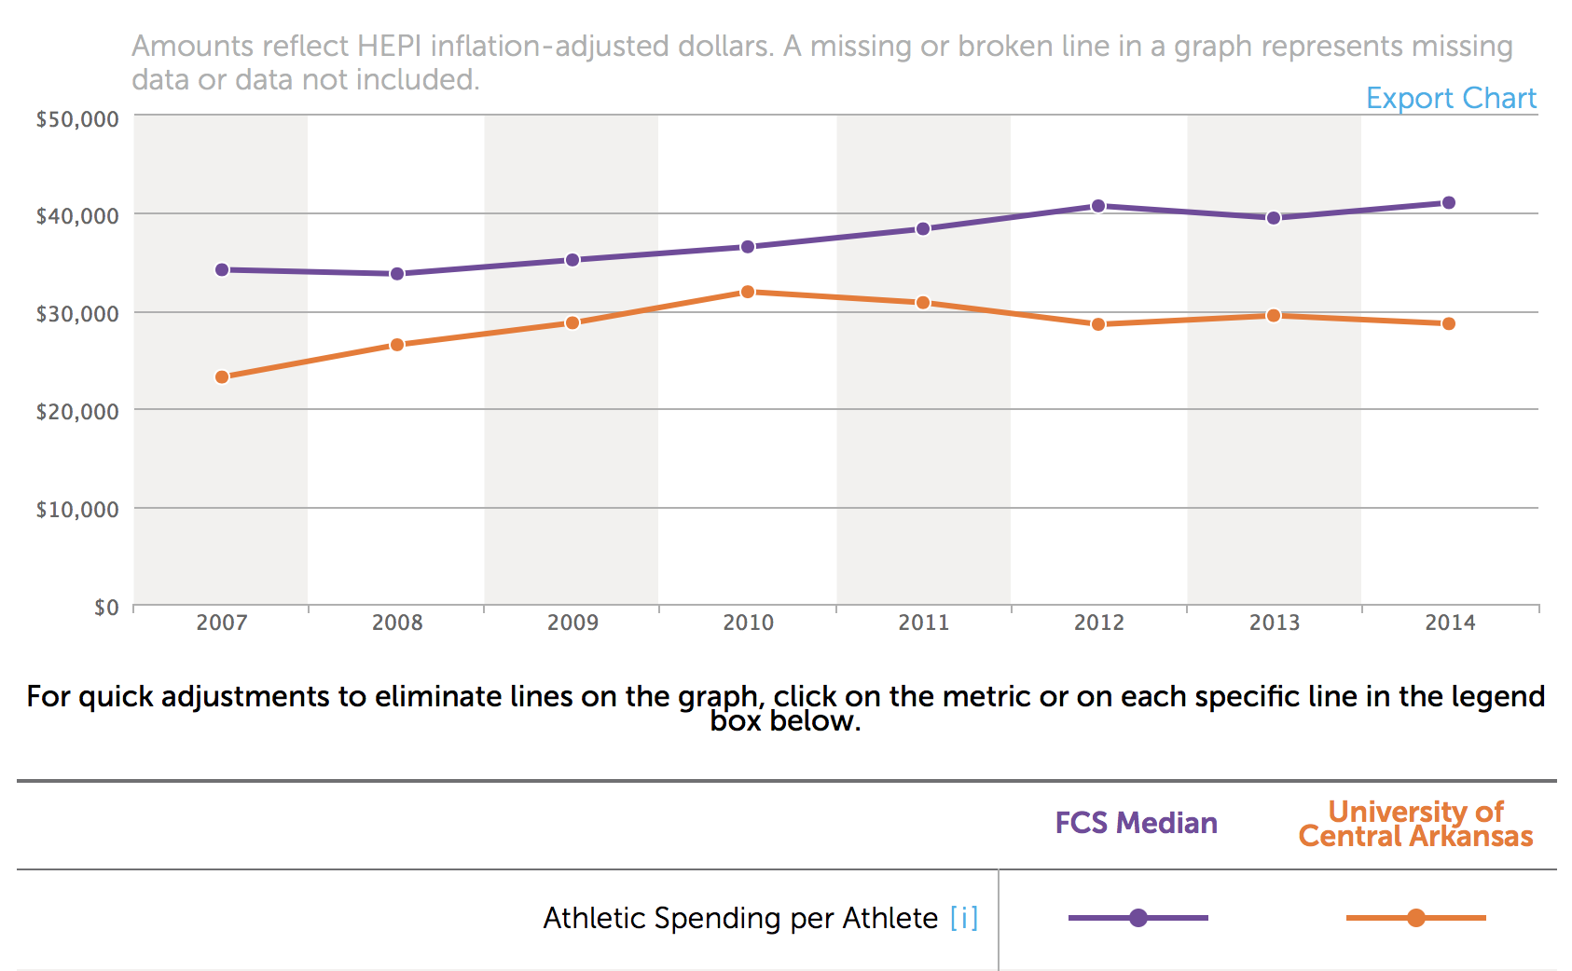
Source: Knight Commission

Figure C details UCA’s inflation adjusted athletic spending per athlete, excluding football. UCA data was only available after 2011. Figure C illustrates that inflation adjusted UCA athletic spending on all sports other than football declined from $23,363 in 2011 to $20,443 in 2014.

FIGURE C
ATHLETIC SPENDING PER ATHLETE EXCLUDING FOOTBALL

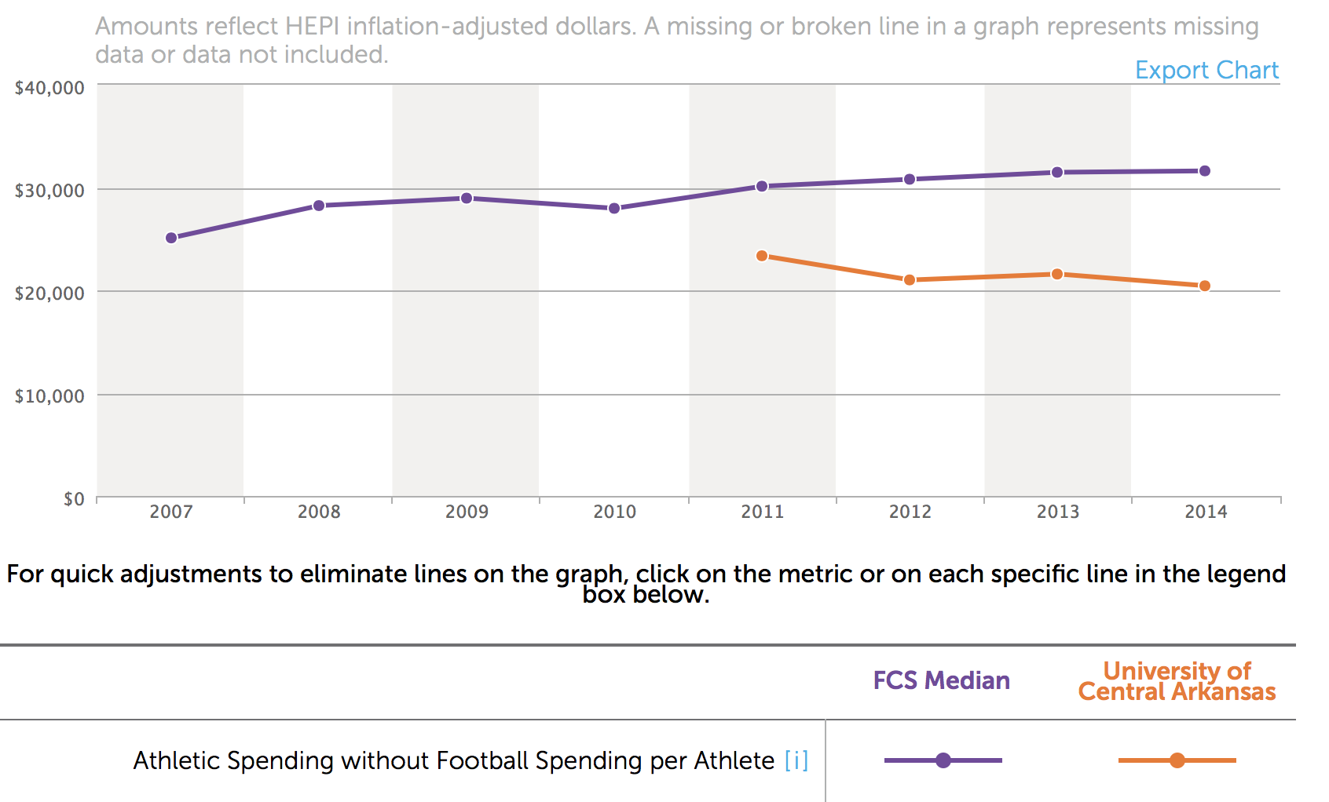
Source: Knight Commission
Note: UCA data not available before 2011

Figure D illustrates that UCA began to bend the curve in 2010 and decrease its year over year inflation adjusted athletics subsidy. This is to be commended and also coincides with the decrease in athletic spending per student athlete excluding football detailed in Figure C.

However, Figure D indicates athletic subsidy per student athlete is up from $19,729 (2007) to $22,011 (2014), an increase of 12%. Again, this should be compared with flat academic and instructional funding over the same time period as presented in Figure A. Athletic subsidies increased while academic and instructional monies were flat or increased substantially less.

FIGURE D
INSTITUTIONAL FUNDING FOR ATHLETICS PER STUDENT ATHLETE

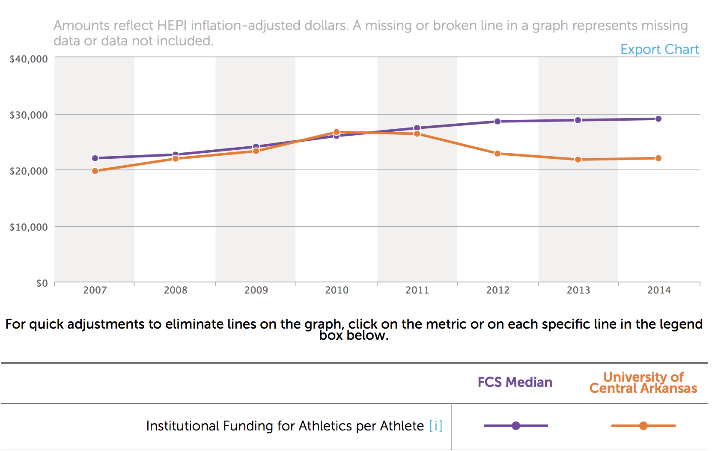
Source: Knight Commission

So it appears we “found religion” in 2010, right? Maybe it depends on how we look at it. Figure E illustrates that football spending per scholarship football player grew 64% from $27,371 in 2011 to $44,961 in 2014 on an inflation adjusted basis, more than the median expenditures of our FCS peers. Whereas funding for other athletic endeavors decreased, and overall institutional funding moderated, football spending per scholarship participant has exploded by 64%.

FIGURE E
FOOTBALL SPENDING PER SCHOLARSHIP FOOTBALL PLAYER

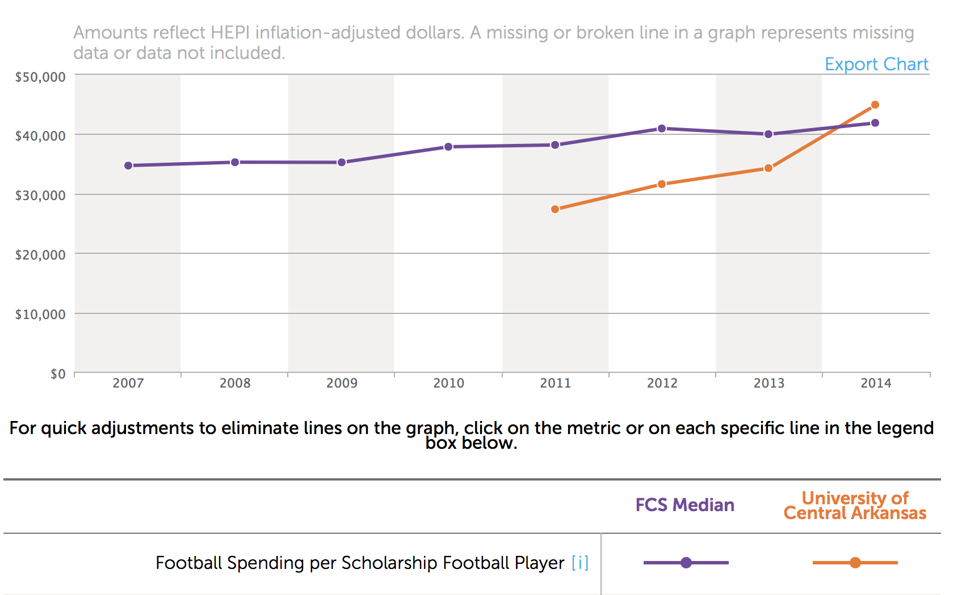
Source: Knight Commission
Note: UCA data not available before 2011

Figure F shows that UCA football coaching salaries per scholarship football player increased 92% from 2011 to 2014 on an inflation adjusted basis. Our football coaches are now paid more than their FCS peers on a per scholarship football player basis. Unless there was a major reduction in scholarship football players from 2011 to 2014, football coaching salaries obviously enjoyed a precipitous increase.

FIGURE F
FOOTBALL COACHING SALARIES PER SCHOLARSHIP FOOTBALL PLAYER
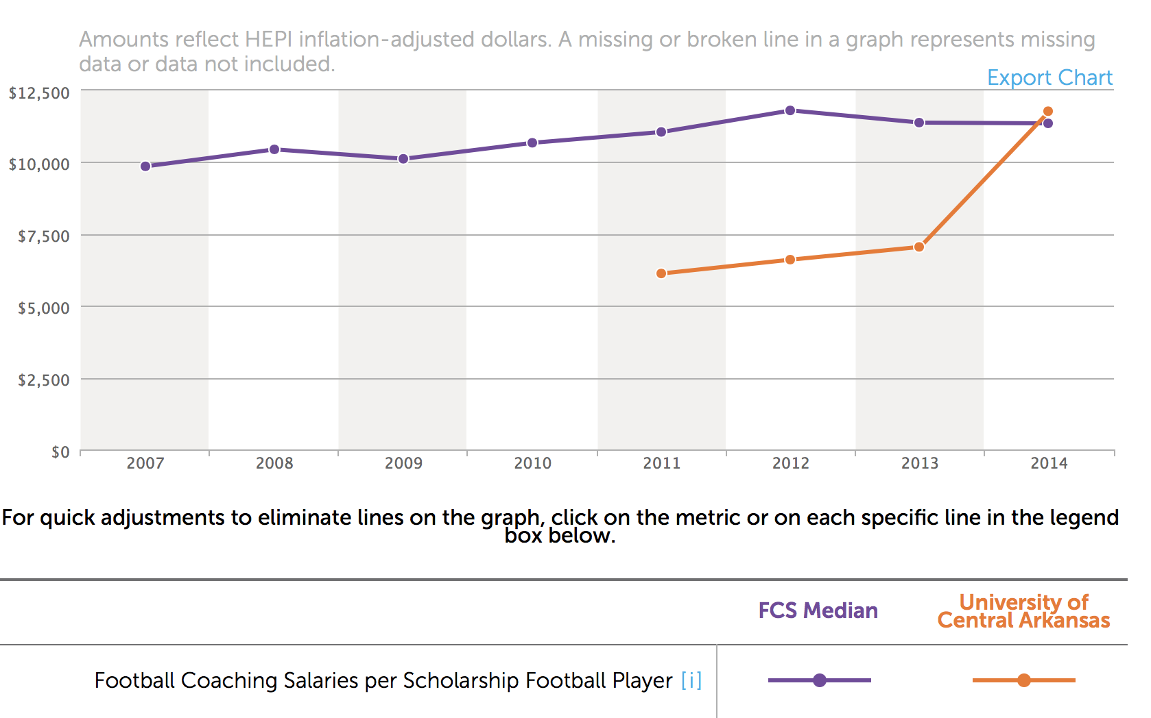
Source: Knight Commission
Note: UCA data not available before 2011

Figure G indicates that UCA also spends a great deal of money servicing debt on athletic facilities. Our expenditures far outstrip those of our FCS peers. Much of this debt was likely necessary to move to Division I.

FIGURE G
ANNUAL DEBT SERVICE ON ATHLETIC FACILITIES

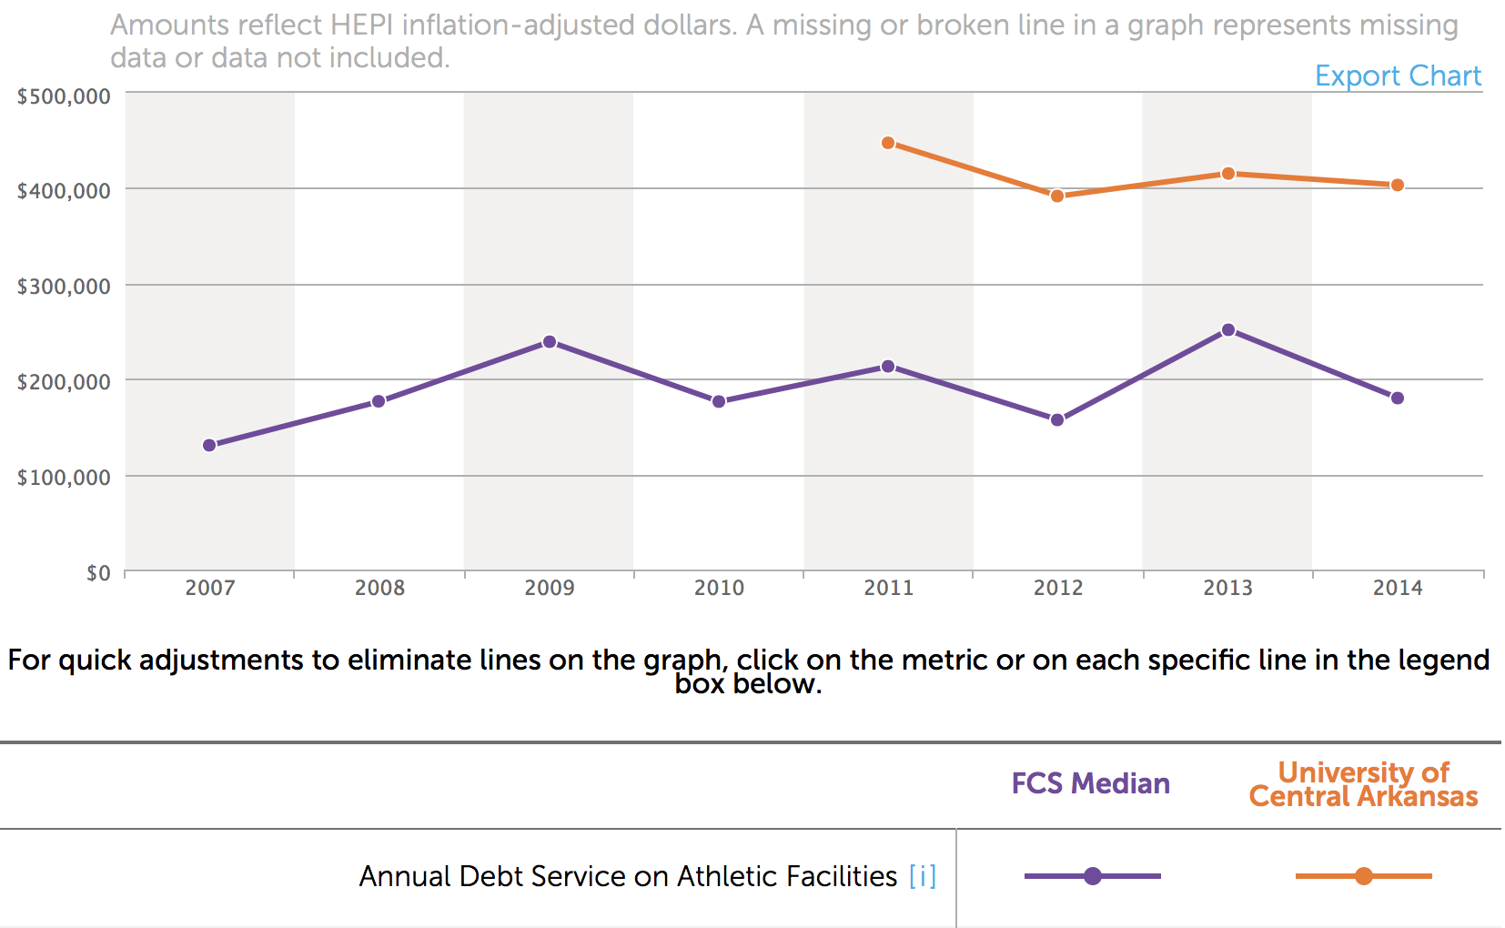
Source: Knight Commission
Note: UCA data not available before 2011

CONCLUSION

It may be time to decide what we want to be as an institution. The state budgetary situation, coupled with the overall mood toward higher education and its relationship with athletics, could very easily lead to consequences for the entire University resulting from over-subsidizing athletics (specifically football).

Athletic spending is up. Football spending is up even more. Data presented seems to indicate that UCA may have moderated spending in other sports to support increased football spending, which is usually considered the most expensive intercollegiate sport due to scholarship expenses and salaries. It would also seem that we have invested heavily in facilities; likely to meet Division I requirements. None of this includes beach volleyball, which begins in 2017, or the potential requirement to pay athletes full cost of attendance. Athletic spending shows no sign of slowing down.

Academic and instructional spending is flat. Could some of the athletic subsidy have been used to hire professors; adjunct or terminally qualified? UCA has recently withdrawn and reallocated adjunct teaching resources. This leads to larger class sizes and less one-on-one student contact, which could impact retention.

Athletic subsidies include athletic fees. Students are charged approximately $500/year in athletic fees whether or not they attend any events. This is money they could use to defray tuition costs, which would improve student retention. Retention is especially important given upcoming changes to higher education funding that will emphasize degrees awarded and time to completion.

In light of these facts, at best, I have concern that UCA athletics fails to return an adequate ROI in its current state. At worst, at the risk of sounding hyperbolic, I have concern that UCA’s very existence as an independent institution may be threatened if we continue to wear the thorny crown bestowed upon Arkansas’ most subsidized athletic program.

Would faculty senate please endeavor to answer the following questions:

1. What is UCA's ROI on the $9,308.495 athletic subsidy?

2. What is the difference between the anticipated and actual amount of NCAA and other revenue UCA expected to gain from the move to Division I? Was the move to Division I based on projected revenue increases that did not come to fruition?

3. How much did athletic donations increase after the move to Division I relative to expectations?

4. How much/if any would fan interest decline following a move to Division II in all sports and/or just football?

5. How much does UCA spend each year to retain Division I status in all sports and, separately, in football?

6. How much would UCA save each year by moving to Division II in all sports and, separately, in football?

7. Do athletics have a net positive or net negative impact on student retention? This answer should have both positive and negative aspects. Athletics may bond students to an institution, thereby improving retention. Student athletes may be retained at a higher rate than non-student athletes. However, athletic fees increase the cost of tuition as do other monies allocated to athletics (e.g. bookstore revenues, housing and auxiliary accounts, etc.), which could be allocated to academics. Increased tuition costs negatively impact student retention.

8. How much of the $9.3M subsidy could be returned to academics in the short-term and long-term if:
a. Athletic fees were reallocated to academics
b. Other monies allocated to athletics (bookstore revenues, housing, etc.) were returned to academics
b. Football was discontinued
c. UCA returned to Division II in all sports or, separately, just in football.

9. How does UCA athletics plan to reduce its reliance on University subsidies given scarce University resources? What are their subsidy reduction goals in 1, 5, and 10 years?

10. Can UCA afford to participate in Division I football? Can we move to Division II in football but remain Division I in other, more affordable sports?

11. How is UCA going to cover full cost of attendance (i.e. pay stipends) for student athletes in the future?

12. Does UCA athletics compensate UCA for space in Bear Hall? If not, is this considered part of the subsidy?

13. What is the opportunity cost associated with land consumed by athletic facilities that could otherwise be used for core University functions? Examples include the indoor practice facility, weight room, and practice field; areas that serve very little purpose to the non-athletic student population. What is the value of this land if used for other purposes? Is this value considered part of the subsidy?

14. What is the true cost per hour and cost per mile for the UCA buses used to transport athletic teams to events? Considered costs should include principle, interest, taxes, insurance, maintenance, operator pay, fuel, administrative costs, and general overhead (cleaning, etc.) costs, among others.

15. How many miles do UCA buses drive each year for athletic purposes? How many hours are UCA buses predisposed each year for athletic purposes?

16. How much does UCA athletics pay per mile and/or per hour for use of UCA buses?

17. If UCA athletics pays less than actual cost, is the difference between actual and UCA athletics paid cost included in the subsidy figure?

Thank you for your time and Go Bears!

http://sports.usatoday.com/ncaa/finances/
http://spendingdatabase.knightcommission.org

