Our Movies/Ourselves
ENGL 4/5304 CRN 19860/20469

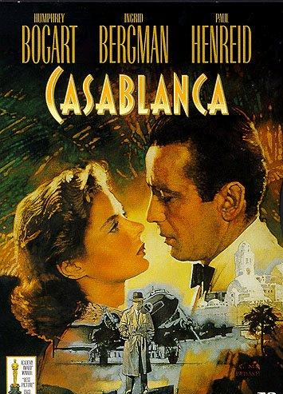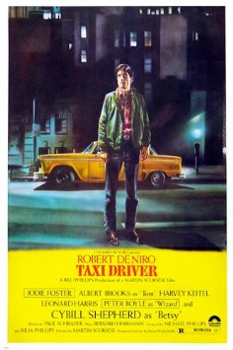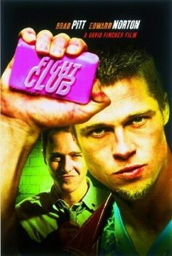

Instructor: Dr. Glenn Jellenik E-mail: gjellenik@uca.edu Office: 430 Irby Time: W 6-8:30 pm Office Hours: MWF 12-2, or by appointment Place: Irby 312
COURSE DESCRIPTION

The premise that drives this class isn’t that much different from the fundamental assumption of many literature classes: namely, the idea that the texts that we produce and consume as a culture reflect, rehearse, drive, and function as productive illustrations of our priorities, concerns, values, and anxieties at any given time. In the case of this course, the texts are films. This course treats American movies from WWII to present in order to focus on the ways that film (and the film industry) explores, engages with, and constructs what we think of as American identity. In essence, this is a historicist approach to film studies that posits films as texts that simultaneously reflect and drive (trace and construct) their audience's notions of identity. (I organize my American and British Lit surveys along similar lines.) Some specific focuses here will be collective social concepts of heroism, success, gender roles (masculinity/femininity), sexuality, love, violence, war, morality, honor, the American Dream, and capitalism. In the end, we will use movies to understand our historical moments and … ourselves.
In order to use films to take these sorts of critical journeys, it will be necessary for you to familiarize yourselves with some of the central concepts of film studies. With that in mind, this course will also function (at times) as an Intro to Film Studies course. That is, we’ll be close reading movies, and to do that, you will need to stock and develop another critical toolbox.

COURSE OUTCOMES

In addition to learning the rudiments of film theory, you will hone your research skills (specifically, critical reading of primary and secondary texts and critical writing), and develop your own critical arguments as they pertain to the texts we study, both in class and in writing. And in the end, you will practice developing a holistic socio-historical understanding of the ways that film can reflect and drive a specific cultural moment, and even further, the ways that that work can ripple forward.

MY POLICIES
Participation: It comprises 15% of your final grade. That means that I expect everybody to participate in our discussions. Since you’re all upper-level and grad students and are (presumably) heavily invested in our subject, I don’t think I need to belabor this point.
Small but not insignificant point: In order to truly participate productively in class, you need to have done all assigned readings/screenings. Again, you are upper-level and grad students, so I expect this not to be an issue.
Attendance: If you intend to make a premium grade, you should attend class every class day. We are a small group here, and your voice is vital. So for yourself and for your peers, come to class. We only meet 15 times, so every class is precious.
Late arrivals/Early departures: Avoid these at all costs; if it’s unavoidable, be as considerate as possible to your classmates.
Cell Phones: Call it a pet peeve, but cell phone interruptions drive me crazy—seriously, they give me facial tics. Please preserve the illusion of my sanity; turn all cell phones off before class.
Late Work: I do not accept late work. All assignments are due on the day indicated on the syllabus, at the start of class. Period.
Assignments:

Critical Presentation 10%
Essay 1 (10/25) 20%
Short Assignments (10/11 & 11/22) 10%
Final Essay (12/13) 35%
SWAs 10%
Participation 15%

Grades: I trust that you’re all excellent students, and I trust that you all want to earn an excellent grade. The way to achieve that is simple: do excellent work. I don’t give you a grade—you earn your grade. Those who understand the implications of that tend to have success.

Academic Honesty:
You are bound by the UCA’s policies on academic honesty, which bar you from presenting any other person’s work or ideas as your own, allowing someone to write an assignment or part of an assignment for you, or failing to properly acknowledge source materials. The University and I take violations of these policies seriously; penalties may include failing the course and expulsion.
Knowing the boundaries between acceptable and unacceptable practices is sometimes tricky. If you’re unsure about anything, do not hesitate to ask me to clarify.
UNIVERSITY POLICIES:
On Academic Integrity: The University of Central Arkansas affirms its commitment to academic integrity and expects all members of the university community to accept shared responsibility for maintaining academic integrity. Students in this course are subject to the provisions of the university's Academic Integrity Policy, approved by the Board of Trustees as Board Policy No. 709 on February 10, 2010, and published in the Student Handbook. Penalties for academic misconduct in this course may include a failing grade on an assignment, a failing grade in the course, or any other course-related sanction the instructor determines to be appropriate. Continued enrollment in this course affirms a student's acceptance of this university policy.
The Americans with Disabilities Act: The University of Central Arkansas adheres to the requirements of the Americans with Disabilities Act. If you need an accommodation under this Act due to a disability, please contact the UCA Office of Disability Services, 450-3613.
Students should familiarize themselves with all policies included in the Student Handbook, particularly the Sexual Harassment Policy and Academic Policies. You are responsible for acting in accordance with these university policies. If you have any questions about these policies and how they pertain to you, do not hesitate to ask me for clarification.
Title IX disclosure: If a student discloses an act of sexual harassment, discrimination, assault, or other sexual misconduct to a faculty member (as it relates to “student-on-student” or “employee-on-student”), the faculty member cannot maintain complete confidentiality and is required to report the act and may be required to reveal the names of the parties involved. Any allegations made by a student may or may not trigger an investigation. Each situation differs and the obligation to conduct an investigation will depend on those specific set of circumstances. The determination to conduct an investigation will be made by the Title IX Coordinator. For further information, please visit: https://uca.edu/titleix. *Disclosure of sexual misconduct by a third party who is not a student and/or employee is also required if the misconduct occurs when the third party is a participant in a university-sponsored program, event, or activity.
Emergency Procedures: Emergency Procedures Summary (EPS) for the building in which this class is held will be discussed during the first week of this course. EPS documents for most buildings on campus are available at http://uca.edu/mysafety/bep/. Every student should be familiar with emergency procedures for any campus building in which he/she spends time for classes or other purposes.
COURSE TEXTS:
Available on line: Course Readings (Blackboard)
SCHEDULE

Week 1. Introductions.
8/30. IM … UR … This is …
Film 101.

Week 2. Film 101.
9/6. Citizen Kane (Welles, 1941)
Read: TBA
Write: SWA 1

Week 3. Unit 1: Establishing (and exploring) a (new) American hero: Bogie
9/13. Casablanca (Curtiz, 1942)
Read: TBA
Write: SWA 2

Week 4. Establishing a domestic American hero
9/20. It’s a Wonderful Life (Capra, 1946)
Read: TBA
Write: SWA 3

Week 5. Exploring domestic dysfunction, the ugly side of beauty, and the Production Code
9/27. A Streetcar Named Desire (Kazan, 1951)
Read: TBA
Write: SWA 4

Week 6. The “death” of the “war” hero?
10/4. Shane (Stevens, 1953)
Read: TBA
Write: SWA 5

Week 7. Mumblin’ about my generation: Youth culture and social rupture
10/11. Rebel Without a Cause (Ray, 1955)
Read: TBA
*Due: Short Assignment 1

Week 8. Unit 2: Neuroses R Us. Things get … weird: What happened to the hero?
10/18. Psycho (Hitchcock, 1960)
Read: TBA
Write: SWA 6

Week 9. Things can now get … weirder: The death of the Production Code
10/25. Bonnie and Clyde (Penn, 1967)
Read: TBA
*Due: Essay 1

Week 10. Hearing voices: Yes, they’re talkin’ to me (us)
11/1. Taxi Driver (Scorsese, 1976)
Read: TBA
Write: SWA 7

Week 11. Descent into madness: the Viet Nam War as tragedy
11/8. Apocalypse Now (Coppola, 1979)
Read: TBA
Write: SWA 8

Week 12. Unit 3: Capitalism, movies, and the perversion of the American dream
11/15. Wall St. (Stone, 1987)
Read: TBA
Write: SWA 9

Week 13. The anarchist’s guide to self help
11/22. Fight Club (Fincher, 1999)
Read: TBA
*Due: Short Assignment 2

Week 14. The yuppie’s guide to psychopathy
11/29. American Psycho (Harron, 2000)
Read: TBA
Write: SWA 10

Week 15. 21st-century breakdown: Travis Bickle goes to business school
12/6. Nightcrawler (Gilroy, 2014)
Read: TBA
Write: SWA 11

****Final Essay Due: W 12/13****

