Restoration & 18th-Century Theater (ENGL 4366)

Playing with culture
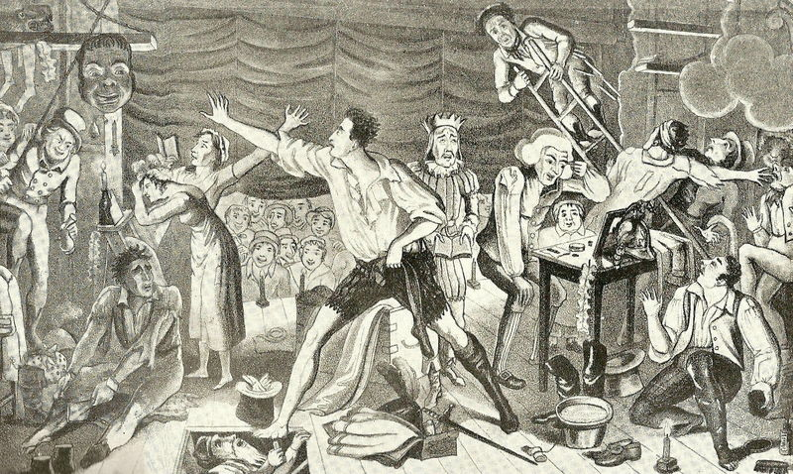
Instructor: Dr. Glenn Jellenik E-mail: gjellenik@uca.edu Office: 410 Irby Time: TTh 12:15-1:30 (CRN 28151) Office Hours: MW 11-1, or by appointment Place: Irby 310

Course Description: When it comes to theater, there are a few periods that stand out for scholars (you know, the people who develop canons and decide what’s literarily “important,” and thus what gets read going forward): ancient Greece (Euripides, Sophocles, Aeschylus), Elizabethan England (Shakespeare, Jonson, Marlowe), 20th-century (Beckett, O’Neill, Miller). If you’re a careful reader (and I really hope you are), you’ll have noticed that the period we’re about to study is not on that list. The fact is, Restoration/18th-century theater is more associated (by traditional scholars) with the decline of drama in British culture than it is with excellence. As a result, almost none of it (with the exception of The Beggar’s Opera) has made it into the canon. Most theater anthologies skip the period altogether. But here’s the great thing about scholarship: canons (and the reading strategies and critical ethoi that develop them) are not written in stone. The academy’s growing internalization of postmodern and cultural-studies approaches to literature gives us an opportunity to re-visit and re-consider previously-ignored periods/genres and recognize their output as incredibly productive and important. So we’ll get this out of the way right off the bat: none of the plays we’ll read this semester are as aesthetically “great” as Hamlet. But their cultural centrality gives us access to a host of socio-cultural, political, economic, and literary changes that went on in a pivotal and revolutionary time in England/ Britain. We’ll use the plays we read as a lens through which to view, process, and understand nothing short of the rise of modernity, and the shifting, changing, evolving role of popular culture and literature (and the emergence of a divide between those two things) in that rise.

Learning Outcome: At its heart, this is a cultural-studies course. Its primary outcome will be a greatly enhanced ability to use a set of texts to trace, process, and understand large-scale historical, social, and cultural developments that occurred in the culture that produced and consumed those texts. You will practice reading literature in its capacity to reflect and drive culture, practice making connections and associations between literature and culture. And you will practice tapping into the arguments, claims, and implications of that literature to produce arguments of your own. Which is to say, you will read, think, and write. A lot.
My Policies.
Participation: It comprises 10% of your final grade. That means that I expect everybody to participate in our discussions. Seriously, you do not want to listen to 75 straight minutes of my talking head every Tuesday and Thursday. That said, we will explore a wide range of texts and topics in class; not only would it be impossible for all of you to agree on everything, it would be boring. I highly encourage you to disagree with one another, and I highly encourage you to disagree with me. All I ask (actually, I don’t ask, I demand) is that you disagree with one another (and me) in a constructive manner that fosters conversation rather than shuts it down. Show respect for one another’s views, opinions and ideas.
In keeping with the idea that this is a safe space to share and test out ideas, I encourage you all to speak to one another in our discussions. That is, not all comments have to go through me at the front of the room. Let ideas bounce around the room—address one another directly. This will be best accomplished if you learn each other’s names. If done properly, we can all join together in a lit-crit sister and brotherhood. We will now join hands and sing Kumbaya.
At this level, this shouldn’t be a concern, but in the interest of dotting all t’s and crossing all i’s: In order to truly participate productively in class, you need to have done the assigned readings. If it becomes obvious that you haven’t been doing the readings—and it’s not difficult to tell—I’ll be forced to administer annoying quizzes at the beginning of each class. Don’t make me administer annoying quizzes. Do the readings.
Attendance: If you intend to make a premium grade (A or B), you should attend class as frequently as possible, preferably every class day. Your final grade for this course will drop two points for every absence after two, except in rare situations. Infrequent absences caused by illness or accident, family death, official university functions, or inclement weather are acceptable. If you should miss 4 or more classes, I will strongly recommend that you drop the class.
Late arrivals/Early departures: Avoid these at all costs; if it’s unavoidable, be as considerate as possible to your classmates.
******************!!!!!!Cell Phones!!!!!!******************
Hear this now: Cell phone interruptions drive me nuts—seriously, they give me facial tics. So please turn off and stow all cell phones before class. Seriously, I don’t even want to see your cell phone. Really. Prove to yourself that you’re not addicted to the little monster: spend our 75 minutes out of its presence (#giveyourthumbsarest).
Late Work: I do not accept late work. All assignments are due on the day indicated on the syllabus, at the start of class. Period.

Grades: Ahh, grading! Here’s the rub. One of the major sticking points between teacher and student comes down to a potential disparity in goals. My goal is that you develop as a thinker, reader and writer. Often (I didn’t say always, so don’t be offended!), your goal is to obtain a grade that will make you happy. See the potential conflict? Honestly, if I thought that handing out A’s were the best way to improve your thinking/reading/writing, I’d do it. Unfortunately, everything about your academic training to this point has worked in an opposite direction. In our system, I tie a carrot (grade) to a stick and dangle it in front of you as you pull the millstone. Sorry. I didn’t invent the system, but it’s where we work. On the bright side, in my experience, it’s relatively rare for the grade not to reflect the effort of the student.
Extra credit opportunities may be offered throughout the semester, but they exist in order to enhance your engagement with the college and our material, not to explicitly improve a student’s grade (though, of course, they will improve your grade). What I’m saying here is, don’t ask me to devise extra extra credit opportunities to make up for missed or poor work.
Assignments and Grade value:
*Essay 1 (3/7) 30% *Essay 2 (5/1) 35% SWAs (short writing assignments) 10% Cross-cultural dialogue (2/19) 7.5% Presentation 7.5% Participation 10% *You cannot pass the class without completing both essays.
University Policies.
Academic Integrity: The University of Central Arkansas affirms its commitment to academic integrity and expects all members of the university community to accept shared responsibility for maintaining academic integrity. Students in this course are subject to the provisions of the university's Academic Integrity Policy, approved by the Board of Trustees as Board Policy No. 709 on February 10, 2010, and published in the Student Handbook. Penalties for academic misconduct in this course may include a failing grade on an assignment, a failing grade in the course, or any other course-related sanction the instructor determines to be appropriate. Continued enrollment in this course affirms a student's acceptance of this university policy.
The Americans with Disabilities Act: The University of Central Arkansas adheres to the requirements of the Americans with Disabilities Act. If you need an accommodation under this Act due to a disability, please contact the UCA Office of Disability Services, 450-3613.
Students should familiarize themselves with all policies included in the Student Handbook, particularly the Sexual Harassment Policy and Academic Policies. You are responsible for acting in accordance with these university policies. If you have any questions about these policies and how they pertain to you, do not hesitate to ask me for clarification.
Emergency Procedures: Emergency Procedures Summary (EPS) for the building in which this class is held will be discussed during the first week of this course. EPS documents for most buildings on campus are available at http://uca.edu/mysafety/bep/. Every student should be familiar with emergency procedures for any campus building in which he/she spends time for classes or other purposes.
Title IX disclosure: If a student discloses an act of sexual harassment, discrimination, assault, or other sexual misconduct to a faculty member (as it relates to “student-on-student” or “employee-on-student”), the faculty member cannot maintain complete confidentiality and is required to report the act and may be required to reveal the names of the parties involved. Any allegations made by a student may or may not trigger an investigation. Each situation differs and the obligation to conduct an investigation will depend on those specific set of circumstances. The determination to conduct an investigation will be made by the Title IX Coordinator. For further information, please visit: https://uca.edu/titleix. *Disclosure of sexual misconduct by a third party who is not a student and/or employee is also required if the misconduct occurs when the third party is a participant in a university-sponsored program, event, or activity.

Class Schedule
Course Texts: The Cambridge Companion to English Restoration Theatre, ed. Deborah Payne Fisk (ERT); The Cambridge Companion to British Theatre, 1730-1830, ed. Jane Moody and Daniel O’Quinn (BT); the Plays (handouts).
Week 1. Introductions:
Th 1/10. IMUR? THIS IS.
Week 2. Setting the stage. English History 101
T 1/15. How do literary texts matter? Wait … there was an English revolution? *Due: SWA 1.
Th 1/17. You say you want a Restoration … Read: “Restoration and Settlement”, “The theatre”, and “The performance” (ERT)
Week 3. The Tempest, or the Enchanted Island (Dryden, 1670)
T 1/22. Read: “Adaptations and revivals” (ERT); The Tempest, or the Enchanted Island *Due: SWA 2
Th 1/24. The Tempest, or the Enchanted Island
Week 4. The Country Wife (Wycherley, 1675) T 1/29. Read: “Comedy” (ERT); The Country Wife *Due: SWA 3
Th 1/31. “Change, Skepticism, and Uncertainty” (ERT); The Country Wife
Week 5. The Rover (Behn, 1677) T 2.5. Read: “Gender, Sexuality, and Marriage” (ERT); The Rover *Due: SWA 4
Th 2/7. The Rover
Week 6. The Way of the World (Congreve, 1700) T 2/12. Read: “The Canon and its Critics” (ERT); The Way of the World *Due: SWA 5
Th 2/14. The Way of the World
Week 7. The Beggar’s Opera (Gay, 1728) T 2/19. Read: “The making of an English audience: the case of the footman’s gallery” (BT); The Beggar’s Opera *Due: Cross-Cultural Dialogue
Th 2/21. The Beggar’s Opera
Week 8. The Tragedy of Tragedies (Fielding, 1731) T 2/26. Read: “Tragedy” (BT); The Tragedy of Tragedies *Due: SWA 6
Th 2/28. The Tragedy of Tragedies
Week 9. The London Merchant (Lillo, 1731) T 3/5. Research: The Licensing Act of 1737. Read: The London Merchant
Th 3/7. The London Merchant *Due: Essay 1
Week 10. She Stoops to Conquer (Goldsmith, 1773) T 3/12. Read: “The Social Life of the 18th-century Comedy” (BT); She Stoops to Conquer Due: SWA 7
Th 3/14. She Stoops to Conquer
Week 11. Spring Break
Week 12. Inkle and Yarico (Colman the Younger, 1787) T 3/26. Read: “Race and Profit in English theatre” (BT); Inkle and Yarico *Due: SWA 8
Th 3/28. Inkle and Yarico
Week 13. Incle and Yarico (Thelwall, 1787) T 4/2. Read: “Dictating to the Empire” (BT): Incle and Yarico *Due: SWA 9
Th 4/6: Incle and Yarico
Week 14. Lover’s Vows (Inchbald, 1798) T 4/9. Read: “Women Playwrights” (BT); Lover’s Vows *Due: SWA 10
Th 4/11. Lover’s Vows
Week 15. Pizarro (Sheridan, 1800) T 4/16. Read: “Theatre and empire” (BT); Pizarro *Due: SWA 11
Th 4/18. Read: “Scenography and technology” (BT); Pizarro
Week 15. Presumption, or the Fate of Frankenstein (Peake, 1823) T 4/23. Read: “Pantomime” (BT); Presumption
Th 4/25. Read: Presumption
***Final Essay Due: Wednesday 5/1***

