English Lit. II (ENGL 2317. CRN: 11118)
The Journey to Modernity (1660-1860)

Instructor: Dr. Glenn Jellenik E-mail: gjellenik@uca.edu Office: 410 Irby Time: TR 12:15-1:30 Office Hours: MWF 11-12, or by appointment Place: Irby 310
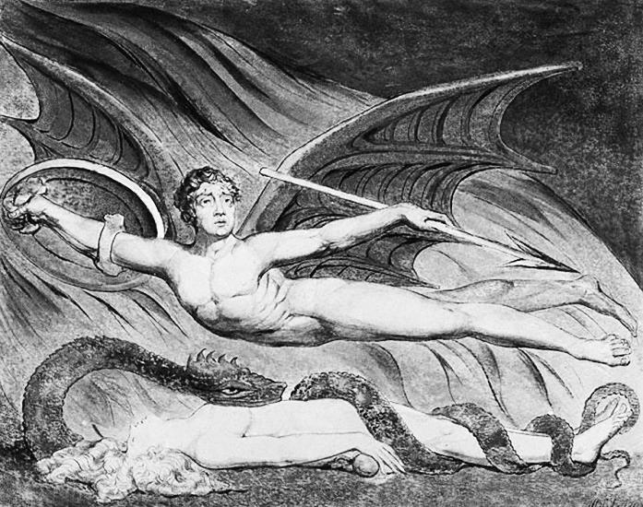
Course Description: This is a survey course in English/British literature covering the Restoration (1660) through the Victorian period (the second half of the 19th century). An awful lot happened in that (roughly) 200-year period—in England/Britain and, by necessary extension, in the literature produced and consumed in England/Britain. This class traces the historical and literary movements that span major moments in our cultural history. The monumental political, social, and cultural changes that occur during this period—the shift from divine-right monarchy to modern democracy, the Enlightenment rise of the individual, the rise of capitalism, the Industrial Revolution, etc.—are reflected by and filtered through the poems, novels, plays, and essays produced in & by the moment. We will read these texts and consider the ways that the literature reflects and drives its radically changing world.

Learning Outcome: This course will be a prolonged exercise in/with careful, active, and creative reading. We all know that writing is a creative act, but so is reading. We’ll look closely at a range of literary texts in order to practice, develop and hone the skill of critical reading, or reading as a creative act. In order to do that, we’ll develop an analytical toolbox, a set of reading strategies that will help us access the interesting and productive ways that literature represents, processes, and constructs not only our understanding of the world, but our world itself.

We will use literature to make associations and connections. That is one of the huge components of solid critical reading; it carefully processes varied and complex material to consider & rehearse the specific ways in which that material connects to, comments on, questions, drives, and reflects issues and situations outside the text. No text exists in a vacuum, and with that in mind, we will put a host of interesting literary texts in conversation with our world-at-large and let your wonderful brains perform the sorcery of making productive connections/associations.

This course offers an overview of English/British literature as a form of cultural expression. In tracing the major literary movements, styles, and innovations from 1660-1860, you will look closely at texts and develop specific critical readings in order to contextualize and understand them. In the end, you will systematically engage with written texts to explore the ways that literature functions simultaneously as a window and a mirror. To do this effectively, you will develop and strengthen your ability to analyze works and to organize and express those analyses in verbal and written form. Throughout the semester, you will practice reading various texts, forming ideas, observations, and arguments about them, and delivering those ideas, observations, and arguments in clear, concise, and effective essays. Writing will be an important part of this class, and the ability to write well in Standard Academic English is vital to your success.
My Policies.
Participation: It comprises 15% of your final grade. That means that I expect everybody to participate in our discussions. Seriously, you do not want to listen to 75 straight minutes of my talking head every Tuesday and Thursday. That said, we will explore a wide range of texts and topics in class; not only would it be impossible for all of you to agree on everything, it would be boring. I highly encourage you to disagree with one another, and I highly encourage you to disagree with me. All I ask (actually, I don’t ask, I demand) is that you disagree with one another (and me) in a constructive manner that fosters conversation rather than shuts it down. Show respect for one another’s views, opinions and ideas.
In keeping with the idea that this is a safe space to share and test out ideas, I encourage you all to speak to one another in our discussions. That is, not all comments have to go through me at the front of the room. Let ideas bounce around the room—address one another directly. This will be best accomplished if you learn each other’s names. If done properly, we can all join together in an English Lit. brother- and sisterhood. We will now join hands and sing Kumbaya.
Small but not insignificant point: In order to truly participate productively in class, you need to have done the assigned readings. If it becomes obvious that you haven’t been doing the readings—and it’s not that difficult to tell—I’ll be forced to administer annoying quizzes at the beginning of each class. Don’t make me administer annoying quizzes. Do the readings.
Attendance: If you intend to make a premium grade (A or B), you should attend class as frequently as possible, preferably every class day. Your final grade for this course will drop two points for every absence after three, except in rare situations. Infrequent absences caused by illness or accident, family death, official university functions, or inclement weather are acceptable, but you need to bring documentation of the reason to receive this consideration. If you should miss 6 or more classes, I strongly recommend that you drop the class.
Late arrivals/Early departures: Avoid these at all costs; if it’s unavoidable, be as considerate as possible to your classmates.
******************!!!!!!Cell Phones!!!!!!******************
Hear this now: Cell phone interruptions drive me nuts—seriously, they give me facial tics. So please turn off and stow all cell phones before class. Seriously, I don’t even want to see your cell phone. Really. Prove to yourself that you’re not addicted to the little monster: spend our 75 minutes out of its presence (#giveyourthumbsarest).
Late Work: I do not accept late work. All assignments are due on the day indicated on the syllabus, at the start of class. Period.
Assignments and Grade value:
*Cross-cultural Dialogue (9/25) 10% *Essay 1 (10/9) 20% *Group Project (11/6) 15% *Final Essay ) (12/13) 30% SWAs (short writing assignments) 10% Participation 15%
****You cannot pass the class without completing both essays****

Grades: Ahh, grading! Here’s the rub. One of the major sticking points between teacher and student comes down to a potential disparity in goals. My goal is that you develop as a thinker, reader and writer. Often (I didn’t say always, so don’t be offended!), your goal is to obtain a grade that will make you happy. See the potential conflict? Honestly, if I thought that handing out A’s were the best way to improve your thinking/reading/writing, I’d do it. Unfortunately, everything about your academic training to this point has worked in an opposite direction. In our system, I tie a carrot (grade) to a stick and dangle it in front of you as you pull the millstone. Sorry. I didn’t invent the system, but it’s where we work. On the bright side, in my experience, it’s relatively rare for the grade not to reflect the effort of the student.
Extra credit opportunities may be offered throughout the semester, but they exist in order to enhance your engagement with the college and our material, not to explicitly improve a student’s grade (though, of course, they will improve your grade). What I’m saying here is, don’t ask me to devise extra extra credit opportunities to make up for missed or poor work.
University Policies.
Academic Integrity: The University of Central Arkansas affirms its commitment to academic integrity and expects all members of the university community to accept shared responsibility for maintaining academic integrity. Students in this course are subject to the provisions of the university's Academic Integrity Policy, approved by the Board of Trustees as Board Policy No. 709 on February 10, 2010, and published in the Student Handbook. Penalties for academic misconduct in this course may include a failing grade on an assignment, a failing grade in the course, or any other course-related sanction the instructor determines to be appropriate. Continued enrollment in this course affirms a student's acceptance of this university policy.
The Americans with Disabilities Act: The University of Central Arkansas adheres to the requirements of the Americans with Disabilities Act. If you need an accommodation under this Act due to a disability, please contact the UCA Office of Disability Services, 450-3613.
Students should familiarize themselves with all policies included in the Student Handbook, particularly the Sexual Harassment Policy and Academic Policies. You are responsible for acting in accordance with these university policies. If you have any questions about these policies and how they pertain to you, do not hesitate to ask me for clarification.
Title IX disclosure: If a student discloses an act of sexual harassment, discrimination, assault, or other sexual misconduct to a faculty member (as it relates to “student-on-student” or “employee-on-student”), the faculty member cannot maintain complete confidentiality and is required to report the act and may be required to reveal the names of the parties involved. Any allegations made by a student may or may not trigger an investigation. Each situation differs and the obligation to conduct an investigation will depend on those specific set of circumstances. The determination to conduct an investigation will be made by the Title IX Coordinator. For further information, please visit: https://uca.edu/titleix. *Disclosure of sexual misconduct by a third party who is not a student and/or employee is also required if the misconduct occurs when the third party is a participant in a university-sponsored program, event, or activity.
Emergency Procedures: Emergency Procedures Summary (EPS) for the building in which this class is held will be discussed during the first week of this course. EPS documents for most buildings on campus are available at http://uca.edu/mysafety/bep/. Every student should be familiar with emergency procedures for any campus building in which he/she spends time for classes or other purposes.
Course Texts: Course Packet (I will email you the document; you will print it). Books: Roxana (Defoe, 1725); Northanger Abbey (Austen, 1818); Frankenstein (Shelley, 1831); Hard Times (Dickens, 1853).
Class Schedule
Week 1: Welcome welcome!
Th 8/23: Introductions
Week 2: Taking apart the Restoration
T 8/28: Milton Due: SWA 1
Th 8/30: Milton
Week 3: Taking apart the Restoration
T 9/4: No class.
Th 9/6: Congreve, The Way of the World Due: SWA 2
Week 4: 18th-Century Breakdown
T 9/11: Congreve, The Way of the World
Th 1/13: Swift Due: SWA 3
Week 5: 18th-Century Breakdown
T 9/18: Pope
Th 9/20: Haywood Due: SWA 4
Week 6: The Rise of the Novel/The Birth of the Individual
T 9/25: Defoe *Due: Cross-cultural Dialogue
Th 9/27: Defoe
Week 7: The Rise of the Novel/The Birth of the Individual
T 10/2: Defoe Due: SWA 5
Th 10/4: Paine & Wollstonecraft
Week 8: Talkin’ About a Revolution (the poetry it is a’ changin’!)
T 10/9: Wordsworth *Due: Essay 1
Th 10/11: Fall Break. No class.
Week 9: Romanticism (the poetry it is a-changin’!)
T 10/16: Wordsworth
Th 10/18: Coleridge Due: SWA 6
Week 10: Romanticism (the poetry it is a-changin’!)
T 10/23: Smith Due: SWA 7
Th 10/25: Shelley & Keats

Week 11: Playing with the Gothic/Tapping into Modernity
T 10/30: Austen Due: SWA 8
Th 11/1: Austen
Week 12: Playing with the Gothic/Tapping into Modernity
T 11/6: Austen *Due: Group Project
Th 11/8: Mary Shelley
Week 13: Playing with the Gothic/Tapping into Modernity
T 11/13: Mary Shelley Due: SWA 9
Th 11/15: Mary Shelley
Week 14: The Victorian Period: Season of Light … Season of Darkness
T 11/20: Tennyson
Th 11/22: Thanksgiving! No class. But be classy and be sweet to your mom!
Week 15. The Victorian Period: Season of Light … Season of Darkness
T 11/27: Browning & Rossetti
Th 11/29: Dickens Due: SWA 10
Week 16. The Victorian Period: Season of Light … Season of Darkness
T 12/4: Dickens
Th 12/6: Dickens
*Final: Final Essay due: Thursday 12/13!! Midnight!!!

