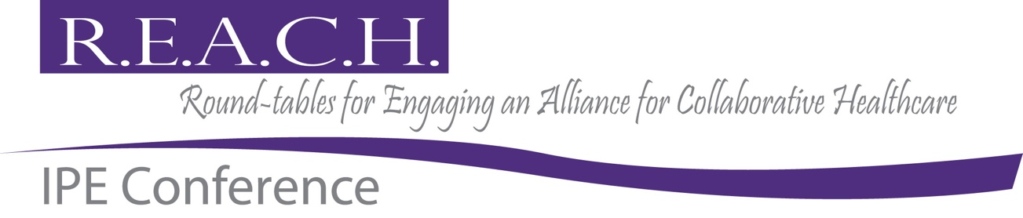
April 3, 2026 / Conway Arkansas
SUBMIT YOUR ABSTRACTS FOR THE 2026 REACH
INTERACTIVE SESSIONS
Abstracts Due: January 26, 2026

This year’s theme is:
“Building Bridges, Sharing Purpose: Collaboration that Connects Care”

Interactive Sessions should be designed to exchange ideas, build collaboration, be highly participatory, and/or support interactive learning. The following categories will be considered:

1. Bridges of Learning: education, teaching methods, and student experiences from concept to delivery
• IPE curriculum design
• Student-driven teamwork projects
• Assessment of teamwork skills
• Preceptor or faculty development

2. Bridges to Patients and Families: Patient, Family, and Caregiver partnerships
• Shared decision training
• Co-design with patients and families
• Cultural humility in team care
• Patient stories as teaching material

3. Bridges Across Professions and Community: collaboration beyond traditional clinical roles.
• Community partnerships
• IPE in public health or schools
• Rural or underserved settings
• Teamwork in disaster or crisis response

4. Bridges of Practice and Innovation emerging teamwork tools and tech
• AI-supported teamwork
• New models for communication
• Low-cost simulation or VR
• Novel interprofessional roles

Submission:
- Abstracts should not exceed 3,125 characters, including spaces.
- Abstracts from an interprofessional team will be given priority.
- Details should be provided on how the session will be interactive for participants.
- All abstracts must be submitted electronically to ChadL@uca.edu for peer review.

The following information must accompany your submission (not applied to character count)
- References
- Presenter/Author(s) Information including:
  - Profession and credentials
  - Contact information
  - Affiliated institutions
  - City and state

