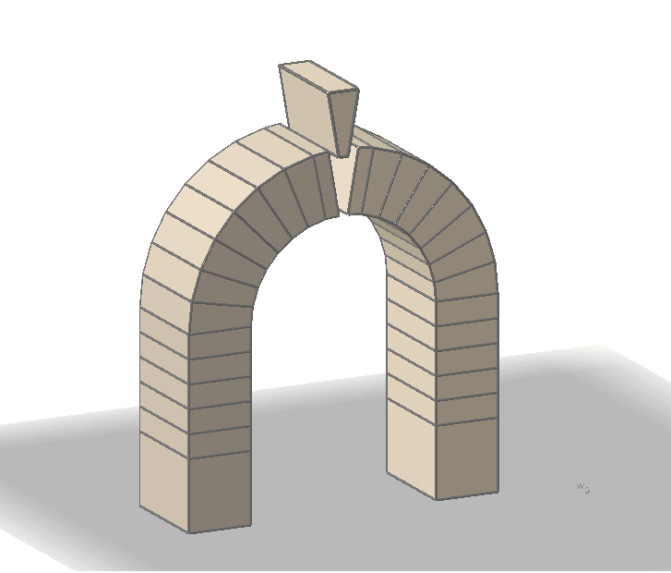
COLLEGE OF ARTS, HUMANITIES,
AND SOCIAL SCIENCES
KEYSTONE CONVERSATIONS
Fall 2026
Keystone Conversations seek to stimulate, foster, and promote campus interest in the Arts, Communication, Humanities, and Social Sciences fields. We invite you to join our live events at the Keystone Steps inside the Windgate Center for Fine and Performing Arts.
- Sept. 10, 2026, 1:40-2:30 pm, “Busy is Good" - How to Navigate Professionalism When you are Always Running," presented by Professor Mazuo Murakami, Dr. Gail Robertson, Dr. Dominic Talanca, and Dr. Matt Taylor, Dept. of Music
Join some of the busiest faculty on campus and hear their stories. This session will help you navigate your college and professional lives by becoming a better planner and someone who stays on task. Learn ways to set realistic goals, how to pace yourself, when to say “no,” and ways to escape! Our goal is to help you know that being busy is actually good.
- Sept. 24, 2026, 1:40-2:30 pm, “Identity and the Ballot: Does Trusting “Others” Change How Africa Votes?,” presented by Dr. Hyo-Won Shin, Political Science Program, Dept. of Government, Public Service, and International Studies
In a world defined by political division and deepening polarization, distrust of others is on the rise. This erosion of social trust is more than a cultural shift; it is fundamentally detrimental to the consolidation of democracy. Against this backdrop, this study examines how social trust influences voting behavior in societies divided along ethnic lines.

- Oct. 8, 2026, 1:40-2:30 pm, "A Cultural Slide in Fandom Towards Conservative Content? A Review of Fanworks," presented by Professor Chloe Showalter, First Year Writing Program, School of Communication
Fanfiction has been a part of the fandom experience for decades. Currently, many fans across social media platforms have been debating whether or not the content of current fanfiction has become more conservative due to our cultural moment. Join Chloe Showalter to learn how the content of fanfiction has changed over time using data from Archive of Our Own to illuminate unexpected trends in the fandom world.

- Oct. 22, 2026, 1:40-2:30 pm, “Reading the Body of the Book,” presented by Dr. Margo Kolenda-Mason, English Program, School of Language and Literature

What can we learn from books as physical objects? What does it feel like to read a first edition of a book from the 1600s? This talk offers a brief history of the book to suggest some ways that looking at old things can help us ask new questions. Dr. Kolenda-Mason and MA students Brea Molaison and Regan Lucero will share some of their adventures from their research trip to the Newberry Library while demonstrating how physical books remain invaluable even in our increasingly digital world.

- Nov. 12, 2026, 1:40 - 2:30 pm, “The Tale of the Goat Princess: A Study Abroad Experience in Philosophy and English,” presented by Dr. Christine Case, English, School of Language and Literature and Dr. Taine Duncan, chair, Department of Philosophy and Religious Studies
Drs. Christine Case and Taine Duncan will share how their May 2026 UCA in Germany study abroad experience afforded collaborative and creative pedagogy for interdisciplinary experiential learning. In their experience, students were able to learn via site visits, collaborative class-time, and thematic readings about the legacy of fairytales, their adaptations, and their intersections with modern and contemporary aesthetic theory. The Tale of the Goat Princess represents both the flexible and adaptive on-the-ground coordination, which ultimately included an unplanned zoo visit, and the collaborative contributions to a shared volume of original fairytales.

