

***Watch Out for Traffic***



FARRIS CENTER HAS AN ALTERNATE STAIR ROUTE THAT WILL ADD AN ADDITIONAL 40 STEPS TO YOUR ROUTE PER LAP

**3rd Floor Hallway End to End 9 Round trips = 0.5 Mile**

**To COB + 2 Figure 8 laps +**

**1 small lap + Back to Wingo 1 Mile**

**To COB + 1 Figure 8 lap + to Mashburn +**

**To Farris + 2 lap in Farris + to Doyne +**

**to SC + back to Wingo 2 Mile**

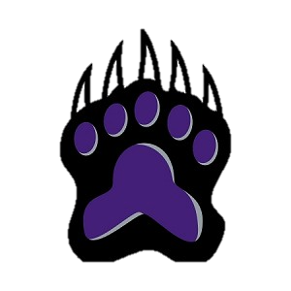



**Tracks to Success**

**WINGO**

***IS ON THE MOVE***