The 1917-1918 UCA Academic Year:
A Difficult Year for UCA Students, Faculty & Staff

Just a few days before the beginning of the 1917 fall term, the president of Arkansas State Normal School (now the University of Central Arkansas – UCA) had opined that enrollment would probably be equal to that of fall 1916. However, he was badly mistaken. Burr Walter (B.W.) Torreyson had taken over the reins of leadership from UCA’s first president, John James Doyne, on September 1, 1917. Like Doyne, he was a Virginian by birth. Torreyson was best known as the man who tamed the out-of-control schools at Fort Smith, and he had served on the UCA Board of Trustees prior to being named president.

While the war in Europe was recognized as a factor in the declining enrollment numbers, the full impact could not be appreciated until the semester was underway. According to The Log Cabin Democrat, “The first year’s administration of the new president, Prof. B.W. Torreyson, promises to be a successful one. While of course the army draft has made inroads upon the male students, the indications today are that the attendance will be equal to that of last year, which was the largest in the history of the institution. The girls’ dormitory is already open and practically every room in it has been reserved.”

Each year since it began operation in 1908, UCA had shown an increase in enrollment every fall semester. In the fall of 1916, the enrollment was 441, according to the numbers released by UCA at the time. But by fall of 1917, the enrollment had dropped to 328, a 25.6% decline. The reason was the war in Europe, which came to be known as World War I.

The United States had declared war on Germany in April 1917, and the number of men on campus had steadily declined as men were drafted into the military. However, it was the spring of 1918 when the bottom was hit. There had been 200 men on campus in spring 1917, but only 12 men were enrolled by the spring of 1918.

Soon after war was declared on Germany, the male faculty members that had military experience began drilling the male students, in order to give them an advantage when they were drafted into the Army. There was one female student, Nora Brown, who also took part in the military exercises and drilled alongside the men. According to a fellow student, Ernest Vinson, Ms. Brown was very enthusiastic during her training.

Many male students were drafted into the military and some also volunteered. This was also true of the faculty. The chair of the UCA Department of History, Dean Depew McBrien was called into service. Heber McAlister, head of the UCA Department of Mathematics, was a major in the Arkansas National Guard and was activated and sent to Europe. Coach Guy Dan Estes, who taught in the math department and coached all men’s sports, replaced McAlister as head of the math department, but that didn’t last very long. Estes volunteered his services and he, too, left the faculty for the Army.

Coach Estes had a Bachelor of Civil Engineering degree and served in the Army Engineering Reserve Corps. Before the war was over, Estes had attained the rank of captain. Lt. J.C. Cook, former head of the UCA Department of Athletics, served in the Army and according to Ted Worley, author of “A History of Arkansas State Teachers College,” Cook wrote a letter dated July 7, 1917 that stated in part, “I am a good Presbyterian; if this is my time, well and good. Nothing is going on but work, drill, drill, and criticism.”

The loss of so many key professors, who were integral to the operation of the small college, was troubling for President Torreyson and the UCA Board of Trustees. In an attempt to retain the services of McBrien and Estes, President Torreyson and the Board communicated to the district draft board to see if a possible exemption for McBrien would be allowed. They also asked that Coach Estes be granted a furlough until a replacement for Estes could be found. Apparently, they were unsuccessful. McBrien returned to UCA in January 1919, and Estes returned in February 1919.

In order to fill the void left by the departure of the male professors, several female faculty were added, including Mrs. John T. Buchholz - instructor in mathematics, whose husband, Dr. John T. Buchholz taught biology. During that time period it was customary for married women to be identified on rosters by their husband’s name, provided they were married. Miss Minnie Snellins was added to the science faculty and Miss Maisie Caraher in music and reading.

Though the head football coach was serving in the Army, and there was not an assistant coach to take over the team, football continued at UCA in fall 1917. It was 1920 before UCA teams received their moniker, or nickname of Bears. Consequently, during the 1917 season, UCA teams were most often called the Pedagogues, by the press. The 1917 football season was not a good one for the Pedagogues.

They won one game and lost three, with the lone win coming against Second District Agricultural School in Russellville, known today as Arkansas Tech University, 7 to 0. The losses were a little lopsided, with the worst loss coming against Arkansas State University (ASU). According to newspaper reports, it took the scorers sometime after the game had ended to tally up the final score, which was ASU – 101 and UCA – 0. The other two losses (both shutouts) were against Russellville High School and Little Rock High School. There was no team fielded in 1918 due to a shortage of men on campus.

A big reason for the disastrous season was due to not having an experienced head coach. The team was coached by one of the older players and team captain, Sam Donnell, and agriculture professor, Keith Holloway. It isn’t known if Professor Holloway had any football experience.

While the male students served in the military, the female students did whatever they could to support the war effort. They, the female students, raised money for armed forces libraries, and assisted the local Conway draft board with paperwork. Six UCA women volunteered to help the Conway draft board when it was announced that the draft board needed assistance with organization and paperwork.

The women of the Young Women’s Christian Association (YWCA) participated in a fund raiser for Liberty Bonds that the students called an Old Maids’ Convention. The program featured a futuristic machine that transformed elderly women into beautiful young women. An elderly woman stepped into the machine and after the machine had time to work its magic, a very young lady emerged, much to the delight of the crowd. A charge of 25 cents was paid by each person to see the show.

UCA women formed an American Red Cross unit on campus and sewed comfort clothing for military men who had been wounded in combat. They also collected reading material and packed bandages for the Red Cross. The UCA women worked diligently throughout the war to do what they could to assist in the war effort.

After the war ended, and the faculty returned to their posts at UCA, a pageant was held on the front porch of Old Main. The pageant, under the direction of Professor D.D. McBrien, showed Europeans that were living in peace before the war, and how this peace was broken by autocracy. According to Ted Worley, “Timely entry of America and her allies drove the forces of autocracy away. The ‘march of democracy’ followed, with fifty young ladies representing the forty-eight states and two island possessions doing a victory loan dance.’”

The two UCA alumni who did not survive the war were PFC Phillip Gillham and PV1 William Conger. Their names are inscribed on UCA’s War Memorial.

To fully comprehend the critical situation faced by the UCA of 1917, the same percentages were applied to show what the impact would have been on UCA in 2016 for loss of enrollment and loss of professors to the military. The reason 2016 is used as opposed to 2017, is that we know the enrollment and other statistics for 2016 at the time this article was written.

● 2,940 students would have left UCA to join the military and take other jobs.
● 109 fewer professors would be on campus and would have been called into service.

The two photographs below show a few UCA alumni in uniform and the UCA unit of the American Red Cross during World War I.
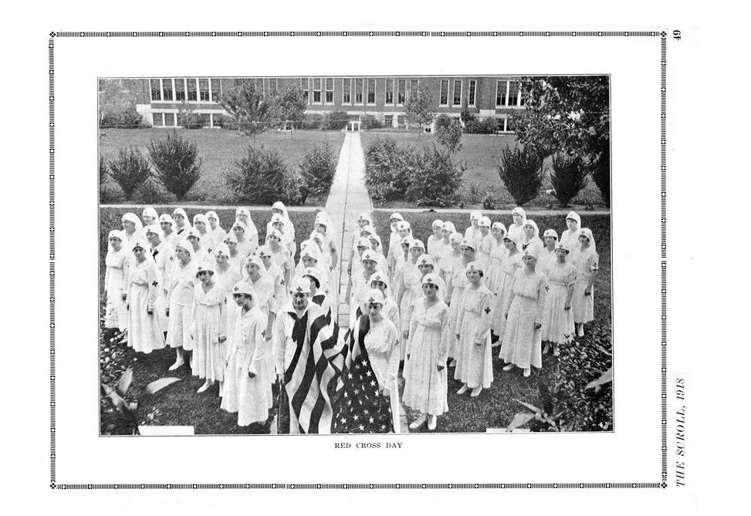
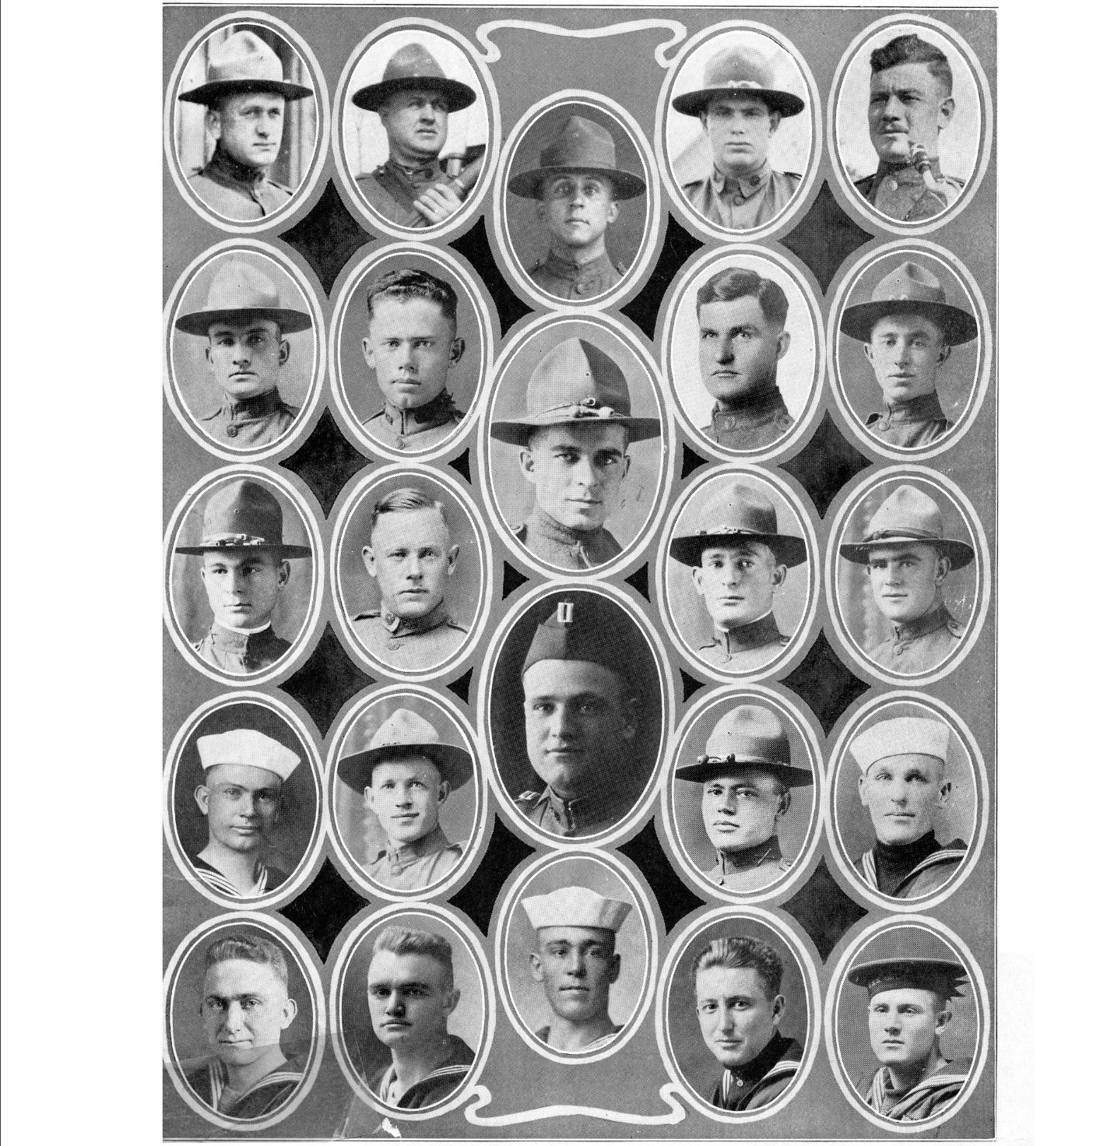

BOTH PHOTOGRAPHS ARE COURTESY OF THE SCROLL, 1918.

Note: Sources for this article included The Log Cabin Democrat, The Echo, The Scroll, the Arkansas State Normal School Bulletin, minutes of the UCA Board of Trustees and “A History of Arkansas State Teachers College” by Ted Worley.

