University of Central Arkansas

Course Syllabus Requirements
Updated 2017-12-20, 2019-03-25, 2019-06-04, 2020-07-23, 2020-08-08, 2021-09-25, 2021-12-03, 2022-05-21, 2022-06-22, 2022-07-13, 2022-07-19
The following are minimum requirements for all course syllabi. Additional material may be added at the discretion of the faculty member. See also Appendix A (p. 3) for required UCA Core course syllabus language and Appendix B (p. 7) for recommended information about the timing of the Student Course Experience Survey for most terms.
- Instructor’s name
- Semester, year, course number, CRN, days and times; location of class
- Instructor’s office hours, office location, and contact information, including UCA phone number and UCA e-mail address
- Brief course description
- Course objectives and requirements
- If the course is part of the UCA Core: approved UCA Core-specific language as detailed in Appendix A: UCA Core Syllabus Language (starts on p. 3 of this document)
- List of required textbooks and other course material
- Description of all major assignments and examinations with due dates
- Grading policies
- Attendance and drop policy
- The following Covid-19 statement (note that the site noted in this statement will be updated for fall 2022):
All students are expected to know and comply with university policy related to Covid-19. For information and resources, see https://uca.edu/coronavirus/.
- The following Academic Integrity statement:
The University of Central Arkansas affirms its commitment to academic integrity and expects all members of the university community to accept shared responsibility for maintaining academic integrity. Students in this course are subject to the provisions of the university’s Academic Integrity Policy, approved by the Board of Trustees as Board Policy No. 709 on February 10, 2010, and published in the Student Handbook. Penalties for academic misconduct in this course may include a failing grade on an assignment, a failing grade in the course, or any other course-related sanction the instructor determines to be appropriate. Continued enrollment in this course affirms a student’s acceptance of this university policy.
- The following Americans with Disabilities Act statement:
The University of Central Arkansas adheres to the requirements of the Americans with Disabilities Act. If you need an accommodation under this Act due to a disability, please contact the Office of Accessibility Resources and Services (OARS), 450-3613.
- The following Building Emergency Plan statement (to be discussed in class/lab during the first week of the semester):
An Emergency Procedures Summary (EPS) for the building in which this class is held will be discussed during the first week of this course. EPS and Building Emergency Plan (BEP) documents for most buildings on campus are available at https://uca.edu/go/bep-library. Every student should be familiar with emergency procedures for any campus building in which he/she spends time for classes or other purposes.
- The following Title IX statement:
In furtherance of its core values— academic vitality, integrity, and diversity—UCA is dedicated to promoting a campus community free from discrimination. Title IX of the Education Amendments Act of 1972 requires all educational institutions to address gender-based discrimination on campus, and UCA implements these Federal requirements through a fair, consistent, and appropriate process of investigation and adjudication. Please see UCA’s Title IX website (https://uca.edu/titleix/) for the university’s policy, relevant forms, training opportunities, and related information.
- Direct students to familiarize themselves with all policies included in the Student Handbook, particularly the following:
- Sexual Harassment Policy
- Academic Policies
On the following pages, find these resources:
Appendix A: UCA Core Syllabus Language 3
Appendix B: Information about the Timing of the Student Course Experience Survey (formerly known as “student course evaluations”) 7

Appendix A: UCA Core Syllabus Language
If your course is part of the UCA Core, please cut-and-paste the relevant description of the lower division or upper-division component(s) of the UCA Core into the course syllabus. The graphic to the left of each description is optional.

Lower-Division Core Language
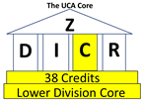
LD Communication
This course is part of the Communication component of the Lower-Division Core. Communication courses promote the ability to develop and present ideas logically and effectively in order to enhance communication and collaboration with diverse individuals and groups. For more information, go to http://uca.edu/core.
LD Critical Inquiry
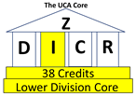
This course is part of the Critical Inquiry component of the Lower-Division Core. Critical Inquiry courses promote the ability to analyze new problems and situations to formulate informed opinions and conclusions. For more information, go to http://uca.edu/core.

LD Diversity
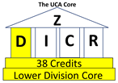
This course is part of the Diversity component of the Lower-Division Core. Diversity courses promote the ability to analyze familiar cultural assumptions in the context of the world’s diverse values, traditions, and belief systems as well as to analyze the major ideas, techniques and processes that inform creative works within different cultural and historical contexts. For more information, go to http://uca.edu/core.
LD Responsible Living
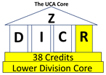
This course is part of the Responsible Living component of the Lower-Division Core. Responsible Living courses promote the ability to address real-world problems and find ethical solutions for individuals and society. For more information, go to http://uca.edu/core.

FYS Syllabi Language
(for inclusion in addition to LD language when the section is also designated FYS)
This section is also designated as a First-Year Seminar [FYS] course. The purpose of the first-year seminar is to provide a small-class learning environment to facilitate engagement in academic study at the collegiate level, make a connection to the university, and reinforce the importance of written communication skills.

Upper Division UCA Core Language
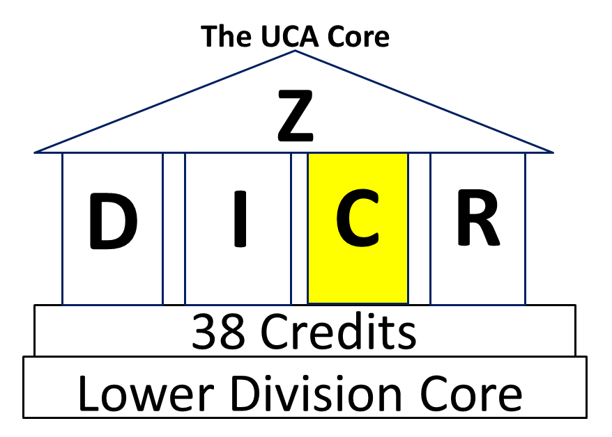
UD Communication
This course is designated [C] which means it satisfies your Communication component of the Upper Division Core. Communication courses promote effective communication: the ability to develop and present ideas logically and effectively in order to enhance communication and collaboration with diverse individuals and groups. For more information, go to http://uca.edu/core.
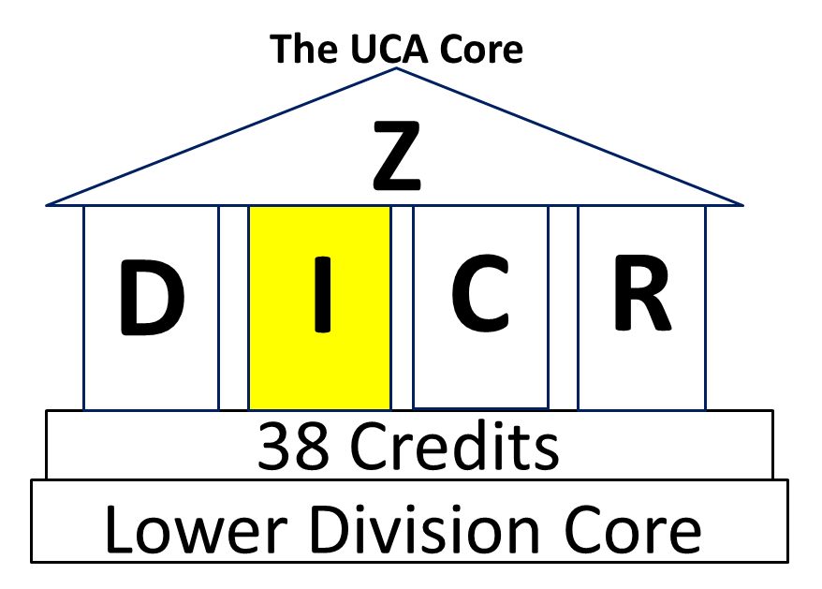
UD Critical Inquiry
This course is designated [I] which means it satisfies your Critical Inquiry component of the Upper Division Core. Critical Inquiry courses promote the ability to analyze new problems and situations to formulate informed opinions and conclusions. For more information, go to http://uca.edu/core.

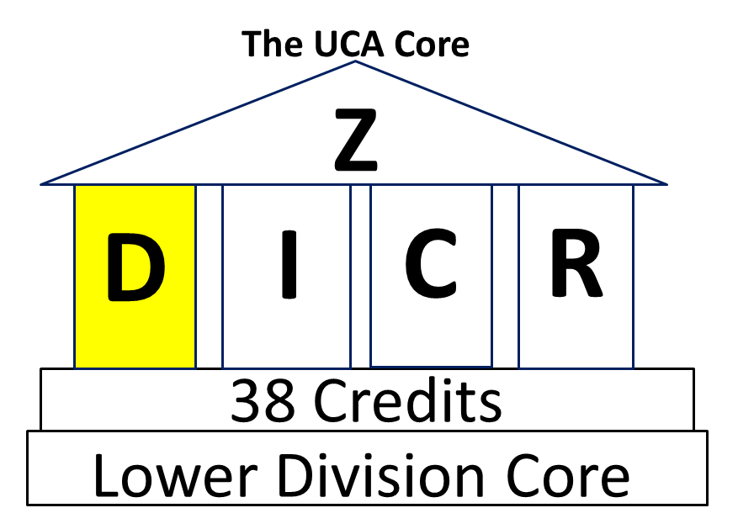
UD Diversity
This course is designated [D] which means it satisfies your Diversity component of the Upper Division Core. Diversity courses promote the ability to analyze familiar cultural assumptions in the context of the world’s diverse values, traditions, and belief systems as well as to analyze the major ideas, techniques and processes that inform creative works within different cultural and historical contexts. For more information, go to http://uca.edu/core.
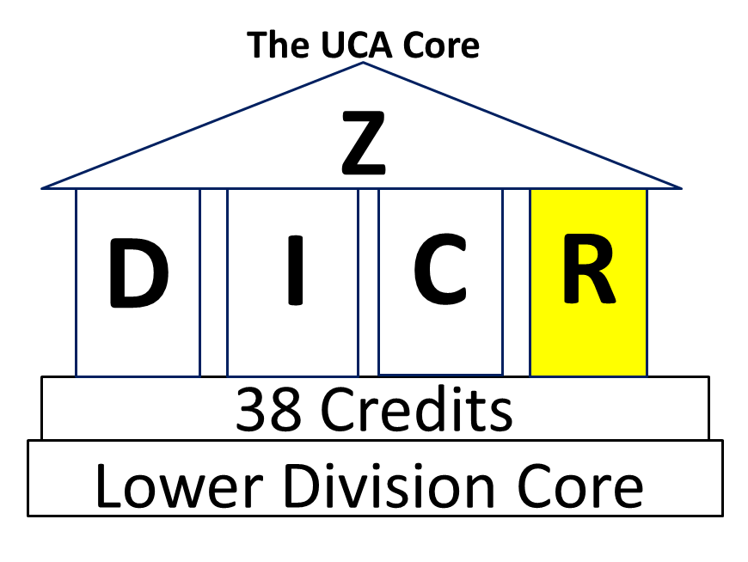
UD Responsible Living
This course is designated [R] which means it satisfies your Responsible Living component of the Upper Division Core. Responsible Living courses promote the ability to address real-world problems and find ethical solutions for individuals and society. For more information, go to http://uca.edu/core.

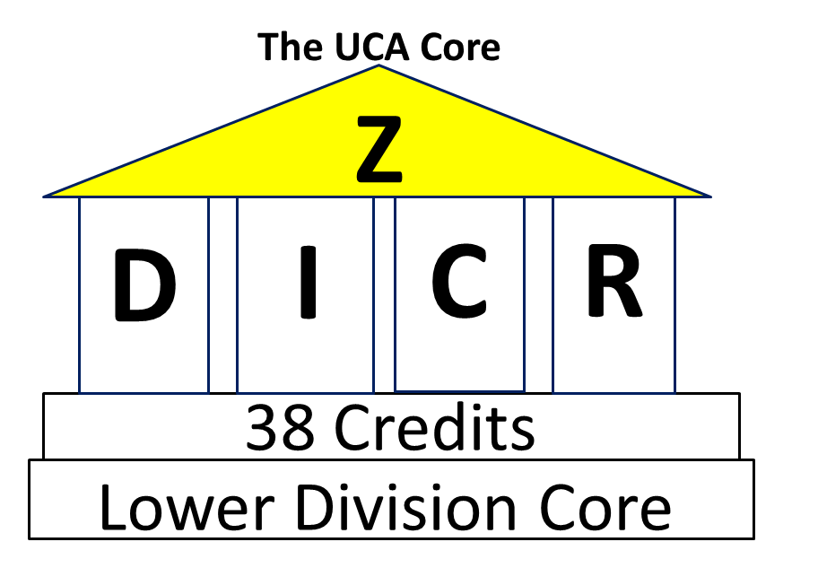
UD Capstone Experience
This course is designated [Z] which means it satisfies your Capstone Experience component of the Upper Division Core. Capstone Experience courses incorporate aspects of Critical Inquiry and Communication within a discipline into a comprehensive, culminating educational experience. For more information, go to http://uca.edu/core.

UD Communication & Critical Inquiry
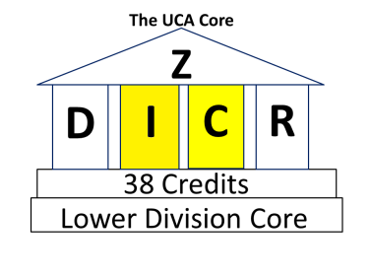
This course is designated [C & I] which means it satisfies your Communication and Critical Inquiry components of the Upper Division Core. Communication courses promote effective communication: the ability to develop and present ideas logically and effectively in order to enhance communication and collaboration with diverse individuals and groups. Critical Inquiry courses promote the ability to analyze new problems and situations to formulate informed opinions and conclusions. For more information, go to http://uca.edu/core.
UD Communication & Diversity
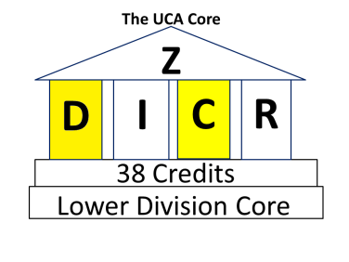
This course is designated [C & D] which means it satisfies your Communication and Diversity components of the Upper Division Core. Communication courses promote effective communication: the ability to develop and present ideas logically and effectively in order to enhance communication and collaboration with diverse individuals and groups. Diversity courses promote the ability to analyze familiar cultural assumptions in the context of the world’s diverse values, traditions, and belief systems as well as to analyze the major ideas, techniques and processes that inform creative works within different cultural and historical contexts. For more information, go to http://uca.edu/core.
UD Communication & Responsible Living
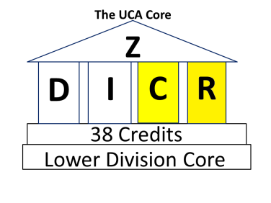
This course is designated [C & R] which means it satisfies your Communication and Responsible Living components of the Upper Division Core. Communication courses promote effective communication: the ability to develop and present ideas logically and effectively in order to enhance communication and collaboration with diverse individuals and groups. Responsible Living courses promote the ability to address real-world problems and find ethical solutions for individuals and society. For more information, go to http://uca.edu/core.
UD Critical Inquiry & Diversity
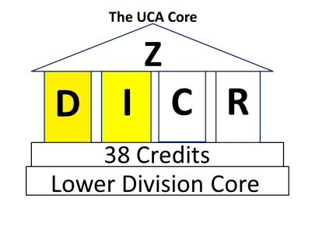
This course is designated [I & D] which means it satisfies your Critical Inquiry and Diversity components of the Upper Division Core. Critical Inquiry courses promote the ability to analyze new problems and situations to formulate informed opinions and conclusions. Diversity courses promote the ability to analyze familiar cultural assumptions in the context of the world’s diverse values, traditions, and belief systems as well as to analyze the major ideas, techniques and processes that inform creative works within different cultural and historical contexts. For more information, go to http://uca.edu/core.
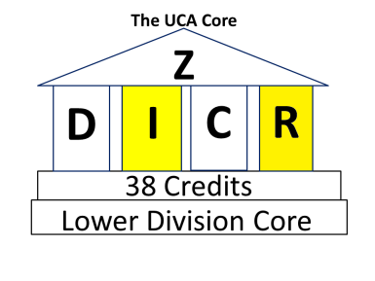
UD Critical Inquiry & Responsible Living
This course is designated [I & R] which means it satisfies your Critical Inquiry and Responsible Living components of the Upper Division Core. Critical Inquiry courses promote the ability to analyze new problems and situations to formulate informed opinions and conclusions. Responsible Living courses promote the ability to address real-world problems and find ethical solutions for individuals and society. For more information, go to http://uca.edu/core.
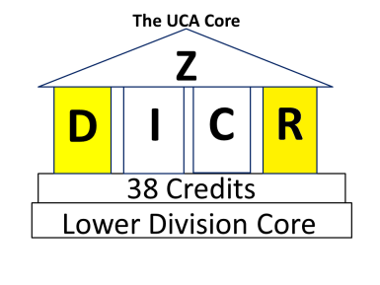
UD Diversity & Responsible Living
This course is designated [D & R] which means it satisfies your Diversity and Responsible Living components of the Upper Division Core. Diversity courses promote the ability to analyze familiar cultural assumptions in the context of the world’s diverse values, traditions, and belief systems as well as to analyze the major ideas, techniques and processes that inform creative works within different cultural and historical contexts. Responsible Living courses promote the ability to address real-world problems and find ethical solutions for individuals and society. For more information, go to http://uca.edu/core.

Appendix B: Information about Timing of the Student Course Experience Survey
(formerly known as “student course evaluations”)
[Updated 2019-06-04. Note: the wording below applies to terms beginning in Fall 2019. For earlier terms, please adjust the language to fit the actual day associated with the published opening or closing dates. Updated again, 2021-12-03 to incorporate the new designation of the survey as the Student Course Experience Survey.]
In addition to the requirements listed above, please consider including in your schedule for the semester information about the timing of the Student Course Experience Survey (SCES, formerly known as “student evaluations of the course and instructor”). The information to be substituted for each “{insert date}” indicator is included in Student Course Experience Survey Schedules published for each academic year and linked from https://uca.edu/assessment/course-evaluation-information/.

Evaluations (Full Term and 2nd 8-Week, Fall)
The Student Course Experience Survey is a crucial element in helping faculty achieve excellence in the classroom and the institution in demonstrating that students are gaining knowledge. Students may complete surveys for courses they are taking starting on Monday, , through the Sunday after finals week by logging in to myUCA and clicking on the Course Evaluations task.

Evaluations (1st 8-Week, Fall and Spring)
The Student Course Experience Survey is a crucial element in helping faculty achieve excellence in the classroom and the institution in demonstrating that students are gaining knowledge. Students may complete surveys for courses they are taking starting on Monday, , through the Sunday after last day of the half term by logging in to myUCA and clicking on the Course Evaluations task.

Evaluations (IEP, Levels 1, 2, and 3: Fall and Spring)
It is important to complete the Student Course Experience Survey. UCA greatly values this process so we know students are learning and everyone is doing their job as best they can. Starting on Monday, , log on to myUCA. Click on the Course Evaluations task. Make sure you are evaluating the correct class and correct teacher.

Evaluations (Winter Intersession)
The Student Course Experience Survey is a crucial element in helping faculty achieve excellence in the classroom and the institution in demonstrating that students are gaining knowledge. Students may complete surveys for courses they are taking starting on Friday, , through the Sunday after the last day of the Intersession by logging in to myUCA and clicking on the Course Evaluations task.

Evaluations (May Intersession)
The Student Course Experience Survey is a crucial element in helping faculty achieve excellence in the classroom and the institution in demonstrating that students are gaining knowledge. Students may complete surveys for courses they are taking starting on Monday, , through the Sunday after the last day of the Intersession by logging in to myUCA and clicking on the Course Evaluations task.

Evaluations (Summer I and Summer II)
The Student Course Experience Survey is a crucial element in helping faculty achieve excellence in the classroom and the institution in demonstrating that students are gaining knowledge. Students may complete surveys for courses they are taking starting on Monday, , through the Sunday after the last day of the five-week term by logging in to myUCA and clicking on the Course Evaluations task.

Evaluations (10-Week Summer)
The Student Course Experience Survey is a crucial element in helping faculty achieve excellence in the classroom and the institution in demonstrating that students are gaining knowledge. Students may complete surveys for courses they are taking starting on Monday, , through the Sunday after the last day of the ten-week term by logging in to myUCA and clicking on the Course Evaluations task.

Evaluations (13-Week Summer)
The Student Course Experience Survey is a crucial element in helping faculty achieve excellence in the classroom and the institution in demonstrating that students are gaining knowledge. Students may complete surveys for courses they are taking starting on Monday, , through the Sunday after the last day of the thirteen-week term by logging in to myUCA and clicking on the Course Evaluations task.

