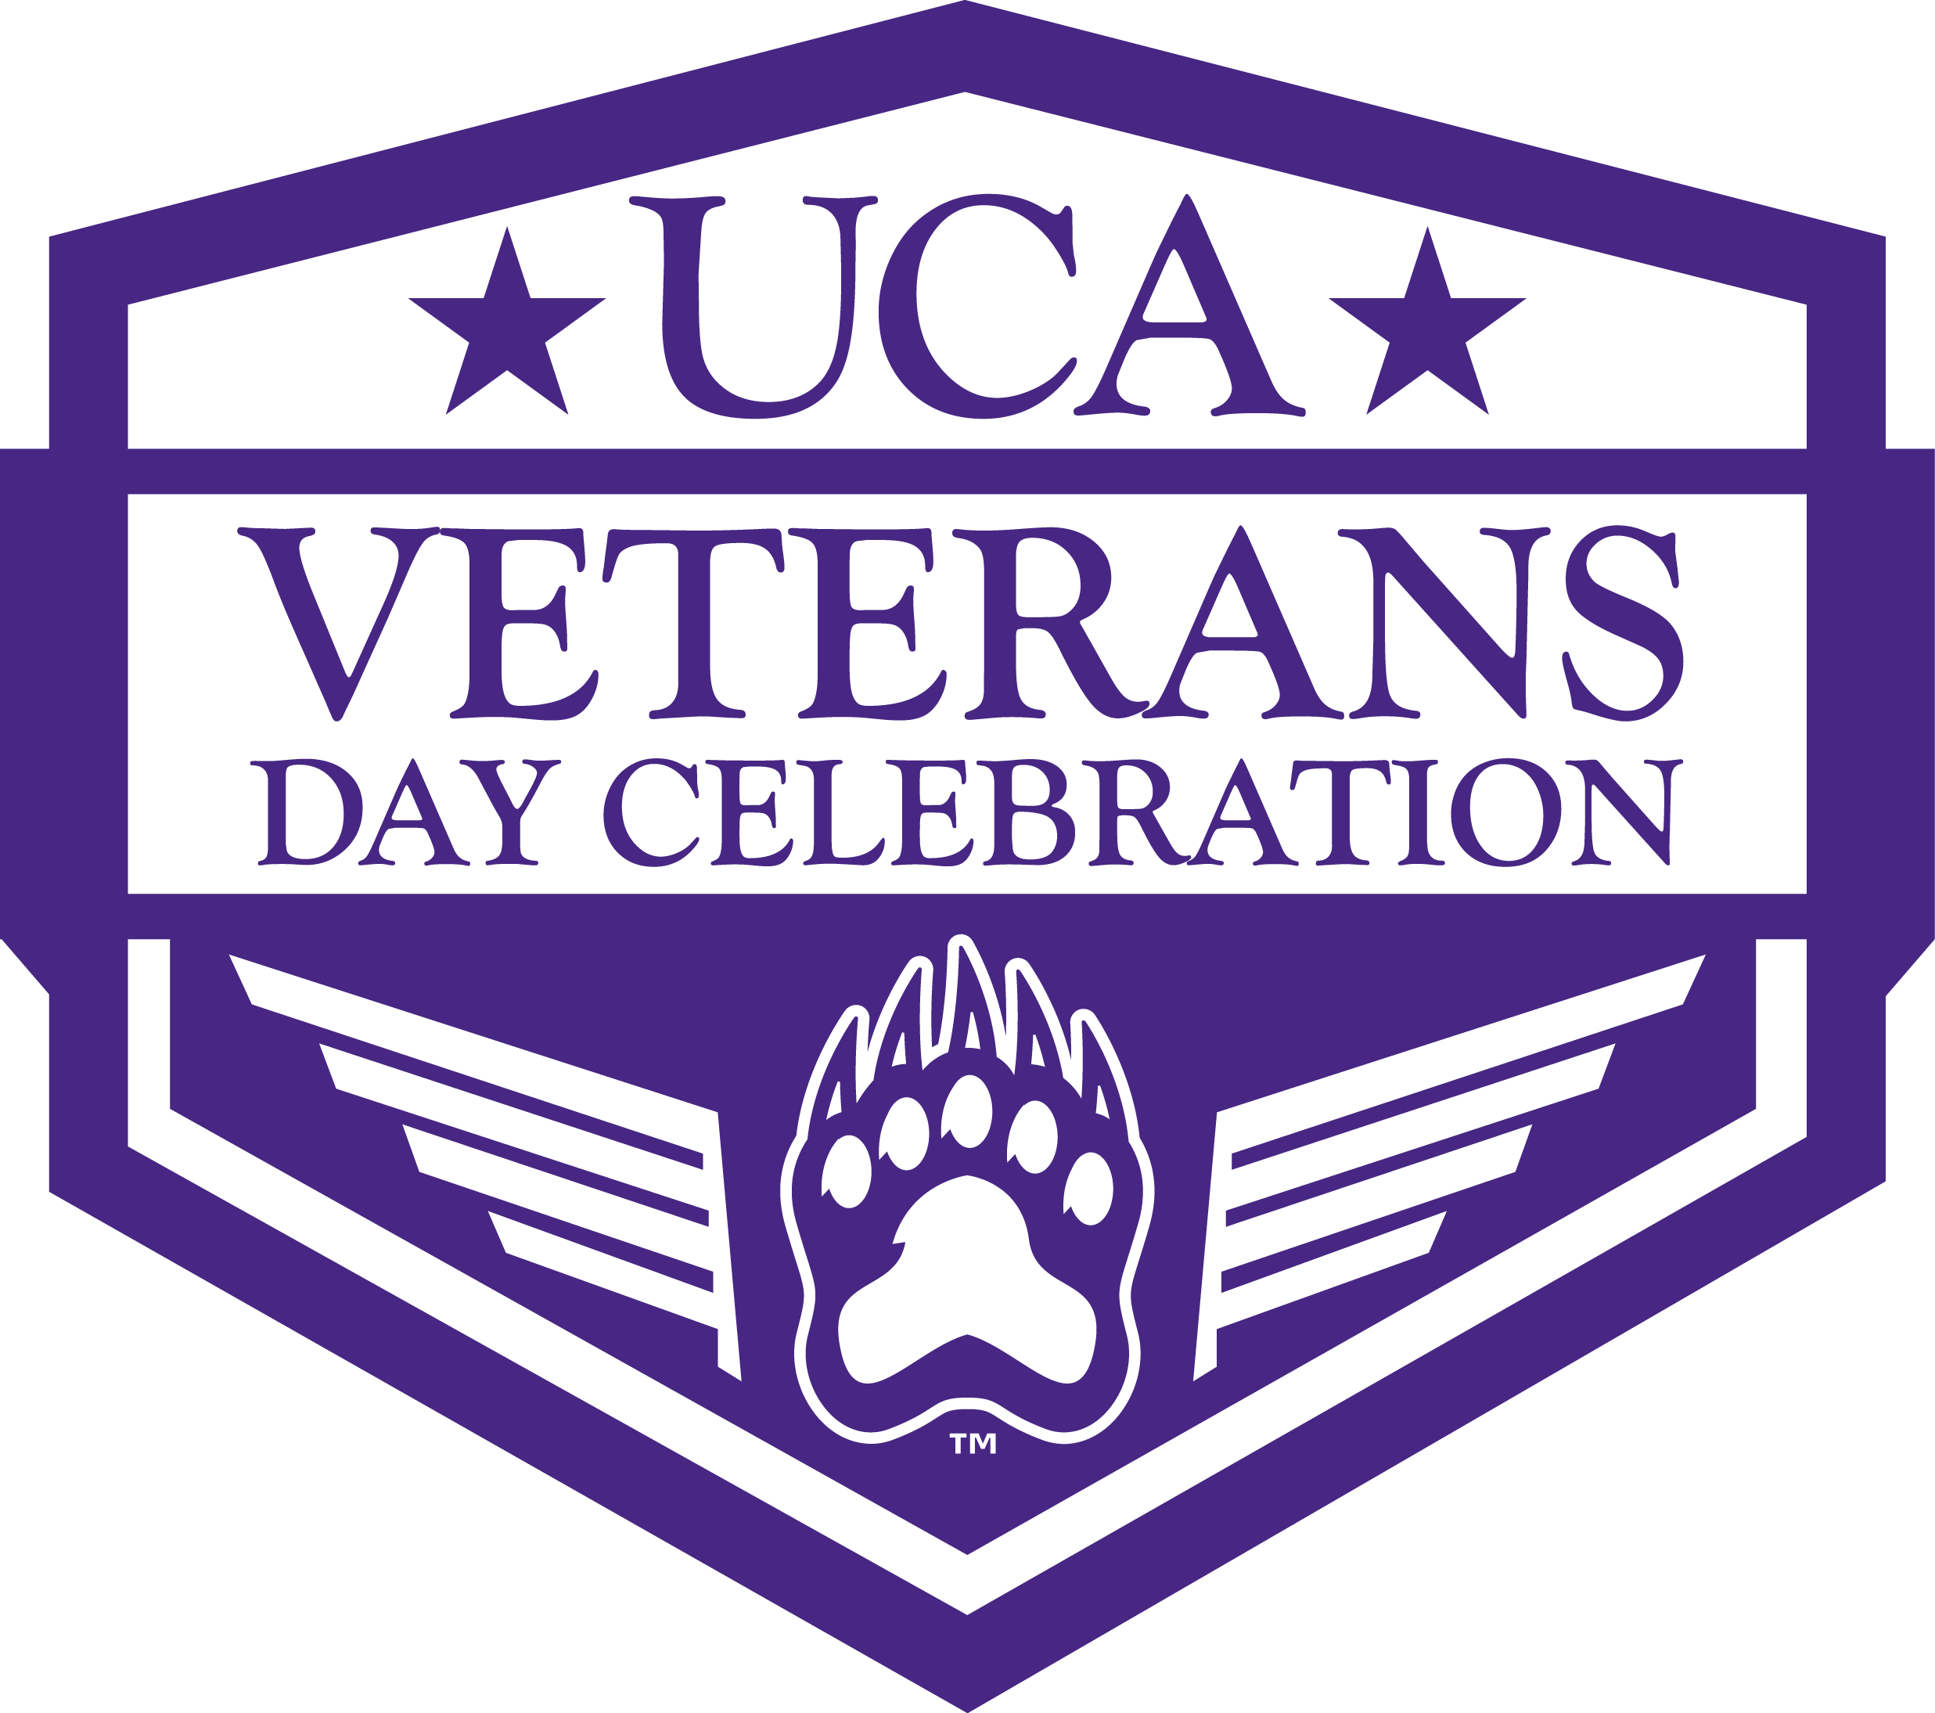
UCA VETERANS DAY CELEBRATION

March 27, 2017

Dear NAME :
The University of Central Arkansas (UCA) will observe its annual Veterans Day Celebration on Thursday, November 9, 2017. The event will commemorate and honor the service of all veterans of the U.S. Armed Forces and feature notable speakers, food, music and a Veterans Information Fair. The Veterans Information Fair will provide information on employment opportunities, support and other services that are available and important to veterans.
This year’s Veterans Day Celebration will begin at 1:00 on the lawn in front of McAlister Hall, near the center of campus. In the event of rain the service will be held in McCastlain Hall. We invite and encourage you to participate through a sponsorship, utilizing one of five levels of financial support. Sponsors also have the opportunity to serve as a vendor by providing food or some other type of product for the Veterans Day Celebration.
Funds raised through sponsorships are used to provide scholarships, which can be life-changing to those who receive them. Please submit your sponsor or vendor application by October 6, 2017. We truly appreciate your willingness to assist UCA in honoring those who are dedicated to keeping the United States safe, secure and free: America’s Veterans.

Sincerely,
David Williams
Chair of the 2017 Veterans Day Committee University of Central Arkansas
VETERANS DAY 2017

Platinum Patriot - $3,000
Event is presented by your organization and UCA
Recognition during ceremony
Logo on front of t-shirt with logo & name on back
Logo on sponsorship board
Logo and name listed on banners
Logo and name listed on marketing materials
Name and logo listed on event agenda

Gold Patriot - $2,000
Logo on front of t-shirt with logo & name on back
Recognition during ceremony
Logo and name listed on all marketing materials
Logo and name listed on banners
Name and logo listed on event agenda

Silver Patriot - $1,000
Recognition during ceremony
Logo and name listed on all marketing materials
Logo and name listed on the back of t-shirt
Name listed on on event agenda
Name listed on banners

Bronze Patriot - $500
Name listed on the back of t-shirt
Name listed on all marketing materials
Name listed on event agenda

Patriot – Below $500
Name listed on the back of t-shirt
Name listed on event agenda

_{SPONSORSHIP OPPORTUNITIES}

2017 UCA VETERANS DAY CELEBRATION

2017 UCA VETERANS DAY CELEBRATION
Company:__________________________________________________________________________
Contact: ___________________________________________________________________________ Name:_____________________________________________________________________________
Email:____________________________________________________________________________ Phone:____________________________________________________________________________

Sponsorship Opportunities
Platinum Patriot: $3,000
Gold Patriot: $2,000
Silver Patriot: $1,000
Bronze Patriot: $500
Patriot: below $500
Amount: $______________
This is an in-kind donation.
Value: $______________

Payment Information:
Check Enclosed (please make check payable to “UCA FOUNDATION”, memo to “2017 Veterans Day”)
Please charge: Visa MasterCard American Express Discover
Name on Credit Card:___________________________ Credit Card# ______________________
Expiration Date: ________________ Signature_____________________________________ Date________

Vendor Opportunities
Food Vendor (table provided at no cost)
List food to be provided by vendor:

Food served onsite Food picked up from vendor

Information Fair Exhibitor
( 6-ft table provided at no cost; no skirting)

Registration Deadline: Monday, October 6, 2017
Please return completed form and payment to:
UCA Foundation, Attn: Kathy Carroll
201 Donaghey Ave, Box 4986 | Conway, AR 72035
Fax: 501-450-5293

For more information, contact:
David Williams
veteranservices@uca.edu
501-852-2999

