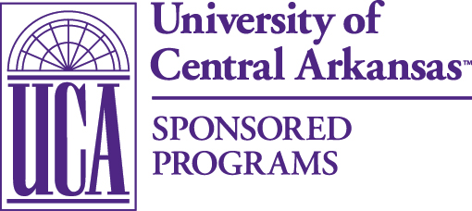
University of Central Arkansas | Sponsored Programs
Torreyson West, Ste. 325
201 Donaghey Ave.
Conway, AR 72035
Tel: (501) 450-3452
Fax: (501) 450-5339

Pre-Award Cost Sharing Authorization Form

Instructions: The use of this form is not required unless cost sharing is presented in your proposal to the sponsoring agency. Please fill out the gray-shaded boxes, print this form, and request the appropriate signatures. Once you have the requisite signatures, send the form to Sponsored Programs, Torreyson West, Suite 324. For cost sharing across departmental and/or college lines, please fill out one of these forms for each division providing cost sharing.

Date: | Funding Opportunity Number:
Principle Investigator: | Sponsoring Agency:
Proposal Title: | Is the proposed cost sharing mandatory and/or voluntary?  Mandatory Voluntary

Type* | Inclusive Dates | Dollar  Amount | Account # | Authorizer’s Name | Authorizing Signature
*Cash matching, in-kind, etc. For more information, please see the cost-sharing policy.

Faculty Member | UCA ID# | % Effort

Fill out only for contributed effort.

Comments:

Approvals

Chair Type name here. ______________________________ Date: ___________________
(signature)

Dean Type name here. ______________________________ Date: ___________________
(signature)

Authorizing Official Dr. Stephanie Bellar ______________________________ Date: ___________________
Dean of the Graduate (signature)
School and Research

Thank you for taking the time to complete this form. Sponsored Programs will respond to your request within five (5) business days.

