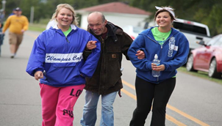

**SATURDAY, OCTOBER 3, 2015**

**@ 8 AM**

**CHDC FAMILY**

**VISITATION COMPLEX**

**150 E. SIEBENMORGEN RD.**

**CONWAY, AR**

Live performance by

Taylor Nealey

*Live performance by*

*Taylor Nealey!*

**Walking With Heroes**



**Proceeds benefit the residents of CHDC!**

**Emceed by**

**Rick**

**Zilkey**

**$25 to walk, free t-shirt to all walkers raising at least $25!**

**DOOR PRIZES!!**

Come dressed as your favorite hero for a chance to win the Best Dressed Superhero Award!