SPARKS
an after school collaboration

Program Description
Prepared by Monte Jones
April 20, 2015

Will someone help me if I fail? Does anyone notice when I succeed? Does anyone care about what matters most to me? Is there a place where I can truly be myself? These are real questions our youth are asking themselves. Now, Conway, Arkansas is answering loud and clear: Yes!

The Need
Ask parents what they want for their child, and listen closely to the answers. You will hear such words as joy, happiness, connection, engagement, fulfillment, kindness, compassion, and generosity. From infancy to old age, these traits are expressed in myriad ways; however, our experience, backed by scientific research, indicates that there is only one source: relationships. Search Institute, the leading organization in discovering what kids need to succeed, defines developmental relationships as “a close connection between a young person and an adult or peer that powerfully and positively shapes the young person’s identity and helps the young person develop a thriving mindset.” Such thriving, they attest, is linked closely to a person’s decisions and behaviors, increasing their likelihood to “work hard both inside and outside of school, and to develop a range of social and emotional skills that are essential for success in college, work, and civic life.”
While a single relationship can be pivotal in a young person’s life, research shows that the greatest outcomes occur when youth have multiple developmental relationships across various environments. And what happens when a young person lacks these connections even from those closest to them? Studies show increased at-risk behaviors, lower graduation rates, and less drive to persevere into success. For them, life is no longer about purpose, joy, or connectedness; rather, the theme of their life is being alone, empty, medicated, confused, and lost.

The Solution
A positive, evidence-based afterschool program, Sparks arrives as a collaboration between several community partners, including Glenhaven Ministries, Choosing 2 Excel, Conway Public School District, the Ministry Center, Pine Street Community Development Center, and other local entities.
Beginning in the 2015 fall semester, Sparks will launch with 4th, 7th, 8th, and 9th grade students. Starting with boys and girls in these grades accomplishes three purposes:
- We will immediately start working among students in the most critical grades. 4th grade is the transitional grade from “learning to read” into “reading to learn” which demands more homework and engagement from the students. Furthermore, 4th grade students usually begin making friends who significantly influence their social and behavioral decisions. If negative relationships are formed and the student gets on a detrimental path, the 7th, 8th, and 9th grades are the times when these decisions begin to blossom, resulting in the highest In-School-Suspension and Alternative Learning Environment placements.
- As Sparks is expected to grow each year to add grades as these initial students enter them, we will be able to expand at a manageable rate, working with grades 4-12 in four years.
- After four years, Sparks will be able to report on comparative graduation rates between program participants and nonparticipating students.
The Conway School District counselors will advocate and coordinate the participation of up to fifty students from grades 4, 7, 8, and 9 who are displaying at-risk behavioral issues and whose parents are willing to provide transportation home from the program. Sparks will administer Developmental Asset Profile surveys for each student in order to establish a baseline of need among these students. A post-survey will also be conducted to demonstrate program effectiveness and specific impact. Created by Search Institute, these surveys have been used with more than four million young people to show that “the more Developmental Assets young people have, the more likely they are to be prepared for life and the less likely they are to engage in a wide range of high-risk behaviors.”
Starting at 3:30 PM Monday through Thursday, students arrive by van from school to the centrally located Sparks campus at the Ministry Center. Students are escorted upstairs to the 10,000 square foot facility originally designed and utilized as a school. Over the next two hours, students will enjoy a healthy snack provided by Pine Street Development, followed by “decompression” activities to transition from the school day. Next, students will engage a daily rotating schedule of Academic Tutoring, Character Training, and Igniting Sparks.
- Academic Tutoring – Qualified teachers with Glenhaven meet students where they are in their academic journey and help with time management and topic mastery for their specific homework and remediation needs, as communicated by their school counselor.
- Character Training – Through a partnership with Choosing 2 Excel, Sparks mobilizes 19 years of remarkable success in engaging minority and at-risk populations in elementary, middle, junior high, and high schools across Central Arkansas. These facilitators and special guest speakers from the local community will connect with students in dialogue and interactive games that impart future planning and wise decision making.
- Igniting Sparks – Glenhaven staff and volunteers invest in students to help them identify their Sparks, those interests and passions that mean the most to them, and to match them with dedicated Spark Champions who provide encouragement and opportunities for students to express their Spark.
At 5:30, parents will arrive to pick up their children. This provides an integral “touch point” between Sparks staff and the parents of the students. To strengthen the opportunity for families to be engaged in their child’s development, Sparks will periodically host a meal, inviting families to stay into the evening for food, fellowship, and insights into their child’s strengths, struggles, and interests, empowering them to strengthen their integral relationships.

Methodology
As a foundation for all activities, Sparks is adopting the Developmental Relationships Framework created by the Search Institute. All staff, volunteers, and parents will be trained in how to form and fortify relationships that unlock a youth’s potential:
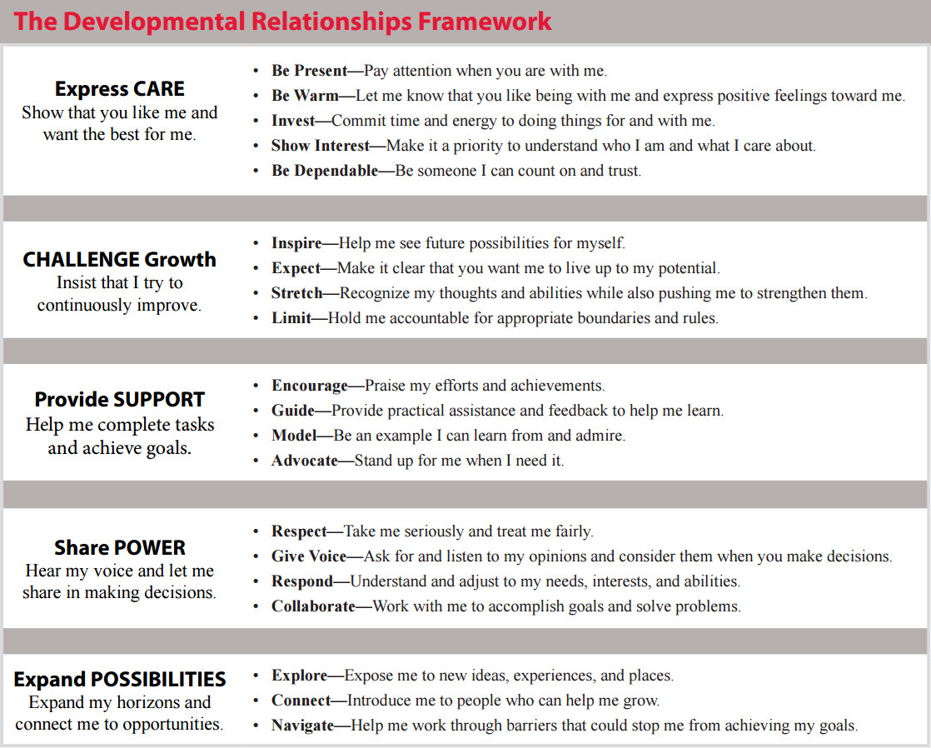

Additional training is centered on Trust-Based Relational Interventions. Developed by Dr. Karyn Purvis and Dr. David Cross at the TCU Institute of Child Development, Trust-Based Relational Interventions is an emerging intervention model for a wide range of childhood behavioral problems. These concepts work hand-in-hand with the Developmental Relationships model of the Search Institute.

Sparks Logic Model
Inputs |  | Outputs (Activities) |  | Targeted Outcomes
Participants: up to 50 students selected from Conway School District’s 4th, 7th, 8th, and 9th grades  Personnel: Program Director, part-time Teachers, Character Trainers, drivers, volunteers, interns, special guests  Partnerships: Glenhaven Ministries, Choosing 2 Excel, the Ministry Center, Conway Public School District, Pine Street Development, local churches, families (Memorandums of Understanding are available upon request.)  Facilities: 10,000 square foot school located at the Ministry Center, 766 Harkrider St.  Curriculum: Igniting Sparks, Choosing the Best, Homework from public schools  Supplies: Computers, school supplies, snacks |  | Transportation: Contract with transportation company for drivers to transport students from school to campus; parents transport home.  Snacks: Students eat a nutritious snack upon arrival.  Recreation: Students decompress after a full day of school by socializing and playing games.  Tutoring: Qualified teachers meet with students to help with homework and time management.  Character Development: Choosing 2 Excel staff engage students through the Choosing the Best curriculum  Sparks: Staff and volunteers interact with students based on their Sparks, expressing interest, confidence, training, and opportunities to express their Spark.  Field Trips: Staff and volunteers take students off campus for recreational and educational experiences.  Community Dinners: Parents of students are periodically invited to stay for dinner and learn more about their child’s interests and progress. |  | Outcome #1: Reduced at-risk behaviors, including drug, alcohol, and tobacco use, sexual activity, depression, and suicide attempts  Indicator: Pre- and post- results of Developmental Asset Profile surveys  Results: Average increase of 3 Assets per student upon completion of program  Outcome #2: Improved academic and behavioral reports at school  Indicator: Regular reports from school counselors  Results: Positive reports from school counselors on 75% of student who complete the program  Outcome #3: Increased motivation to persevere and excel in school and other relationships  Indicator: Pre- and post- Thriving and Sparks surveys  Results: 90% of students who complete program can identify their Spark, name three personal Spark Champions, and identify opportunities to express their Spark

