Course Syllabus
Fall 2015
CRN: 20325
COMM 1306
Communication and Civic Engagement

WTH 211 TR 10:50 – 12:05

Course Description

University of Central
Arkansas

Department of Communication

Instructor:

Katherine Bray
kbray@uca.edu
Tel: 501-852-2351
Office: WTH-207 E

Office Hours:
9:50 – 12:00 MWF
9:00 – 9:25, 12:05 – 12:40 TR
Virtual Hours: 5:00 – 6:30 M

Table of Contents
Course Description 1 Learning Objectives 1
Text 2
Class Assignments 2 - 3
Course Policies 4
Course Schedule 5

In this course, students will study and practice a variety of communicative approaches needed to participate more effectively in civic culture, including political, organizational, and community contexts. Students will understand the fundamental place public communication has in a democracy through group deliberation, public speaking, questioning and responding, petitioning, and letter writing. This course will also give students an opportunity to meet with local civic leaders and to find engagement opportunities on campus and in the surrounding community.
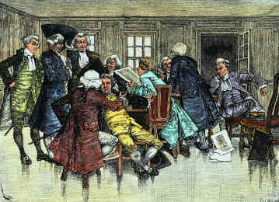

Student Learning Objectives

This course is part of the Responsible Living component of the Lower-Division Core. Responsible Living courses promote the ability to address real-world problems and find ethical solutions for individuals and society. For more information, go to http://uca.edu/core.

This section is also designated as a First-Year Seminar [FYS] course. The purpose of the first-year seminar is to provide a small-class learning environment to facilitate engagement in academic study at the collegiate level, make a connection to the university, and reinforce the importance of written communication skills.

- Articulate the relationship between public communication and democracy.
- Participate in matters of civic deliberation effectively.
- Situate their voice among a range of outlets for civic engagement.
- Employ rhetorical strategies through participation in a variety of forums for civic expression.

Required Texts:

Gastil, J. (2008). Political communication and deliberation. Los Angeles, CA: Sage.

Schlesinger, A. B. (2009). The death of "Why?": The decline of questioning and the future of democracy. San Francisco, CA: Berrett-Koehler.

Tannen, D. (1999). The argument culture: Stopping America’s war of words. New York, NY: Ballantine.

Grading: Final grades will be determined out of 500 points (500-450 = A; 449-404 = B; 403- 362 = C; 361-325 = D; 324-0 = F). Points will be earned based on the following course assignments:

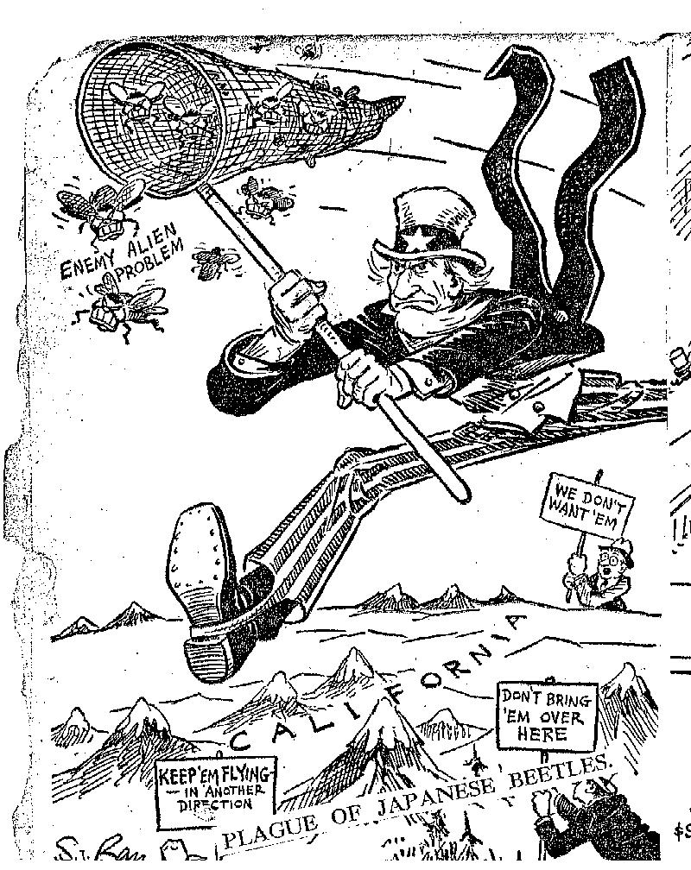
Major Assignments:
Assignments are due when class begins and can be turned in on Blackboard or by hand. Students are expected to check the comments section for assignments that are turned in on Blackboard. All assignments are to be typed in a 12 point font. Assignments that come in after the start of class will be considered late. The penalty on late work depends on the number of points it is worth and how late it is. No assignments will be accepted a week after the due date.

Participation/Discussion 100 points
A large part of this course requires student discussion, if you are not there you cannot benefit from these discussions. There will be discussion prompts to facilitate these discussions, they are due at the beginning of class and will not be accepted late.

Homework 50 points
Assignments generally given in class and posted on blackboard that are due within a week of being assigned. There will be assignments to facilitate class discussions, they are due at the beginning of class and will not be accepted late.

Group Case study on Japanese Internment Camps 50 points
Students will work in small to groups to answer one of the following questions and present this information to the class. Each group will provide all references in APA style citation both in the presentation and on a reference page.
http://www.archives.gov/research/alic/reference/military/japanese-internment.html provides a large variety of information concerning the Japanese Internment Camps, however, it should not be the only place you list as a source for these assignments.
- Research the history behind Executive Order 9066. Provide two examples of editorials ofthe day and identify the bias in each. Provide two examples of other media outlets and identify the bias in each. How did this contribute to the order being signed? What measures have been taken to prevent this from happening again? How do you feel about American Citizens being held in camps based on ethnicity?

- Research the history of one of the citizens detained in an internment camp. Provide two examples of the impact internment had on their daily life at the time. Provide two examples of the impact internment had on their life overall. Did this experience change their view of America? How would you feel if you had been stripped of your rights as a citizen? How would you feel about your country afterwards?

- Research ways that citizens could have taken action to prevent this from occurring such as letters to officials, petitions, campus and community events, and collective symbolic action. Provide two examples of citizens that tried to prevent or end the internment of American citizens. Provide two examples of what you could have done to prevent or end the internment of American citizens.

Case Study Reflection 50 points
Reflect on how the performance of Remembrance made you feel about the Japanese Internment Camp experience. How does the art reflect the experiences you researched? Reflect on how the research you have done and studying the internment camps changed the way you feel about your country?

Service Learning Project 250 points

Reflective papers
- What are my expectations of this service learning experience? Have you ever participated in a service learning class before?

- What did I observe? What were my interactions with the clients? How did these make me feel?

- Your group will interview one of the clients in a group to learn their story. Each group will prepare questions to get this information allowing for possible follow up questions based on the client’s answers. Each group will prepare questions to uncover the client’s opinion on current issues (remember you are here to listen and not interject your opinion) Probing, but not leading questions should be used. These questions will be approved by the instructor prior to the interview. After the interview you will write a transcript from your notes and memory. How has their story made you feel? Which issues to you identify with? Which of these issues you would like to research for the Engaged Activity?

- What is something you learned that surprised you? How can you use this information in the future? How has this experience changed you?

Engaged Activity 1: 50 points
Pick one of the issues raised in the interview at the Senior Center. Advocating both sides of the issue, choose one of the following three forms of engagement: editorials, letters to officials, or petitions and follow through the process.

Editorials: Provide at three examples of editorials, identifying the bias, for each side of the issue.

Letters to officials: Draft two letters to the proper authority for each side of the issue.

Petitions: Draft two petitions following protocol for each side of the issue.

Engaged Activity 2: 50 points
Pick one of the issues raised in the interview at the Senior Center. Advocating both sides of the issue, choose one of the following three forms of engagement: online activism, campus and community events/forums, or collective symbolic action and plan a campaign.

Online Activism/Social Media Participation: Research any current activity for both sides of your issue. In a paper provide examples of current trends comparing the pros and cons of each. Provide a plan to create your own campaign for this issue.

Community Events/Forums: Research any current activity for both sides of your issue. In a paper provide examples of past community events or forums comparing the pros and cons of each. Provide a plan to create your own community event or forum for this issue.

Collective Symbolic Action/Protests/Boycotts: Research any current activity for both sides of your issue. In a paper provide examples of past collective symbolic action, protests, or boycotts comparing the pros and cons of each. Provide a plan to create your own collective symbolic action, protests, or boycotts for this issue.

Presentations 50 points
Students are required to deliver a formal 3 – 4 minute presentations in this class. The presentation will be over one of the engaged activity assignments. For this presentation, students will develop a formal outline and use notes to deliver the presentation extemporaneously.

Course Policies

Attendance: Your attendance is expected for each class. Attendance is connected to your participation in the course. Please note that my policy is to drop students in this course for nonattendance (WF grade) in the following manner: 4 consecutive or 6 total absences.

Classroom Behavior: It is the policy of the Department of Communication that any student in a Department of Communication class whose behavior regularly interferes with the instructor’s ability to conduct the class and foster student learning, or who exhibits a behavior so outrageous as to severely impede the conduct of a class, may be dropped by the instructor after the instructor consults with the department chair. Prior warning will be provided to the student when possible, but under extraordinary circumstances such warning may not always be possible.

Academic Integrity: The University of Central Arkansas affirms its commitment to academic integrity and expects all members of the university community to accept shared responsibility for maintaining academic integrity. Students in this course are subject to the provisions of the university's Academic Integrity Policy, approved by the Board of Trustees as Board Policy No. 709 on February 10, 2010, and published in the Student Handbook. Penalties for academic misconduct in this course may include a failing grade on an assignment, a failing grade in the course, or any other course-related sanction the instructor determines to be appropriate. Continued enrollment in this course affirms a student's acceptance of this university policy.

Disabilities Accommodation: The University of Central Arkansas adheres to the requirements of the Americans with Disabilities Act. If you need an accommodation under this Act due to a disability, please contact the UCA Office of Disability Services, 450-3613. If you have already been approved to receive accommodations through UCA Office of Disabilities Services, please contact the professor as soon as possible to make such accommodations as may be necessary.

Sexual Harassment: Sexual harassment by any faculty member, staff member, or student is a violation of both law and university policy and will not be tolerated at the University of Central Arkansas. Sexual harassment of employees is prohibited under Section 703 of Title VII of the Civil Rights Act of 1964 and sexual harassment of students may constitute discrimination under Title IX of the Education Amendments of 1972.

Student Handbook: Your UCA Student Handbook provides an excellent overview of the policies that apply to all student-scholars on campus. Please familiarize yourself with this text and ensure that you have a clear understanding of the UCA policies regarding sexual harassment and academic responsibilities.

Title IX University Policy: If a student discloses an act of sexual harassment, discrimination, assault, or other sexual misconduct to a faculty member (as it relates to “student-on-student” or “employee-on-student”), the faculty member cannot maintain complete confidentiality and is required to report the act and may be required to reveal the names of the parties involved. Any allegations made by a student may or may not trigger an investigation. Each situation differs and the obligation to conduct an investigation will depend on those specific set of circumstances. The determination to conduct an investigation will be made by the Title IX Coordinator. For further information, please visit: https://uca.edu/titleix.

Building Emergency Plan Statement: An Emergency Procedures Summary (EPS) for the building in which this class is held will be discussed during the first week of this course. EPS documents for most building on campus are available at http://uca.edu/mysafety/bep/. Every student should be familiar with emergency procedures for any campus building in which he/she spends time for classes or other purposes.

Course Schedule: This is a tentative course schedule and is subject to change. Please check blackboard for any changes to due dates.

Tuesday | Thursday
August 20
Introduction to class
August 25  Chapter 1 Tannen  Chapter 1, 2 Schlesinger | August 27  Chapter 1 Gastil
September 1  Chapter 2 Gastil | September 3  Chapter 3, 4 Schlesinger
September 8  Chapter 2,3 Tannen | September 10  Chapter 3 Gastil
September 15  Chapter 9 Schlesinger | September 17  Service Learning Paper 1 due
September 22  Chapter 4 Gastil | September 24  Chapter 5 Gastil
September 29  Chapter 4,5 Tannen  Case Study 1 due | October 1  Case Study 2 due
October 6  Case Study 3 due | October 8  Chapter 6 Gastil
October 13  Chapter 7 Gastil | October 15  Chapter 5, 6 Schlesinger  Service Learning Paper 2 due
October 20  Chapter 7, 8 Schlesinger | October 22  Fall Break
October 27  Chapter 10, 11 Schlesinger  Interview questions due from group | October 29  Chapter 9 Tannen
November 3  Chapter 8 Gastil | November 5  Chapter 9 Gastil
November 10 Performance of Remembrance 9th  Chapter 7, 8 Tannen  Reflection Paper on Case Study due | November 12  Chapter 10 Gastil
November 17 | November 19  Service Learning Paper 3 due
November 24 | November 26  Thanksgiving Holiday
December 1  Presentations for Engaged Activity 1 and assignment due  Service Learning Paper 4 due | December 3  Presentations for Engaged Activity 2 and assignment due

