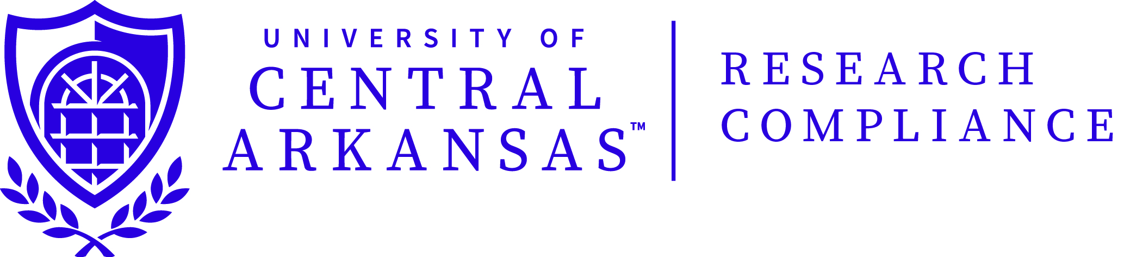

APPLICATION CHECKLIST

This checklist is to help you verify the completeness of your research proposal application for IRB review. Remember, if your application is not complete, it will be returned to you to complete and re-submit.

- ___ For each investigator, is documentation of required education in ethics/protections for
human subjects attached?

Note: This is required for ALL expedited and full review applications.

- ___Did you answer every question?

- ___ Is the correct time frame for the research given? (Do not give a date that is before you
submit the application.)

- ___ Are copies of subject recruitment flyers, advertisements, newspaper and/or e-mail
announcements attached?

- ___ Are copies of instruments, tests, questionnaires, and surveys attached?

- ___ In the description and informed consent, did you use lay language, or define discipline
specific terms?

- ___ Are the procedures described step-by-step, so that a clear “picture” is given of what subjects
will do?

- ___ Are copies of the informed consent, parent permission, assent, cover letter and/or debriefing
statement attached?

- ___ Have all signatures been obtained – the investigator(s), the department chair, and the faculty
advisor if student research?

- ___ Do you have the correct number of copies?

Do NOT send this checklist with your application

