Fall 2018

Greek and Roman Philosophy Phil 3300
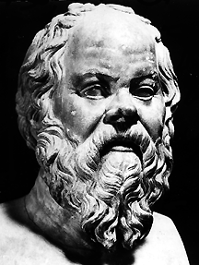

Professor Benjamin Rider

Office: Irby 118F
Office Hours: MW 2-3; Tues 10:00-1:30, and by appointment
E-Mail: brider@uca.edu
Website: Blackboard, accessible through the Courses tab on MyUCA

Description: The history of Western philosophy and science began in the ancient Mediterranean when members of Greek colonies on the coast of Asia Minor and southern Italy started asking questions about the world around them and the place of human beings in that world. Turning away from ad hoc mythology about gods and heroes, they sought to use arguments, evidence, and critical thinking to try to understand the deepest questions of human life. Their efforts laid the foundation for the world we live in today.
In this class, we will focus on a few of the most important texts and thinkers from this period, and in particular, we’ll investigate the historical context that influenced their ideas. We’ll begin with selections from Thucydides’ History of the Peloponnesian War. Though famous as a historian, Thucydides was also a keen observer of human nature and an insightful commentator on political philosophy. Then we’ll investigate the responses of two of the most influential figures of European thought—Socrates and Plato. Finally, we’ll consider two important later philosophers who built on these ideas: Aristotle and Marcus Aurelius.
Goals and objectives: In this course, you will:
- Read and engage with some of the foundational works of Western philosophy.
- Learn about the historical context (including language) in which ancient philosophy took shape and how the philosophers of this period both responded to and shaped their culture.
- Develop skills for analyzing, evaluating, and discussing philosophical arguments (Critical Inquiry).
- Work out and present your own ideas on the questions and problems we consider (Effective Communication).
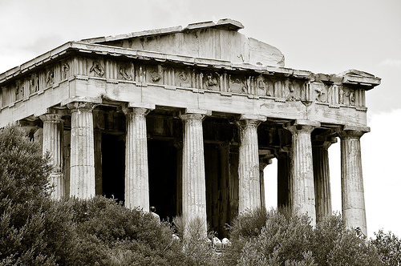
Primary texts:
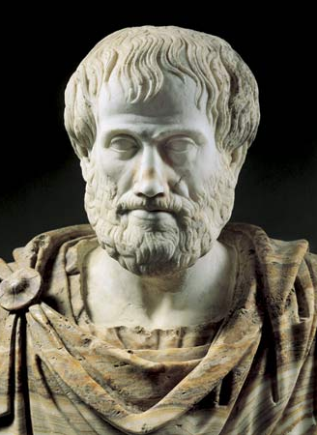
- Thucydides, On Justice, Power, and Human Nature. Trans. Woodruff. Hackett, 1993. ISBN 0-87220-168-6
- Plato, Gorgias. Trans. Zeyl. Hackett, 1987. ISBN 978-0872200166
- Plato, Republic. Trans. Reeve. Hackett, 2004. ISBN 978-0-87220-736-3
- Marcus Aurelius, Meditations, trans. Hard. Oxford University Press, 2011. ISBN 978-0199573202
You must have all of these books to participate in class discussions. Please purchase copies from a suitable source. If you cannot obtain the books, please let me know so we can make alternative arrangements!
Course assignments and grading:
The assignments for this class are designed to facilitate class discussion and to provide you with a variety of ways and opportunities to respond to the material.
- Attendance, participation, and homework (15%): You are expected to attend all class meetings. I keep track of attendance, so if you must miss a class, please let me know. More than two unexcused absences will result in deductions of this portion of the grade.
Active engagement and participation in the class discussions are also required. This does not mean that you must participate vocally in each class. But it should be clear that you are actively involved. Moreover, I will occasionally assign class preparation assignments (homework), which you can draw on in getting involved in discussions.
- Greek Language Quizzes (5%): For most class meetings, I’ll introduce a Greek term or phrase important for the issues we’re discussing. Quizzes ensure you’re paying attention!
- Meditations (~1-3 pages typed) (20% total): During the course of the semester, I will assign several (at least 12) topics for “Meditations.” Each will take up and ask you to think more about something we’ve discussed in class. The format is informal—write your thoughts on the topic, with analysis of the primary text, as well as some illustrative examples or arguments of your own. You may do as many of these as you like—the top five count toward your grade. The first set of topics will be distributed soon.
- Take-home tests (30% total): Due September 19, October 24, and November 30.
- Paper proposal, rough draft, and meeting with the professor to prepare the final essay (10% total): The biggest assignment for this course is the final essay, due at the end of the semester. We will be doing the final essay in stages, with multiple chances for me to give you feedback on your work, so that you can have a final product you can be proud of.
- Final essay (8-12 pages) (20%): Due during Finals Week. I encourage you to develop a topic of interest from one of your Meditations or take-home tests.
Important course policies:
Attendance: Attendance in class is required. You are allowed two unexcused absences without penalty. After that point, any further unexcused absences will result in a 1% penalty to your final grade. On the other hand, I understand that things happen in life—people get sick, important appointments have to be scheduled, cars break down, etc. I am happy to excuse absences, so long as (a) you let me know as soon as possible, and (b) you make up any missed work. Excused absences do not count against your allowance of unexcused ones!
Ill-considered boldness was counted as loyal manliness; prudent hesitation was held to be cowardice in disguise, and moderation merely the cloak of an unmanly nature. A mind that could grasp the good of the whole was considered wholly lazy. –Thucydides, describing the collapse of values during civil war on Corcyra
Late work: I will accept late submissions for major assignments (take-home exams, parts of the final essay), but a penalty of 5% of the total assignment grade will be applied for each weekday that it is late. If you have an excused absence for a day when a homework assignment or Meditation is due, you may turn the assignment in when you return, as long as you do so as soon as you return!
Class conduct: Please, always, show respect to your teacher and classmates! We are here to learn, so any activities (talking, text messaging, surfing the Internet, etc.) that disrupt the class environment are prohibited. If I must ask you to stop, I will mark you absent for the day.
UCA’s Academic Integrity Policy: The University of Central Arkansas affirms its commitment to academic integrity and expects all members of the university community to accept shared responsibility for maintaining academic integrity. Students in this course are subject to the provisions of the university's Academic Integrity Policy, approved by the Board of Trustees as Board Policy No. 709 on February 10, 2010, and published in the Student Handbook. Penalties for academic misconduct in this course may include a failing grade on an assignment, a failing grade in the course, or any other course-related sanction the instructor determines to be appropriate. Continued enrollment in this course affirms a student’s acceptance of this university policy.
My Academic Integrity Policy: Do not attempt to pass off someone else’s work as you own. All sources that you use in writing or researching your essay or take-home exams should be properly cited and credited, even if you paraphrase. If I suspect your work has been plagiarized, I will take the following measures: A first offense will result in your receiving zero credit on that assignment, with no possibility of making up the grade. A second offense, depending on circumstances, may result in failing the class. All appeals of my decisions may be taken up with the Chair of the Philosophy and Religion Department, Dr. Charles Harvey.
Some keys to success:
An upper-division course in philosophy is never an easy A, but here are some things you can do to ensure your success in this course.
- Read all reading assignments carefully and thoroughly and take reading notes with important points from the text and questions you have while reading.
- Ask any questions that occur to you during or after class.
- Come to my office hours. Especially if you are having trouble with any assignment!
- Set aside enough time to do your best work on take-home tests and essay components. I have seen way too many students fail to meet their potential because of procrastination and poor planning. If you need help understanding assignments and expectations, don’t be afraid to ask!

Schedule of readings and topics

We are likely to get behind at some point (perhaps very soon!) so keep in mind that all readings and topics below are subject to change. If you have any questions about where we are, please ask!
Date Topic Reading Assignment
8/24 Justice, nature, war: The Fifth Century Greek Enlightenment

Part I: War is common and justice is strife.
8/27 The Pre-Socratic background: Heraclitus Handout
8/29 Heraclitus, continued Podcast, “Heraclitus” from
History of Philosophy without Any Gaps
8/31 Thucydides’ History and the Peloponnesian War Thucydides, Chapter 1

9/3 LABOR DAY: NO CLASS
9/5 The origins of war Thucydides, Chapter 2
9/7 Pericles and the idea of democracy Thucydides, Chapter 3.a, 39-46; selections from Plato’s Protagoras

9/10 Protagoras and democracy, continued continue Protagoras selections
9/12 Human nature’s dark side: Plague and civil war Thucydides, Chapter 3 part b; Chapter 5
9/14 The Melian dialogue Thucydides, Chapter 6

Part II: The unexamined life is not worth living for a human being.
9/17 Introduction to Socrates “Socrates” (article on Blackboard)
9/19 Socrates’ defense Plato, Apology (on Blackboard)
Take-home exam #1 due September 19
9/21 Rhetoric and leadership Plato, Gorgias 447a-466a, pp. 1-26

9/24 What is true power? Gorgias 466a-481b, 27-50
9/26 Callicles on justice Gorgias 481b-491d, 51-64
9/28 Happiness, pleasure, and self-mastery Gorgias 491d-499b, 64-76

10/1 “I am one of the few to try the true politics.” Gorgias 499b-514a, 76-95

Part III: From having been many, he becomes one.
10/3 What is justice? Republic Book 1
10/5 Thrasymachus and Socrates Book 1, continued

10/8 Glaucon’s challenge for Socrates Republic, Book 2
10/10 Sketching the ideal city Republic, Book 2-3
10/12 FALL BREAK: NO CLASS

10/15 The ideal city, the Myth of the Metals Republic, Book 3-4
10/17 The parts of the soul Republic, Book 4
10/19 Justice in the soul Republic, Book 4

10/22 Women and children in the ideal state Republic, Book 5
10/24 Catch-up, other topics TBA
Take-home exam #2 due October 24
10/26 The Myth of the Cave Republic, Book 7 (selections)

10/29 The degeneration of the soul Republic, Book 8-9 (selections)

Part IV: Man is a social animal.
10/31 Introduction to Aristotle Selections online
11/2 Dr. Rider at Ethics Bowl Regionals

11/5 Nicomachean Ethics 1: The human good NE 1 (on Blackboard)
11/7 Nicomachean Ethics 2: Virtue and happiness NE 2 (on Blackboard)
11/9 Nicomachean Ethics continued No new reading
Proposal for Final Essay due November 9

11/12 The origin of the polis Politics Book 1, selections (BB)
11/14 Politics: the citizen, types of constitution Politics Book 3, selections (BB)
First draft of Final Essay due November 14
11/16 Politics in the real world Politics Book 4, selections (BB)

Part V: MARCUS QUOTE
11/19 The basics of Stoicism Selections (BB)
11/21-3 THANKSGIVING BREAK—NO CLASS

11/26 Epictetus’s Handbook Selections from Enchiridion on BB
11/28-12/5 Marcus Aurelius, Meditations TBA
Take-home test #3 due November 30
12/7 STUDY DAY—NO CLASS

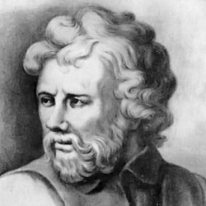
Other notices required by UCA administration:
Philosophy does not claim to secure for us anything outside our control. Otherwise it would be taking on matters that do not concern it. For as wood is the material of the carpenter, and marble that of the sculptor, so the subject matter of the art of life is the life of the self. –Epictetus, Discourses I.15.
Evaluations: Student evaluations of a course and its professor are crucial in helping faculty achieve excellence in the classroom and the institution in demonstrating that students are gaining knowledge. Students may evaluate courses they are taking starting on the Monday of the twelfth week of instruction through the end of finals week by logging in to myUCA and clicking on the Evals button on the top right.
Disabilities: The University of Central Arkansas adheres to the requirements of the Americans with Disabilities Act. If you need an accommodation under this Act due to a disability, please contact the UCA Office of Disability Services, 450-3135.
Emergency procedures: An Emergency Procedures Summary (EPS) for the building in which this class is held will be discussed during the first week of this course. EPS documents for most buildings on campus are available at http://uca.edu/mysafety/bep/. Every student should be familiar with emergency procedures for any campus building in which he/she spends time for classes or other purposes.
Title IX disclosure: If a student discloses an act of sexual harassment, discrimination, assault, or other sexual misconduct to a faculty member (as it relates to “student-on-student” or “employee-on-student”), the faculty member cannot maintain complete confidentiality and is required to report the act and may be required to reveal the names of the parties involved. Any allegations made by a student may or may not trigger an investigation. Each situation differs and the obligation to conduct an investigation will depend on those specific set of circumstances. The determination to conduct an investigation will be made by the Title IX Coordinator. For further information, please visit: https://uca.edu/titleix. *Disclosure of sexual misconduct by a third party who is not a student and/or employee is also required if the misconduct occurs when the third party is a participant in a university-sponsored program, event, or activity.
Other University Policies: Please familiarize yourself with the rights and responsibilities as well as the academic policies governing students and faculty in the 2015-2016 Student Handbook.

