Upcoming Events
(Please make sure you look at the list on our website before adding any of the dates to your program.)

Nov 21 7:30PM Viola/Violin Studio Recital SFA
Nov 28 7:30PM Wind Ensemble/Symphonic Band Concert RPH
Nov 29 7:30PM Guitar Ensemble Concert SFA
Nov 30 7:30PM The Studio of Neil Rutman in Recital SFA
Nov 30 7:30PM Band Extravaganza! RPH
Dec 2 3:00PM Austin Storm, Senior, Bassoon SFA
Dec 3 5:00PM Zhu Jun, Graduate Certificate, Voice SFA
Dec 4 7:30PM Stefan Petrov, Guest Artist, Piano SFA
Dec 4 7:30PM Voices of Central Arkansas Concert IDA
Dec 5 7:30PM Jeremy Landry, Graduate, Trombone SFA
Dec 7 7:30PM Messiah SFA
Dec 8 5:30PM Kaitlynn Ledet, Graduate, Trumpet SFA
Dec 9 7:30PM CSO Concert ** RPH
Dec 10 3:00PM CSO Concert ** RPH
Dec 10 7:30PM Taylor Brandon, Senior, Trumpet SFA

SFA—Snow Fine Arts Recital Hall
RPH—Donald W. Reynolds Performance Hall
MHB—McCastlain Hall Ballroom
IDA—Ida Waldron

Full Calendar of Events University of Central Arkansas
uca.edu/music/calendar Department of Music Facebook:

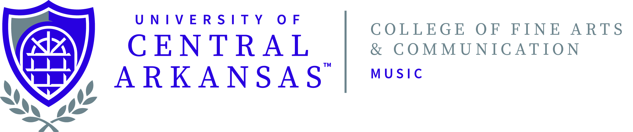
University of Central Arkansas
College of Fine Arts and Communication
Department of Music

presents

Name, Instrument

(Type of) Recital
Day, Date, Time
Snow Fine Arts Recital Hall

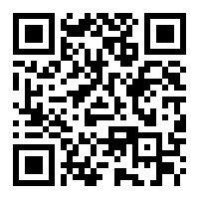
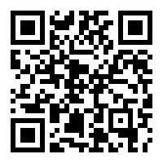

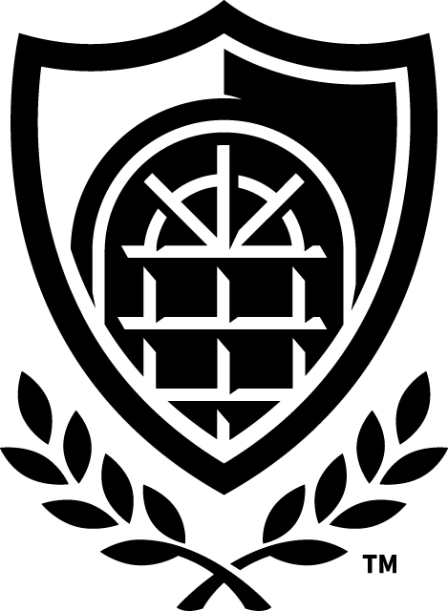

PROGRAM

Name of Piece Composer
(birth - death)
Performer’s name, instrument
Performer’s name, instrument

BIOS

