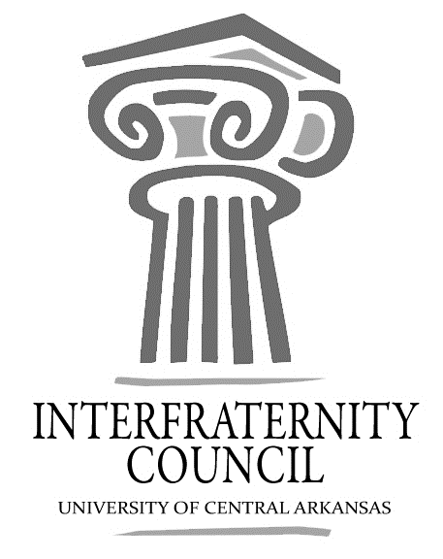
Interfraternity Council
Official minutes available immediately after meeting online: https://orgsync.com/54961/files
All IFC Public Documents: http://uca.edu/ifc/forms-and-policies/
Key:
Times New Roman: pre-submitted agenda
Times New Roman italicized: meeting notes
General Meeting
University of Central Arkansas
Tuesday, April 4, 2017

Action Items
What needs to be turned in by delegates, completed by exec board members, etc

Decisions Made
What concrete decisions were made at this meeting?

Upcoming Dates
What important events and deadlines should you be looking out for?
- April 6, 2017, x period, alumni circle
  - Walk a mile in her shoes
- April 9, 2017, 5:13, Hall of Fame Room
  - Sigma Iota Alpha New Member Presentation
- April 10, 2017, 5-6 PM, HPER Rec Field
  - Greek Week Paint War
- April 12, 2017, 4-6 PM, HPER Rec Field
  - Battle of the Greeks
- April 12, 2017, 6:30 PM, McCastlain Ballroom
  - Student Involvement Awards/ Greek Awards
  - 3 People per chapter not counting applicants
- April 13, 2017, X-period, Estes Field
  - Greek Week Picture
- April 13, 2017, 6 PM, HPER Rec Field
  - Greek Week Cookout

- Commence Meeting:
- Delegate Roll Call
- Guest speakers
  - Student Activities Board
- Executive Discussion
  - VP of Development – Steve Moorhead
  - VP of Recruitment – Drew Estes
    - Recruitment Roundtable recap
  - VP of Judicial Affairs – Drew Himstedt
  - VP of Communications – Hayden Murry
  - President – Matt Lawrence
    - Walk a Mile in her Shoes
- Advisors’ Report
  - Skyfactor Assessment
    - Last Chance to fill out Survey, 4/5.
  - Student Involvement Awards
    - 3 People per chapter

- Old Business
- New Business
- Chapter Reports
  - Alpha Sigma Phi- No Report

  - Beta Upsilon Chi – No Report

  - Kappa Sigma – No Report

  - Phi Gamma Delta – No Report

  - Phi Sigma Kappa – No Report

  - Pi Kappa Alpha – No Report

  - Sigma Nu – No Report

  - Sigma Phi Epsilon – No Report

  - Sigma Tau Gamma – No Report

- End Meeting:

Interfraternity Council Contact Information
President | Matt Lawrence | Mlawrenc6@cub.uca.edu
VP Communications | Hayden Murry | Hayden.murry@ucaphigam.com
VP Judicial Affairs | Drew Himstedt | jhimstedt1@cub.uca.edu
VP Recruitment | Drew Estes | cestes1@cub.uca.edu
VP Development | Steve Moorhead | Smoorhead1@cub.uca.edu
 |  | ucaifcexec@gmail.com

