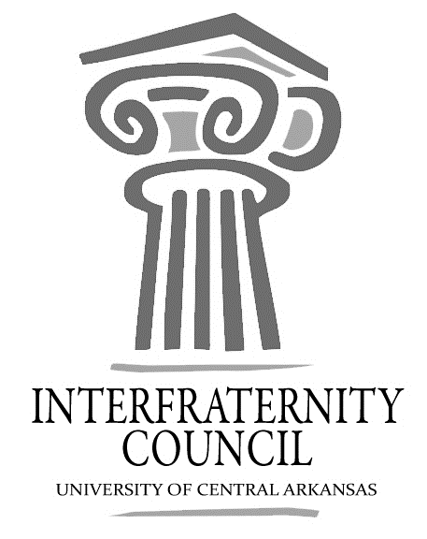
Interfraternity Council
Official minutes available immediately after meeting online: https://orgsync.com/54961/files
All IFC Public Documents: http://23277uca.edu/ifc/forms-and-policies/
General Meeting
University of Central Arkansas
Tuesday, October 3, 2017

Action Items
What needs to be turned in by delegates, completed by exec board members, etc

Decisions Made
What concrete decisions were made at this meeting?

Upcoming Dates
What important events and deadlines should you be looking out for?

- Commence Meeting:
- Delegate Roll Call
- Guest speakers
- Executive Discussion
  - VP of Development –
  - VP of Recruitment – Drew Estes
  - VP of Judicial Affairs – Drew Himstedt
  - VP of Communications – Hayden Murry
  - President – Matt Lawrence
- Advisors’ Report
  - Greek Convocation make up
  - Greek 101 Makeup
  - Bear Facts Days
  - Open Bids
  - New Member Behavior
- Old Business
  - Dues proposed
    - $5/member + $10/new member, no cap
- New Business
- Chapter Reports
  - Alpha Sigma Phi- No Report
  - Beta Upsilon Chi – No Report
  - Kappa Sigma – No Report
  - Phi Gamma Delta – No Report
  - Phi Sigma Kappa – No Report
  - Pi Kappa Alpha – No Report
  - Sigma Nu – No Report
  - Sigma Phi Epsilon – No Report
  - Sigma Tau Gamma – No Report
- End Meeting:

Interfraternity Council Contact Information
President | Matt Lawrence | mlawrenc6@cub.uca.edu
VP Communications | Hayden Murry | hmurry3@cub.uca.edu
VP Judicial Affairs | Drew Himstedt | jhimstedt1@cub.uca.edu
VP Recruitment | Drew Estes | cestes1@cub.uca.edu
VP Development
 |  | ucaifcexec@gmail.com

