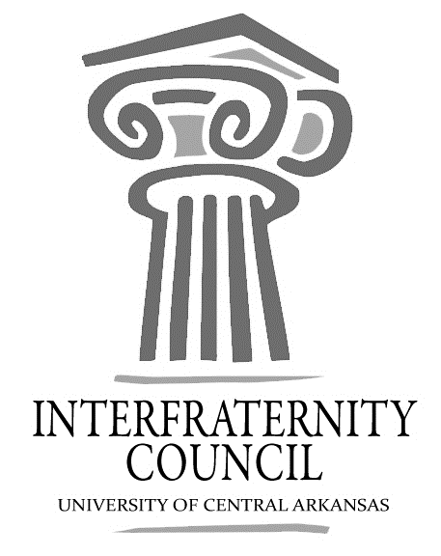
Interfraternity Council
Official minutes available immediately after meeting online: https://orgsync.com/54961/files
All IFC Public Documents: http://uca.edu/ifc/forms-and-policies/
Key:
Times New Roman: pre-submitted agenda
Times New Roman italicized: meeting notes
General Meeting
University of Central Arkansas
Tuesday, January 24, 2017

Action Items
What needs to be turned in by delegates, completed by exec board members, etc

Action Items
What should have been turned in by delegates, completed by exec board members, etc

Decisions Made
What concrete decisions were made at this meeting?

Upcoming Dates
What important events and deadlines should you be looking out for?
- January 25, 7:00 pm, SC 213
  - Greek 101
- January 26, x-period, SC 223
  - Greek 101
- January 27, 2017, 4 pm, Old Main Steps
  - IFC Bid Day
- February 3, 2017 7 PM, SC 205B
  - Phi Iota Alpha New Member Presentation
- February 7, 2017, X-period, SC 215
  - President’s Roundtable (No IFC Meeting)
- February 8, 2017, 5 – 6:45 pm, Fireplace Room
  - Phi Iota Alpha Welcome Reception
- February 14, 2017
  - IFC Dues due
- Commence Meeting:
- Delegate Roll Call
- Guest speakers
- Executive Discussion
  - VP of Development – Steve Moorhead
    - Scholarship roundtable to be held in February or March
  - VP of Recruitment – Drew Estes
    - Monthly recruitment roundtable
    - Rush week rules review
  - VP of Judicial Affairs – Drew Himstedt
    - New Judicial Board reps needed from each chapter
  - VP of Communications – Hayden Murry
    - Follow IFC on Instagram and Twitter
    - Invoices out next week
  - President – Matt Lawrence
    - Walk a mile in her shoes
    - President’s roundtable
    - Rush Week
- Advisors’ Report
  - Bid Day Reminders
    - Shirts
  - Sig Tau Statement
  - All Greek Step Show
  - Phi Iota Alpha
    - New Member Presentation
    - Welcome Reception
  - President 1v1’s
- Old Business
- New Business
- Chapter Reports
  - Alpha Sigma Phi- No Report

  - Beta Upsilon Chi – No Report

  - Kappa Sigma – No Report

  - Phi Gamma Delta – No Report

  - Phi Sigma Kappa – No Report

  - Pi Kappa Alpha – No Report

  - Sigma Nu – No Report

  - Sigma Phi Epsilon – No Report

  - Sigma Tau Gamma – No Report

- End Meeting:

Interfraternity Council Contact Information
President | Matt Lawrence | Mlawrenc6@cub.uca.edu
VP Communications | Hayden Murry | Hayden.murry@ucaphigam.com
VP Judicial Affairs | Drew Himstedt | jhimstedt1@cub.uca.edu
VP Recruitment | Drew Estes | cestes1@cub.uca.edu
VP Development | Steve Moorhead | Smoorhead1@cub.uca.edu

