Diversity, Equity and Justice: An Asian Studies Symposium
University of Central Arkansas, Student Center
March 10-11, 2017

Free and Open to Faculty and Students
A Faculty Development Workshop Conducted by:
Peter Hershock, Ph.D., Director of Asian Studies Development Program,
East West Center, Honolulu, HI
Jin Y. Park, Ph.D., Professor of Philosophy and Religion,
American University, Washington, D.C.
Registration: Email the attached form to nbrasovan@uca.edu
Registration Deadline: March 1, 2017

Symposium Website:

Sponsored by the University of Central Arkansas: College of Liberal Arts,
Regional Center for Asian Studies,
Gender Studies Minor,
Asian Studies Minor,
Center for Teaching Excellence,
Department of Philosophy and Religion
Symposium Schedule
Friday, March 10, 2017. UCA Student Center

9:00 - 9:15am Introduction

9:15am - 12:15pm Session One
Relational Virtuosity: Reconceiving Freedom, Diversity and Equity
Presenter: Peter Hershock

Abstract. This session will begin by considering the challenges of engaging culturally and/or historically distant traditions as a means to new ways of responding to contemporary issues. Making use of the notion of conceptual blending, a route will be opened beyond ‘construction’ and ‘conversation’ as metaphors for the dynamics of intercultural engagement. Following this, a case will be made for seeing how contemporary discussions of diversity, equity and justice express commitments to the ontological and ethical primacy of the individual as rationally autonomous agent, and how these commitments foster both to a quantitative understanding of diversity and the pursuit of equity as a measure of equality of access or non-exclusion, rather than as an achieved quality of inclusion. Making use of East Asian conceptual resources—Confucian as well as Buddhist—an alternative, relational conception of persons will be developed that opens prospects for significantly rethinking diversity and equity as global values and public goods, and for reconceiving both the meanings-of and means-to social justice.
12:15 – 1:15pm Lunch

1:15– 4:30pm Session Two
Thinking Differently: Buddhist Perspectives on Gender, Justice and Ethics
Presenter: Jin Y. Park

Abstract. Social equality and the celebration of diversity cannot be achieved unless we stand firm with the idea that accepting differences is a starting point for understanding others. Women’s engagement with Buddhism and Buddhist philosophy is a good example for demonstrating the importance of difference in gender issues. Unlike male-dominated and Western modes of philosophizing that focus on theory, women’s Buddhist philosophy tends to be more engaged with lived experience; thus, it creates what I call a “narrative philosophy.” This form of philosophy opens flexible avenues for a context-based understanding of others and our environments instead of relying on abstract theory. The priority of lived experience is also fundamental in envisioning justice and ethics in a more inclusive way. From the Buddhist perspective, reality is always fluctuating, and no being is a fixed entity. A view of justice in a real-life context tells us that justice does not have a fixed form, but is constantly influenced by the ecology of our existence and especially by social power structures. A better execution of justice requires a new approach to ethics, an approach that is sensitive to the contexts of our existence rather than adhering to a series of unchanging rules. Based on the Buddhist teaching of relational existence and the non-substantial nature of reality, we will examine a new form of ethics that is more conducive to celebrating diversity and creating social equality.

Saturday, March 11, 2017. UCA Student Center

9:00am – 12:00pm Session Three
Plenary and Small Group Discussions
Facilitators: Peter Hershock and Jin Y. Park
Presenters
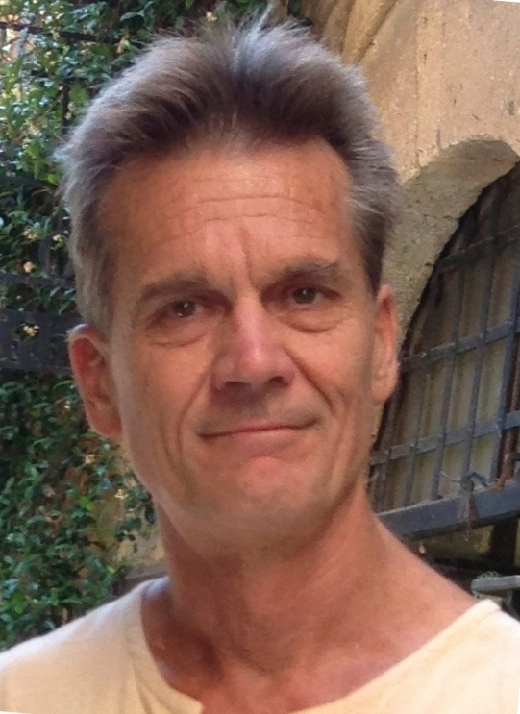
PETER D. HERSHOCK is Director of the Asian Studies Development Program (ASDP) and Education Specialist at the East-West Center (EWC) in Honolulu, Hawai’i. His work with ASDP over the past twenty years has centered on designing and conducting faculty- and institutional-development programs aimed at enhancing undergraduate teaching and learning about Asian cultures and societies. As part of the EWC Education Program, he has collaborated in designing and hosting international leadership programs and research seminars that examine the relationship among higher education, globalization, equity and diversity. Trained in Asian and comparative philosophy, his main research work has focused on using Buddhist conceptual resources to reflect on contemporary issues of global concern. His books include: Liberating Intimacy: Enlightenment and Social Virtuosity in Ch’an Buddhism (1996); Reinventing the Wheel: A Buddhist Response to the Information Age (1999); Chan Buddhism (2005); Buddhism in the Public Sphere: Reorienting Global Interdependence (2006); Changing Education: Leadership, Innovation and Development in a Globalizing Asia Pacific (edited, 2007); Educations and their Purposes: A Conversation among Cultures (edited, 2008); Valuing Diversity: Buddhist Reflection on Realizing a More Equitable Global Future (2012); Public Zen, Personal Zen: A Buddhist Introduction (2014); and Value and Values: Economics and Justice in an Age of Global Interdependence (edited, 2015).

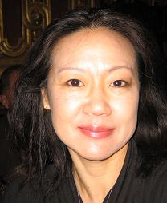
Jin Y. Park is Professor of Philosophy and Religion and Founding Director of Asian Studies Program at American University. Park specializes in East Asian Buddhism (especially Zen and Huayan Buddhism), Buddhist ethics, Buddhist philosophy of religion, Buddhist-postmodern comparative philosophy, and modern East Asian philosophy. Park employs Buddhist tradition to engage with contemporary issues with a special focus on gender, justice, and ethics. Park’s research on modern East Asian Buddhist philosophy examines the dawn of philosophy in East Asia and the East-West encounter in that context. Park currently serves as President of the North American Korean Philosophy Association and Vice President of the Society for Asian and Comparative Philosophy. Her books include Women and Buddhist Philosophy (2017); Reflections of a Zen Buddhist Nun (2014); Makers of Modern Korean Buddhism (2010); Merleau-Ponty and Buddhism (co-edited with Gereon Kopf, 2009); Buddhism and Postmodernity (2008), Buddhisms and Deconstructions (2006).

