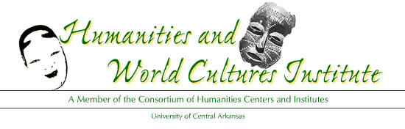
2012 UCA Humanities Fair
UCA will hold a humanities fair for high school students on Thursday, November 8, 2012 (National Humanities Month) from 9:45-2:00pm. High school students will be invited to UCA to experience what it is like to attend university courses.
- UCA Faculty will make presentations exploring the chosen theme of “Patriotism: Civility, Civil Disobedience, and Consequences."
- UCA Faculty will visit individual high-school classrooms in Little Rock, Conway, and rural areas to generate enthusiasm for the idea of the fair, which is to use a popular culture film for creative inspiration. They will provide a preview of their presentation and encourage students to develop their own original poems, essays, multi-media presentations, and short stories.
- The students will produce their own creative works which will be submitted in advance to UCA where a committee of scholars will select 1st, 2nd, and 3rd winners for each category.
- Students and their teachers will attend the humanities fair on November 8 and will be able to choose from a variety of humanities mini-lectures with discussions given by UCA faculty.
Students attending the fair will benefit by exposure to the ways the humanities can enrich their lives whether they go to college or not. We hope that the students will benefit by learning that each person has a choice of values to live by and aspire to, and that we all have life experiences that can be expressed through poetry, essays, short stories, or films. High-school students will benefit by learning how students of the humanities are able to “see” more clearly through the lens of their studies.
The theme of “Patriotism: Civility, Civil Disobedience, and Consequences" has so many potential angles that there are many books within the existing high school curricula that can inspire students to produce their own projects. UCA faculty presentations will include:
- Keynote: “When Did Jesus Become a Patriot? The Origins of an American Heresy” (Dr. Conrad Shumaker, English)
- “ Rules of Civility: Molding the First President” (Dr. Wendy Castro, History)
- “Early African American Print Culture and Citizenship" (Dr. Lori Leavell, English)
- “A Nation Through the Lens: American Civics in Cinema” (Mr. Chad Terrell, English)
- “Celebrating American Towns and Promoting Civility: The New Urbanism Movement in City Planning” (Dr. Michael Yoder, Geography)
- “Shakespeare, Spenser, and the Creation of National Self-Consciousness” (Dr. Raymond Jean Frontain, English)
- “Joan of Arc and the Making of France” (Dr. Jay Ruud, English)
- “Avatars in America: Asian Religions in Pop Culture” (Dr. James Deitrick, Religious Studies)
- " Un-patriotic Bull sh!t: Respect for Truthfulness, Political Discourse, and the Duty to be Reasonable" (Dr. Jacob Held, Philosophy)
EVENING PUBLIC FILM/DISCUSSION PROGRAM: November 8 (Thursday) Film: “Daisy Bates: The First Lady of Little Rock” introduced and Q&A by Dr. Jayme Millsap Stone

