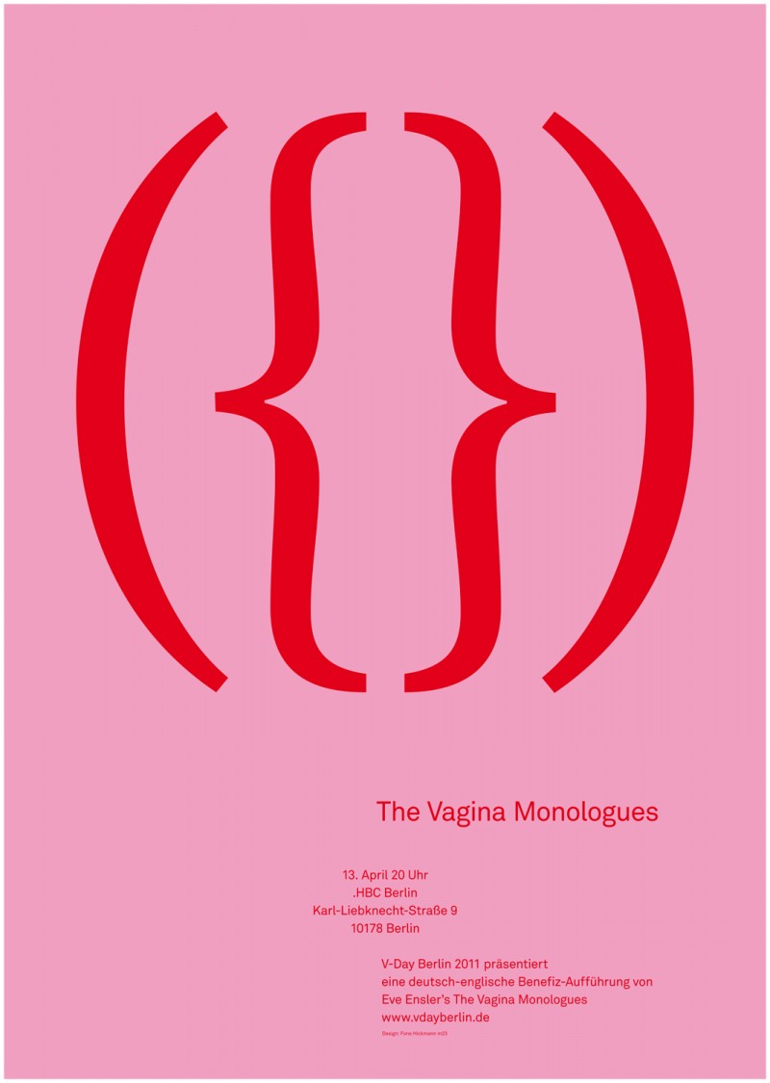

## sponsored in part by the gender studies minor and the feminist union rso

✹

# The Vagina Monologues is a moving, funny, and intense play that was inspired by interviews with women around the world. In these interviews, women revealed their experience and struggles as women, and the Vagina Monologues reflect that. The cost to attend is $5. The proceeds will go to Conway Women’s Shelter and the Eve Ensler Foundation.

Wednesday, march 12 – friday, march 14

at 7 p.m. in burdick 205

✹

The vagina monologues

For more information, contact:

Dr. Taine Duncan, Director of Gender Studies, tduncan@uca.edu, or

Kelsey Foster, Intern for Gender Studies, kfoster8@uca.edu

# Women’s History Month Presents