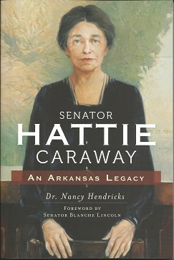

## sponsored by uca’s history department

✹

# Author of Hattie Caraway: An Arkansas Legacy, Nancy Hendricks, will give a performance of Hattie Caraway, the first woman elected on the U.S. Senate, who served from 1932-1945. Caraway has numerous connections to both Conway and UCA. Her program will be a great tie of historical, women’s achievement, and Arkansas-related events.

# The event is free, and ‘brown bag’ lunches are welcome.

For more information, contact

Dr. Taine Duncan, Director of Gender Studies, [tduncan@uca.edu](mailto:tduncan@uca.edu), or

Kelsey Foster, Intern for Gender Studies, tduncan@uca.edu

thursday, march 6 from 12-2pm

the mirror room in mccalister hall

✹

Hattie Caraway Performance

# Women’s History Month Presents