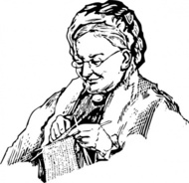

# Exploring Our World Series:

# Associate dean of the Honors College, Donna Bowman, will be giving a presentation on the relationship between women’s domestic pursuits (such as knitting) and Christianity. This lecture will provide insight on the relationship between Christianity and feminism.

# This event is free. Check out uca.edu/world for details on the lecture!

✹

## sponsored by uca college of liberal arts

For more information, contact:

Taine Duncan, Director of Gender Studies, [tduncan@uca.edu](mailto:tduncan@uca.edu), or

Kelsey Foster, Intern for Gender Studies, kfoster8@uca.edu

March 18, 2014 from 6-7 p.m.

brewer-hegeman conference center

✹

Knitting in the corner: christianity, feminism, and domestic pursuits

# Women’s History Month Presents