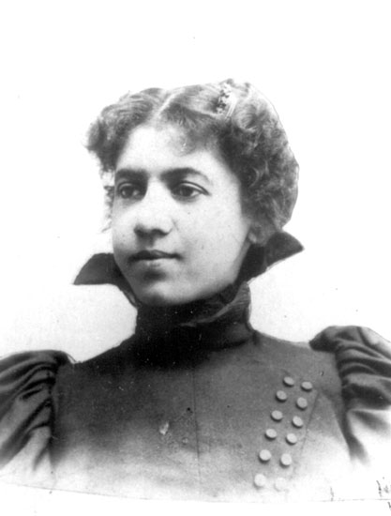

# Director of Learning Communities and Instructor of History, Jayme Stone, is bringing awareness to local Arkansan social justice. In particular, her presentation will spotlight Carrie Shepperson, a charter member of the Little Rock NAACP. Shepperson utilized the talents and networks of women and children to thrust Arkansas’s activism against lynching into the national spotlight. This will be an informative and inspiring presentation to attend!

✹

carrie shepperson: arkansas’s women and their role in anti-lynching campaign

## sponsored in part by the office of diversity and community and the gender studies minor

For more information, contact

Dr. Taine Duncan, Director of Gender Studies, tduncan@uca.edu, or

Kelsey Foster, Intern for Gender Studies, kfoster8@uca.edu

thursday, march 20th during x-period

in the student center room 225

✹

# Women’s History Month Presents