In academic year 2015, the Faculty Senate voted to fund $12,000 worth of picnic tables for the UCA campus. Suggestions for locations were received in October 2015. These locations and pictures are listed below. The photos are a general review of the areas suggested for table or bench placement. The photos do not represent the exact installation site. The general cost of a table installation is $3350 and a bench is $2050 (6ft) & $2150 (8ft). This price includes a concrete pad for the unit. We have enough funding for 3 tables and one bench (+$200 overage). Locations at this cost must be next to a sidewalk or accessible substrate for handicapped access.
Faculty Senators are being asked to review the listed sites and provide a ranking vote on priority for each site (voting poll is at the end of this memo).
L1) Behind Burdick Hall (Benches) – Currently, two picnic tables are located behind Burdick Hall. There are no benches.
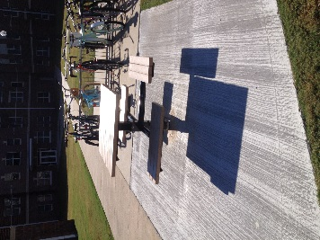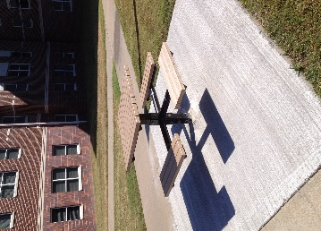

L2) Mashburn Hall (Tables) – One table located out front of Mashburn Hall. COE Administration has noted people waiting to use the one table at various times.
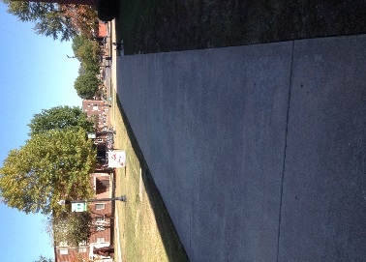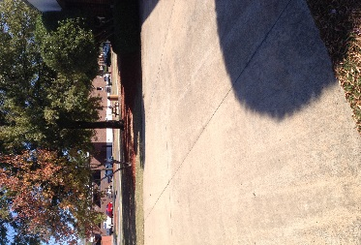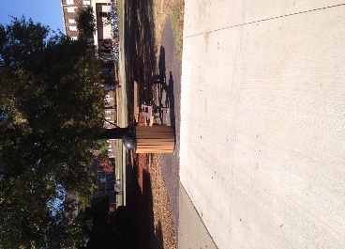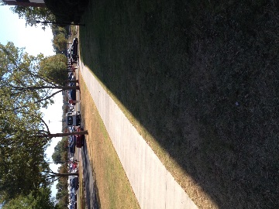

L3) Christian Cafeteria (Tables) – No tables are present in the open areas in front of the Cafeteria.
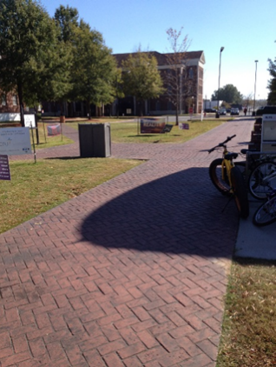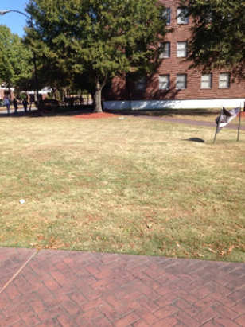

L4) Snow Fine Arts Center (Tables) – No tables are located in front of or in the courtyard between the Arts Center and the Theatre.
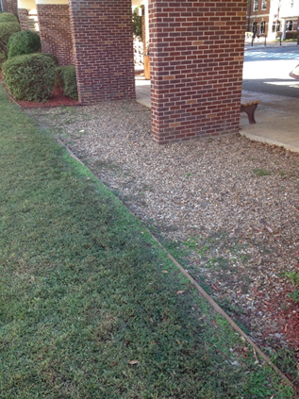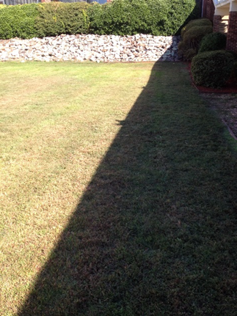

L6) Between Irby and the Library (Tables) – There are 9 picnic tables near this areas as a cluster between these two building.
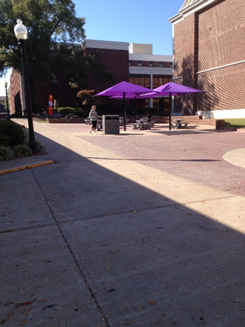

L7) South Side of Irby Hall (Tables) – No tables are located at the South Side of Irby Hall
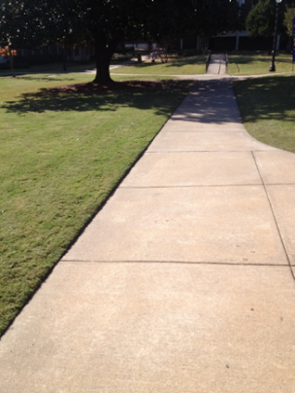

L8) Between Thompson & Irby Hall ( Tables) – No tables are located between Thompson and Irby Hall.
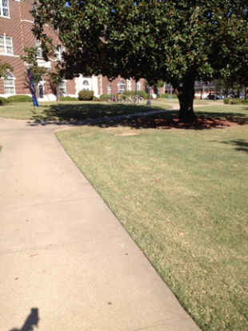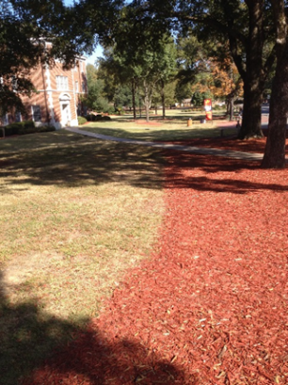

L9) Between McAlister Hall and Donaghey Avenue – No tables are located between Thompson Hall and Donaghey Avenue.
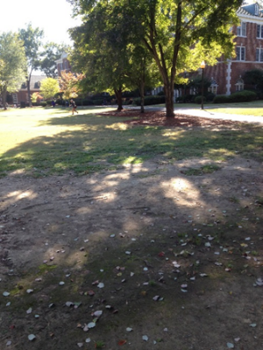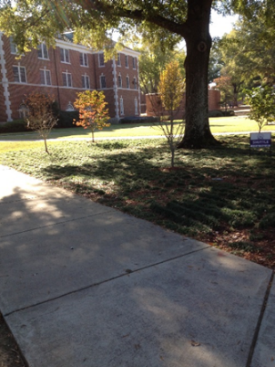

Faculty Senate Vote for locations of installations: Please indicate your ranking by underlining or italicizing the appropriate rank category for each site included in the memo. Please return your rankings to Kevin Stoltz at kstoltz@uca.edu
Low Priority = LP Moderate Priority = MP High Priority = HP
L1) LP MP HP
L2) LP MP HP
L3) LP MP HP
L4) LP MP HP
L5) LP MP HP
L6) LP MP HP
L7) LP MP HP
L8) LP MP HP
L9) LP MP HP

