- International Engagement: Scholarships
- Background: Recent changes to scholarship policy disallow institutional scholarships being offered to international students.
- Issue: This is having a negative impact on the diversity in the Honors College.
- Response:
  - IE was not involved in the recent changes to the Honors College scholarship policy. However, IE is in support of international students being eligible for membership in the Honor’s College. It is the understanding of IE that the Honor’s College scholarships are no longer available to international students because of the reclassification of this scholarship as an Academic Scholarship rather than a Departmental Scholarship.
  - IE awards scholarships to international students and will award over $180k this academic year.

- International Engagement: Communication
- Background:
- Issue: Various departments, including AAC, Library, and UC need more advanced notice regarding arrival of large groups of international students, especially during the summer.
- Response:
    - IE will be happy to meet directly with College Deans or the appropriate representatives in order to provide additional information regarding new students arriving at the university. IE will be contacting each College in order to request meetings before the end of the Fall semester. IE did this specifically with the College of Business over a year ago and since then has developed a strong relationship. This partnership developed when a trend was observed in which many incoming Transfer Students were Business majors. This partnership has been a positive experience for both the students and the faculty advising the students.
    - Given the recent trends of international students enrolling in University College courses, IE understands the importance of working more closely with the UC. IE will be more active in alerting other departments, specifically those mentioned, to ensure preparations can be made.
    - Please note IE maintains ongoing communication with various departments including the Intensive English Program, Housing Department, SHC, Cafeteria, and Student Accounts, among others, to alert the departments of the incoming international students. Also, IE has invited the AAC international student advisor to IE weekly staff meetings for the past 2 years and continues to do so. As preparations begin for the arrival of new international students, meetings are held directly with the AAC and information is continuously shared.

- International Engagement: Recruiting
  - Questions: What is the current strategic plan for recruiting international students? What areas are we recruiting from? How can we be better prepared to ensure that they are successful here?
  - Response:
- President Courtway assigned IE the goal of having 750 international students enrolled at UCA by Fall 2017. To meet this goal, IE set annual benchmarks for international student enrollment and specified recruitment efforts would focus on three world regions: Africa, Asia, and Latin America and the Caribbean.
- The international student recruitment plan was based on goals established in the university wide strategic plan and was approved and published in the Enrollment Management Plan compiled by Institutional Research in August 2013.
- International Engagement (IE) developed a sustainable international recruitment program. The plan is based on creating and maintaining mutually beneficial trusted partnerships that ensure student success and academic excellence.
- Increasing enrollment of international students brings cultural diversity to the classroom and the community at large. In order to effectively attract, enroll, and retain international students, UCA will need to provide a welcoming campus climate. Every member of the UCA community will have a shared role in internationalizing UCA and the community at large. See excerpt below:

INTERNATIONAL student recruitment
From the UCA Strategic Plan
Goal 6: Promote Diversity in All Areas
Objective A: Increase gender and racial diversity as highest priorities, but seek also socioeconomic, ethnic, linguistic, cognitive, intellectual, and age diversity in student, staff, and faculty populations.
- UCA’s Office of International Engagement (IE) has introduced a five-year plan to increase international student enrollment in support of the UCA Strategic Plan. This plan is not only focused on increasing international student enrollment but also on diversifying the international student population.

Table 1: Past International Enrollment
Term | International Enrollment | Countries Represented
Fall 2009 | 602 | 66
Fall 2010 | 578 | 66
Fall 2011 | 623 | 61
Fall 2012 | 528 | 60
Fall 2013 | 489 | 59

- IE has established goals for the next five years and identified particular world regions for recruitment. Moving forward, IE will focus on recruitment primarily in three world regions – Latin America and the Caribbean, Asia, and Africa – in order to accomplish this goal.

Table 2: Goals for International Enrollment
Term | Total International Enrollment | Latin America & Caribbean | Asia | Africa
Fall 2014 | 550 | 50 | 350 | 100
Fall 2015 | 625 | 95 | 355 | 115
Fall 2016 | 700 | 120 | 385 | 125
Fall 2017 | 750 | 130 | 405 | 135
Fall 2018
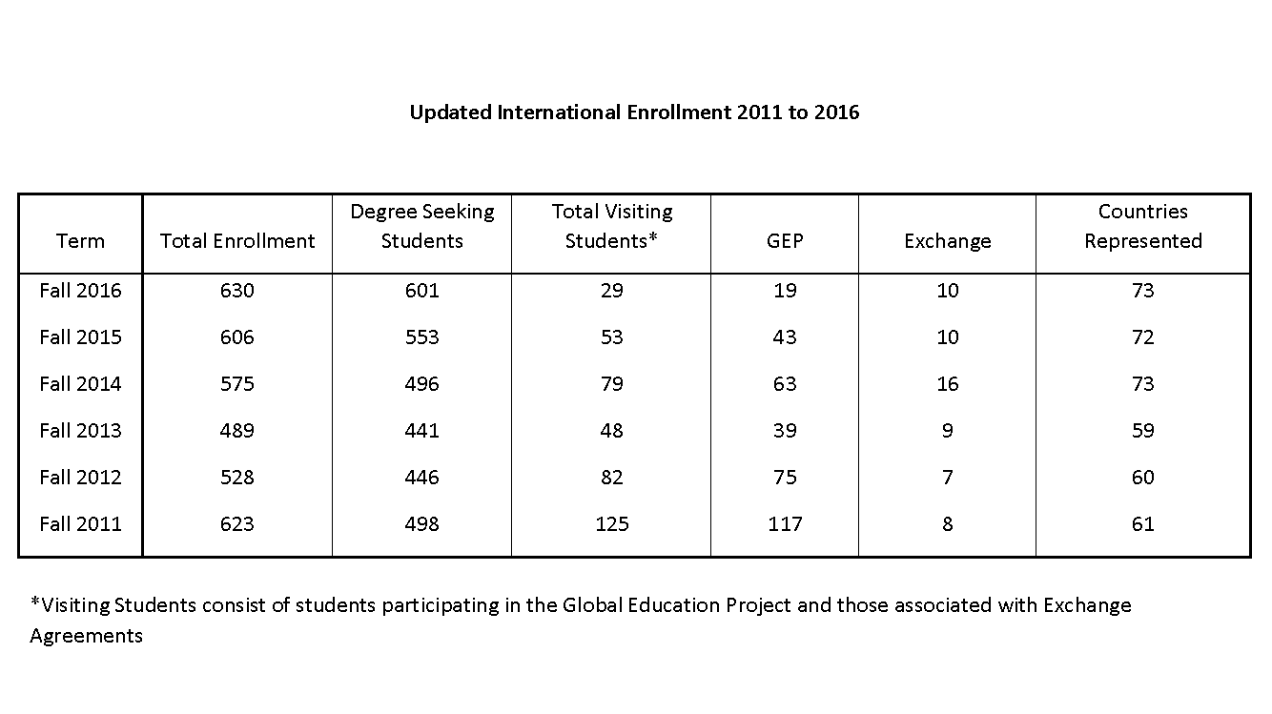
- How can we be better prepared to ensure that they are successful here?
  - International students are in a unique situation at UCA: away from their home country, often for the first time, and adapting to a completely different culture and language environment. International Engagement (IE) aims to ease this drastic transition by immersing the students in campus life, ensuring the students feel at home, and fostering adequate preparation for the academic challenges ahead at UCA.
  - IE begins each semester with an orientation program. Team Global, a volunteer student ambassador program, helps engage international students with current UCA students in various activities during orientation and beyond. Additionally, international students can participate in International Friendship Outreach, which hosts students to provide them with a sense of home. IE works to continually communicate with the students, using social media outlets, such as Facebook, to keep them constantly engaged.
  - IE works with other university departments to advocate for the unique needs of international students, such a keeping campus housing open during winter break and helping with communication barriers. Although IE aspires to get the graduation rate for international students as high as possible, their initiatives are aimed at all international students (including exchange and visitor), while standard retention and graduation rate only looks at first-time undergraduates; as IE serves a larger population outside this defined group, accurate assessment of success is more difficult. That being said, Institutional Research Fall 2009 data reports a graduation rate of 57.1% for international students and 44.6% for domestic undergraduate students.

- International Engagement: TB testing for international students
  - Question: There has been discussion on campus about many international students arriving at UCA and testing positive for TB. What is being done to avoid this? What is being done for the students who are here? What is being done to prevent spreading of TB to other campus members?
  - Response:
The questions related to students testing positive for TB are serious concerns. Due to the medical complexities associated with it, IE recommends that a meeting take place with the Student Health Clinic, IE and Faculty Senate representatives and/or the concerned faculty. IE contacted Student Health to request such a meeting, should one be desired, and received a positive response from Student Health.
Below are the minutes from the meeting IE had with Student Health at the beginning of the Fall semester to address the increase in students testing positive for TB. Please note that these steps include conducting clinical screenings (#3 below) of all students moving forward which has not been done previously. This step was added in particular to be proactive with communication to the campus community in case students show symptoms of TB.
1) International students, particularly those from high-risk countries, will visit Student Health on the first day of orientation. International Engagement will require students to complete their Student Health paperwork before arriving at Student Health to expedite the process.
2) Visits at Student Health will start an hour earlier, at 9am, instead of 10am.
3) Student health staff will give clinical screenings along with the T-spot screening. This will take longer per student, but allow for more prevention, as symptoms such as fever would be caught.
4) Holds will still be placed on student accounts as a way to alert them and help get them back into the clinic for follow up.
5) Student Health will provide a list of high and low-risk countries for TB exposure to International Engagement.
6) Student Health will provide a list of students who test positive on the T-spot (and clinical screening if applicable) to IE, so they can get in touch with students to ensure follow up.
7) For communication to those concerned: The health system infrastructure is in place in AR to treat people for symptoms, or prophylactically. Also, no students who has been screened and had their test results/X-rays come back has had active TB to date. Only active TB is contagious.
The SHC adheres to the Arkansas Department of Health rules and regulations regarding Tuberculosis screenings. These guidelines can be provided if desired.
- International Engagement: Certification of Academic Credits
  - Question: We have had outside agencies “certify” academic credits to allow international students to apply to UCA, and they perform badly. Sometimes these students already have a degree in some majors or credentials are otherwise not evaluated properly. Can we ensure that reputable certification firms are used for students coming to UCA? Why are we spending so much effort on international students, when we have a domestic market for potential students?
  - Response:
    - IE consulted with the UCA Registrar’s Office in 2013 to identify International Education Evaluations (IEE) as a reputable credential evaluation company that prospective students could use during the admission process. IE strongly recommends that international students with foreign transfer credits use IEE in the review of their foreign transcripts because IEE will perform a UCA course match. Other credential evaluation companies do not provide this service and some are simply not reputable. IE consults with the Registrar’s Office as prospective international students submit evaluations from other companies to determine if they will be approved. WES is a widely recognized credential evaluation company, but their evaluations of transfer transcripts have caused some concern in the last few semesters.
    - IE is actively working with the Registrar’s Office to improve the credential evaluation and review process.
    - In regard to the recruitment of international students, IE was charged by the President to increase enrollment to 750 international students by 2017.

- International Engagement: East China Normal University
  - Concern: A faculty member who recently taught in Shanghai heard disturbing reports of how participants in our exchange program with East China Normal University (ECNU) had been treated by UCA's International Programs.
  - Response: IE was unaware of ECNU exchange student concerns with the Associate Director or Associate Vice President. Upon receiving this information, IE met with the Director of Confucius Institute and the Deputy Director of Confucius Institute (who is also a faculty member at ECNU). Neither knew of any complaints. ECNU is a valued partner. IE will follow up to learn about the exchange student complaints from the faculty member. IE strives to ensure all international students have rewarding, positive experiences at UCA.
- International Engagement: Mysore
  - Concern: A faculty member had been sent to India by a previous International Programs director to sign an exchange agreement with the University of Mysore. This faculty was contacted by that campus after the exchange agreement had lapsed to see if it might be renewed. This faculty contacted IE and was given assurance that it would be renewed. It was not and left the faculty in an embarrassing situation.
  - Response:
    - IE is very interested in supporting faculty and their work and interest in international programming, including student and faculty mobility. IE conducted a comprehensive review of partnership agreements beginning in 2013. The review was difficult, because MOUs were found in two laundry baskets in a storage closet, digital copies of MOUS did not exist, and the legal agreements were inconsistent in format and documentation.
    - IE worked with UCA University Counsel to create templates for international partnership agreements including: the Global Education Project Agreement, Exchange Agreement, and Framework for Cooperation Agreement. When the approved templates were completed, IE began the process of updating agreements. In May, 2015, Jane Ann Williams requested via email the (former) study abroad coordinator to work on an updated UCA - Mysore University agreement. Williams was out of the country and did not realize the contract had not been completed. We apologize for the error. We agree that Mysore University offers much potential for faculty and student international collaboration and mobility. We will send a letter of apology to Mysore and will now begin the process of renewing this partnership.

