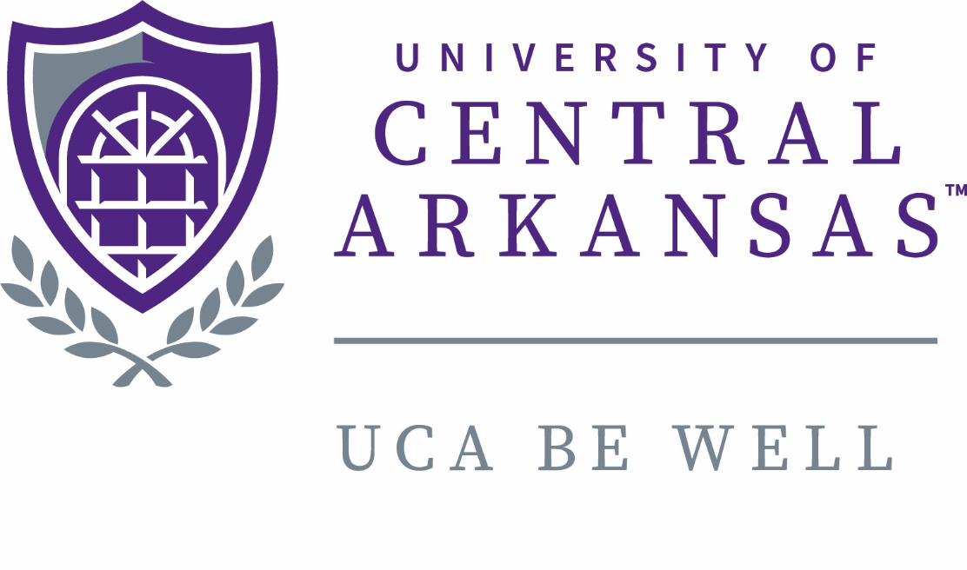

Health and Wellness Advisory Committee Report

December 2017

Health and Wellness Advisory Committee
Annual Report
December 6, 2016

Chair: Alicia Landry (Interim)

Current Committee Members: Kimberly Ashley-Pauley (CHBS, Staff Senate Appointment)
Kim Eskola (CHBS, Faculty Senate Appointment)
Chad Hearne (Student Accounts, Staff Senate Appointment)
Alicia Landry (CHBS, Faculty Senate Appointment)
Ed Powers (Incoming EBAC Chair)
Victor Puleo (Outgoing EBAC Chair)
Ary Servedio (Campus Recreation, Staff Senate Appointment)
Candice Thomas (CNSM, Faculty Senate Appointment)
Rhonda Roberts (HR Representative, non-voting)
Graham Gillis (Ex-officio, non-voting)
Meeting Dates:
January 17
February 14
February 28
March 2
March 9
March 17
April 4
May-July – Search Committee Enacted
August 3
August 18
September 15
October 26
November 10
November 30
December 12

Charge
- Coordinates individual, departmental, and university efforts to promote health and wellness for UCA faculty and staff employees. Specifically, the committee will:
  - Assist in development of a variety of initiatives and programs
  - Work with faculty and staff in encouraging employee participation in the wellness program

Summary of Activities
- Accepted resignation of Wellness Coordinator and began searching for a new coordinator
- Opted to explore options for Wellness Vendors and asked Stephen’s to create and distribute RFP for vendors
- Provided draft Strategic Plan and Plan of Work to Faculty and Staff Senate President’s for comment
- Updated Committee Charge and worked closely with EBAC to define responsibilities
- Continued 450 Movement Challenge through the year
- Assessed biometrics, HRA, and participation data from 2017 – 37% participation rate
- Formed workgroup to establish recommendations for programming (workgroup currently meets weekly)

Future
- Identify evidence based incentive structure and wellness requirements for 2018

