American Lit. II (ENGL 2313. CRN: 23558)
Instructor: Dr. Glenn Jellenik E-mail: gjellenik@uca.edu Office: 430 Irby Time: MWF 10-10:50 Office Hours: MWF 12-2, or by appointment Place: Irby 313
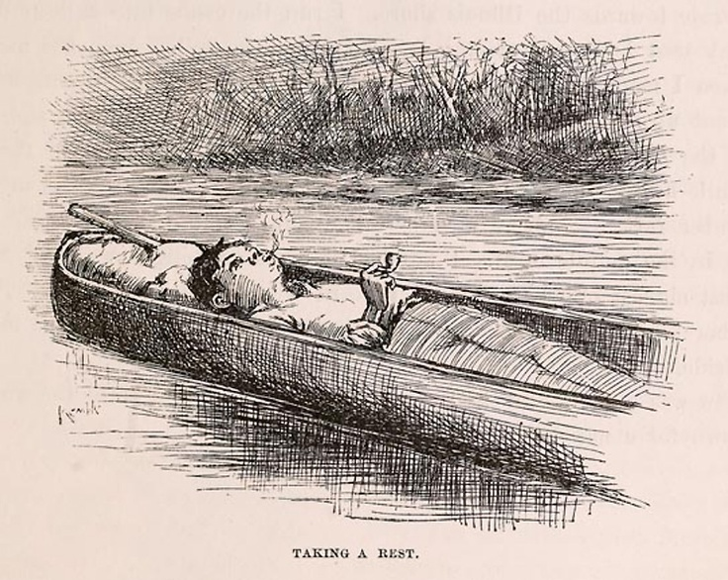
Course Description: Put simply, this is a survey course in American literature covering the years from the end of the Civil War to our present day (and yes, despite the absurd insistence of some, the Civil War is over). As you know, an awful lot has happened between 1865 and today, and we will cover the major literary innovations and movements. In doing so, we will put that literature in conversation with what is happening in the nation and world. As Salman Rushdie says, “Man is the storytelling animal, the only creature on earth that tells itself stories to understand what kind of creature it is.” So for the purposes of this class, American literature is a set of stories we tell ourselves in order to better understand ourselves. And this class will allow you to engage with those stories and explore the self-understandings they produce.

This course will be a prolonged exercise in/with careful, active, and creative reading. We all know that writing is a creative act, but reading is, as well. So we’ll be looking closely at a huge range of literary texts in order to practice, develop and hone the skill of critical reading, or reading as a creative act. In order to do that, we will develop an analytical toolbox and a set of reading strategies that will help us access the interesting and productive ways that literature represents, processes, and constructs our world.

We will use literature to make associations and connections. In short, that is one of the huge components of solid critical reading; it carefully processes varied and complex material to consider & rehearse the various specific ways in which that material connects to, comments on, questions, drives, and reflects issues and situations outside the text. No text exists in a vacuum. We will put a host of interesting literary texts in conversation with our world-at-large and let your wonderful brains perform the sorcery of making productive connections/associations.
Learning Outcome: This course offers an overview of American literature as a form of cultural expression. In tracing the major literary movements, styles, and innovations from 1865 to today, you will look closely at texts and develop specific critical readings in order to contextualize and understand them. In the end, you will systematically engage with written texts to explore the ways that literature functions simultaneously as a window and a mirror. To do this effectively, you will develop a critical toolbox that will allow you to strengthen your ability to analyze works and to organize and express those analyses in verbal and written form. Throughout the semester, you will practice reading various texts, forming ideas, observations, and arguments about them, and delivering those ideas, observations, and arguments in clear, concise, and effective essays. Writing will be an important part of this class, and the ability to write well in Standard Academic English is vital to your success.
My Policies.
Participation: It comprises 15% of your final grade. That means that I expect everybody to participate in our discussions. Seriously, you do not want to listen to 50 straight minutes of my talking head every MWF. That said, we will explore a wide range of texts and topics in class; not only would it be impossible for all of you to agree on everything, it would be boring. I highly encourage you to disagree with one another, and I highly encourage you to disagree with me. All I ask (actually, I don’t ask, I demand) is that you disagree with one another (and me) in a constructive manner that fosters conversation rather than shuts it down. Show respect for one another’s views, opinions and ideas.
In keeping with the idea that this is a safe space to share and test out ideas, I encourage you all to speak to one another in our discussions. That is, not all comments have to go through me at the front of the room. Let ideas bounce around the room—address one another directly. This will be best accomplished if you learn each other’s names. If done properly, we can all join together in an American Lit. brother- and sisterhood. We will now join hands and sing Kumbaya.
Small but not insignificant point: In order to truly participate productively in class, you need to have done the assigned readings. If it becomes obvious that you haven’t been doing the readings—and it’s not that difficult to tell—I’ll be forced to administer annoying quizzes at the beginning of each class. Don’t make me administer annoying quizzes. Do the readings.
Attendance: If you intend to make a premium grade (A or B), you should attend class as frequently as possible, preferably every class day. Your final grade for this course will drop two points for every absence after three, except in rare situations. Infrequent absences caused by illness or accident, family death, official university functions, or inclement weather are acceptable, but you need to bring documentation of the reason to receive this consideration. If you should miss 6 or more classes, I will strongly recommend that you drop the class.
Late arrivals/Early departures: Avoid these at all costs; if it’s unavoidable, be as considerate as possible to your classmates.

******************!!!!!!Cell Phones!!!!!!******************
Hear this now: Cell phone interruptions drive me nuts—seriously, they give me facial tics. So please turn off and stow all cell phones before class. Seriously, I don’t even want to see your cell phone. Really. Prove to yourself that you’re not addicted to the little monster: spend our 50 minutes out of its presence (#giveyourthumbsarest).
Late Work: I do not accept late work. All assignments are due on the day indicated on the syllabus, at the start of class. Period.
Assignments and Grade value:
*Essay 1 (2/15) 25% Group Project (3/30) 15% *Final Essay ) (4/27) 30% SWAs (short writing assignments) 15% Participation 15%
*You cannot pass the class without completing both essays.

Grades: Ahh, grading! Here’s the rub. One of the major sticking points between teacher and student comes down to a potential disparity in goals. My goal is that you develop as a thinker, reader and writer. Often (I didn’t say always, so don’t be offended!), your goal is to obtain a grade that will make you happy. See the potential conflict? Honestly, if I thought that handing out A’s were the best way to improve your thinking/reading/writing, I’d do it. Unfortunately, everything about your academic training to this point has worked in an opposite direction. In our system, I tie a carrot (grade) to a stick and dangle it in front of you as you pull the millstone. Sorry. I didn’t invent the system, but it’s where we work. On the bright side, in my experience, it’s relatively rare for the grade not to reflect the effort of the student.
Extra credit opportunities may be offered throughout the semester, but they exist in order to enhance your engagement with the college and our material, not to explicitly improve a student’s grade (though, of course, they will improve your grade). What I’m saying here is, don’t ask me to devise extra extra credit opportunities to make up for missed or poor work.
University Policies.
Academic Integrity: The University of Central Arkansas affirms its commitment to academic integrity and expects all members of the university community to accept shared responsibility for maintaining academic integrity. Students in this course are subject to the provisions of the university's Academic Integrity Policy, approved by the Board of Trustees as Board Policy No. 709 on February 10, 2010, and published in the Student Handbook. Penalties for academic misconduct in this course may include a failing grade on an assignment, a failing grade in the course, or any other course-related sanction the instructor determines to be appropriate. Continued enrollment in this course affirms a student's acceptance of this university policy.
The Americans with Disabilities Act: The University of Central Arkansas adheres to the requirements of the Americans with Disabilities Act. If you need an accommodation under this Act due to a disability, please contact the UCA Office of Disability Services, 450-3613.
Students should familiarize themselves with all policies included in the Student Handbook, particularly the Sexual Harassment Policy and Academic Policies. You are responsible for acting in accordance with these university policies. If you have any questions about these policies and how they pertain to you, do not hesitate to ask me for clarification.
Title IX disclosure: If a student discloses an act of sexual harassment, discrimination, assault, or other sexual misconduct to a faculty member (as it relates to “student-on-student” or “employee-on-student”), the faculty member cannot maintain complete confidentiality and is required to report the act and may be required to reveal the names of the parties involved. Any allegations made by a student may or may not trigger an investigation. Each situation differs and the obligation to conduct an investigation will depend on those specific set of circumstances. The determination to conduct an investigation will be made by the Title IX Coordinator. For further information, please visit: https://uca.edu/titleix. *Disclosure of sexual misconduct by a third party who is not a student and/or employee is also required if the misconduct occurs when the third party is a participant in a university-sponsored program, event, or activity.
Emergency Procedures: Emergency Procedures Summary (EPS) for the building in which this class is held will be discussed during the first week of this course. EPS documents for most buildings on campus are available at http://uca.edu/mysafety/bep/. Every student should be familiar with emergency procedures for any campus building in which he/she spends time for classes or other purposes.
Course Texts: Course Packet (I will email you the document; you will print it). Books: A Streetcar Named Desire (Williams, 1947); Slaughterhouse-Five (Vonnegut, 1968); Maus (Spiegelman, 1980); The Road (McCarthy, 2006).
Class Schedule
Week 1.
F 1/8. Introductions.
Week 2. Post-Civil War. America picks up the pieces: (Re) Building a National Identity
M 1/11. Whitman
Due: SWA 1
W 1/13. Whitman
F 1/15. Twain. Huckleberry Finn
Week 3.
M 1/18. MLK Day. No Class
W 1/20. Huckleberry Finn
Due: SWA 2
F 1/22. Huckleberry Finn
Week 4.
M 1/25. Huckleberry Finn
W 1/27. Huckleberry Finn
F 1/29. Dickinson
Due: SWA 3
Week 5. A Short (Story) History of the Turn of the Century
M 2/1. Dickinson
W 2/3. Charlotte Perkins Gilman, “The Yellow Wallpaper”
Due: SWA 4
F 2/5. Kate, Chopin, “The Story of an Hour”
Week 6. A Short (Story) History of the Turn of the Century
M 2/8. Henry James, The Turn of the Screw
Due: SWA 5
W 2/10. The Turn of the Screw
F 2/12. The Turn of the Screw
Week 7. Post-WW I. Modernism’s fissures, fractures, traumas.
M 2/15. Eliot
*Due: Essay 1
W 2/17. Eliot

F 2/19. Hughes
Due: SWA 6
Week 8. Post-WW I. Modernism’s fissures, fractures, traumas.
M 2/22. Hemingway, “Hills Like White Elephants”
Due: SWA 7
W 2/24. Fitzgerald, “Babylon Revisited”
F 2/26. “Babylon Revisited”
Week 9. Post-WW II. America re-calibrates: (Re Re) building a national identity in a fractured world.
M 2/29. Tennessee Williams, A Streetcar Named Desire
Due: SWA 8
W 3/2. A Streetcar Named Desire
F 3/4. A Streetcar Named Desire
Week 10. Post-WW II. America re-calibrates: (Re Re) building a national identity in a fractured world.
M 3/7. Hughes
Due: SWA 9
W 3/9. Hughes
F 3/11. Ginsburg
Week 11. Post-WW II. America re-calibrates: (Re Re) building a national identity in a fractured world.
M 3/14. Ginsburg
Due: SWA 10
W 3/16. Kurt Vonnegut, Slaughterhouse-Five
F 3/18. Slaughterhouse-Five
Week 12. Spring Break
Week 13. Post-WW II. America re-calibrates: (Re Re) building a national identity in a fractured world.
M 3/28. Slaughterhouse-Five
Due: SWA 11
W 3/30. Slaughterhouse-Five
*Due: Group Project
F 4/1. Raymond Carver, “Cathedral”
Week 14. Post-WW II. America re-calibrates: (Re Re) building a national identity in a fractured world.
M 4/4. Art Spiegelman, Maus
Due: SWA 12
W 4/6. Maus
F 4/8. Maus
Week 15. Post-9/11. fissures, fractures, traumas, Part II.
M 4/11. Maus
W 4/13. Cormac McCarthy, The Road
F 4/15. The Road
Due: SWA 13
Week 16. Post-9/11. fissures, fractures, traumas, Part II.
M 4/18. The Road
W 4/20. The Road
Final Essay Due: Wed. 4/27!!

