English 4364/5364: Special Topics in Children’s and Adolescent Literature

DYSTOPIAN FICTION FOR YOUNG ADULTS

Instructor: Dr. Sonya Fritz

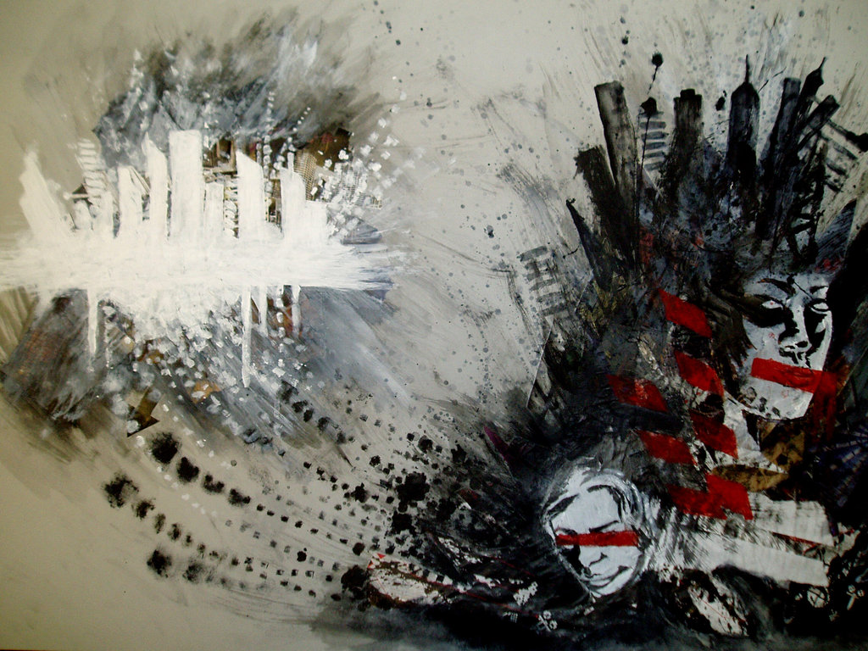

“Utopia vs Dystopia” by Seniver
Where and when: T/R 10:50 am -12:05 pm, Irby 303
E-mail: sfritz@uca.edu
Office: Irby 317 C
Office phone: 450-5127 (email, however, is much better)
Office Hours: W/F 1-2 pm and 3-4 pm; T/R 9:30-10:30 am
and 3-4 pm; and by appointment

Course description

This special topics course will be taught as an exploration of dystopian literature for adolescents and young adults, a genre that not only has become a heavy-hitter in the YA literary and film markets (Sexy vampires are out! Bleak futures are in!) but also has contributed significantly to a Zeitgeist that’s manifesting itself in mainstream as well as youth culture. The wave of recent scholarship on the genre (including no less than three edited collections of essays on the Hunger Games trilogy published in 2012) also indicates that this fiction is a rich area to mine for analysis, engendering a variety of interpretations and critical debates.

We will explore the YA dystopian novel as social commentary, cautionary tale, and coming-of-age story, among other things. We will consider a variety of critical questions, including the following: How does dystopian fiction lend itself to the concerns and characteristics of YA literature and vice versa? What socio-cultural, philosophical, and/or artistic purposes does dystopian fiction serve, particularly when it is written for an implied audience of young people? What particular kinds of definitions and/or portrayals of adolescence does YA dystopian fiction tend to offer, and what is so appealing or compelling about these? How does this fiction tap into various memories of the past, anxieties about the future, and/or present-day interests that are a part of our contemporary cultural consciousness? And, finally, what is the deal with all of the trilogies?

In general, the goals of this course as an upper-division English class are to:

- Engage in literary and cultural criticism as we read and analyze the texts selected
- Work on our understandings of various theoretical frameworks and critical lenses that are relevant to the works we’re reading this semester, and hone our uses of these apparatuses in our discussion of the selected texts
- Develop our skills as critical thinkers, researchers, and writers—i.e., as literary scholars—through lively class discussion and a variety of writing assignments

Required texts and materials
-The Hunger Games, Suzanne Collins
-Uglies, Scott Westerfeld
-The Maze Runner, James Dashner
-Divergent, Veronica Roth
-Feed, M. T. Anderson
-The House of the Scorpion, Nancy Farmer
-The Adoration of Jenna Fox, Mary Pearson
-Naughts & Crosses, Malorie Blackman (also published under the title Black & White)
-Ship Breaker, Paolo Bacigalupi

Our required reading for the course also includes texts of which you will not have to purchase hard copies. I will post files with these readings on Blackboard for you to access or distribute hard copies in class.
You are also required to have:
- Access to a computer so that you can log on to our Blackboard shell and class blog for the course as necessary
- Access to a good dictionary and writing handbook to aid you in writing your papers for the class
- A UCA email account that you check daily
- Opinions and insights that you develop thoughtfully and voice respectfully during class discussions. The success of this course depends in large part on its members’ willingness to seriously and actively engage the material and participate in discussions.

Policies

Attendance. Daily attendance will be taken in this class. You are allowed two unexcused absences. Each subsequent unexcused absence will result in the deduction of five percentage points from your final grade. Please use your two absences wisely—they are not intended for those days when you feel like sleeping in, but rather for days when you cannot come to class but your absence is not excused. Nine or more absences, excused or otherwise, provide grounds for the student to be dropped from the course.

You are responsible for providing evidence and/or appropriate documentation to substantiate excused absences. Excused absences can include illness requiring a doctor’s visit, the serious illness of an immediate family member or illness of a dependent, the death of a relative, etc. Please direct any questions concerning what constitutes an excused absence to me. If you know in advance that you will miss a class due to an excused absence, you are responsible for informing me and making any necessary arrangements to make up class work.

Keep in mind that trips out of town for weddings or family vacations and children’s school programs or ceremonies are not excused absences. Please also try to avoid scheduling routine medical check-ups, such as dental cleanings or yearly physicals, during class time—I will not excuse these absences.

It is important for all of us to respect one another’s time and arrive promptly for class. Students who arrive to class after half of the class period (calculated by the duration of the class period in minutes) or more has passed will be counted absent. Students who arrive to class after attendance has been taken are responsible for checking with me after class to make sure their attendance has been recorded. Chronic tardiness will be penalized by counting each third tardy as an unexcused absence. Students should also come to class planning to stay for the duration of the period. If you cannot do so, do not come to class; leaving class early is disruptive and disrespectful. See me if you have questions about this.

If you are absent on the day of an exam, you are responsible for contacting me as soon as possible to schedule the make-up exam. If your absence is excusable, you are responsible for providing documentation to substantiate this at the time of the make-up exam. Five late points will be deducted from the exam grade if the absence is not excused (i.e., you overslept). Five late points may also be deducted if you do not contact me in a timely manner to schedule the make-up exam, whether your absence is excused or not. Unless other arrangements have been made with me, any exam that is not made up by the deadline for submitting final grades to the registrar will receive a grade of zero (0).
Students who miss class are responsible for obtaining information regarding missed class notes, material, and assignments. It is my policy to email students information regarding missed class notes only for excused absences and only when the student has sent a request via email specifying student name, course number and section, and class date(s) missed. I strongly recommend that students also talk with their classmates about what they have missed, as all I can offer students are any Power Point slides and/or handouts used during the class period.
Classroom Behavior. Disruptive classroom behavior is defined as anything that would interfere with an instructor's ability to conduct the class or the ability of other students to profit from the instructional program. All individuals and the opinions they express in class are to be treated with respect during class discussions. Students who are asked to leave class for disruptive behavior will be counted absent for that day.
Paper Format. Unless otherwise specified, all homework and paper assignments should be typed (letter-quality printing required) in 12-point Times New Roman font with one-inch margins and double-spaced on white bond paper, according to MLA guidelines. Documentation must be provided in MLA format.
Late Papers. Papers and other written assignments that are turned in late without an excused absence/absences are subject to a deduction of 5 points per day that they are late.
Appropriate Attribution. Any assignment that fails to include clear and appropriate attribution of sources will receive a grade of zero (“0”). Do not consult secondary sources for your work unless explicitly instructed to do so. Public-access internet sources such as SparkNotes and Answers.com are not appropriate to use in this course at any time. Any assignments that reflect unauthorized aid will receive a grade of zero (“0”).
Bringing visitors to class. Students must receive permission from me in advance in order to bring any visitors to class. Unless otherwise specified, students are not allowed to bring children under the age of 12 with them to class. Please see me if you have any questions about this.
E-mail, phone, and fax. I will not discuss grades via e-mail or over the phone and, unless otherwise specified, I will not accept assignments attached to e-mail messages. I am happy to answer via email any student questions—including questions about assignments—that will take me less than 8 minutes to answer. Any questions that require a longer and more involved answer will be deferred to a face-to-face meeting. The English department will not accept papers or excuses for absences faxed to me.

Feedback on student work. I want all students to meet their full potential in this course this semester. I encourage students to ask for clarification if they are confused about an assignment and to feel free to come to me for help on their work. However, I will not pre-grade, edit, or proofread students’ work for them; I will offer feedback, but only when students formulate and articulate specific questions about their work that they want me to address. I do this because I want all students to function as active thinkers and learners throughout the semester; this is not happening if I am doing the work of cataloging every aspect of a paper that a student needs to change or improve. Likewise, students should understand that getting feedback on their work does not guarantee that they will earn a certain grade on the assignment.
Electronic devices. Students who use electronic devices in an inappropriate way during class will be asked to leave and will lose the privilege of using electronic devices in class. Cell phones must remain off (not simply on vibrate) and out of sight in one’s pocket or bag for the duration of the class.
Evaluations. Student evaluations of a course and its professor are a crucial element in helping faculty achieve excellence in the classroom and the institution in demonstrating that students are gaining knowledge. Students may evaluate courses they are taking starting on the Monday of the thirteenth week of instruction through the end of finals week by logging in to myUCA and clicking on the Evals button on the top right.

Scholastic Dishonesty Academic Integrity and Scholastic Dishonesty. The University of Central Arkansas affirms its commitment to academic integrity and expects all members of the university community to accept shared responsibility for maintaining academic integrity. Students in this course are subject to the provisions of the university's Academic Integrity Policy, approved by the Board of Trustees as Board Policy No. 709 on February 10, 2010, and published in the Student Handbook. Penalties for academic misconduct in this course may include a failing grade on an assignment, a failing grade in the course, or any other course-related sanction the instructor determines to be appropriate. Continued enrollment in this course affirms a student's acceptance of this university policy.

Other University Policies. Please be sure to familiarize yourself with the policies outlined in the UCA Student Handbook, particularly those pertaining to sexual harassment and academics.

Students needing support service

The University of Central Arkansas adheres to the requirements of the Americans with Disabilities Act. If you need an accommodation under this Act due to a disability, please contact the UCA Office of Disability Services, 450-3613.

Building Emergency Plan
An Emergency Procedures Summary (EPS) for the building in which this class is held will be discussed during the first week of this course. EPS documents for most buildings on campus are available at http://uca.edu/mysafety/bep/. Every student should be familiar with emergency procedures for any campus building in which he/she spends time for classes or other purposes.
The University Writing Center

The UCA Writing Center, located in Thompson 109, offers students one-on-one tutoring and online assistance with their writing. For more information, see the web site: www.uca.edu/writingcenter.

Course requirements and grade determination
In addition to the required reading, throughout the semester, all students will write three response papers, a summary/analysis of a scholarly article, and a final paper, preceded by an abstract and annotated bibliography. There will also be a final exam. The response paper assignment is explained below; more detailed descriptions of the other assignments, including prompts/assignment sheets, will be given in class as the semester progresses. The final will be an analytical essay exam.
With the exception of the final exam, I consider all of the assignments listed above to be formal writing assignments, and they should be treated by students as such. I expect formal writing assignments to reflect careful thought and refinement in terms of scope of topic, presentation and development of a coherent argument, paragraph and general essay organization, language, syntax, and punctuation, as well as attention to the paper formatting rules stipulated in the syllabus and the guidelines provided for each particular assignment. It’s likely that you’ll need to engage in some kind of revision or proofreading process before you submit your work to me in order for it to reflect this discipline; whatever you do, however, you need to be sure to bear these expectations in mind when writing papers for this class.
The final grade will be determined in the following manner:
Response papers 25%
Article summary/analysis 20%
Abstract and annotated bibliography 15%
Final paper 25%
Final exam 15%

Final grade values:

A 90-100 B 80-89
C 70-79 D 60-69
F 59 and below

No extra credit will be offered in the class. Grades—including final averages—will not be rounded up, except in the case of 59.5/ 69.5/ 79.5/ 89.5.

Response papers
Response papers should be 3 pages long (a full 3 pages, not 2 ½) and should present and respond to a question that one of the texts we have read thus far in the semester has raised in your mind. Your papers should introduce and specify your question and then develop an answer to it through close reading and analysis of the text.
The question you choose to address in each paper can concern a specific element of the text or the text as a whole, but it should be open-ended, concerning a text-related issue that’s actually debatable and open to interpretation of the text. Questions can pertain to aspects of the story’s plot, the characters, ambiguities in the text, possible themes, symbols or imagery, etc.—these should be questions that require critical analysis of the text and other critical thinking to form an answer. They should be questions that turn to the text itself to develop an answer. Questions that lead to speculation about the author and his/her personal experiences or what he/she was thinking when writing the text are not appropriate for this assignment, as analysis of the text itself cannot answer these questions. Likewise, questions should focus on analysis of the text rather than evaluation of the text (for example, the addressing question “Is X novel appropriate for young audiences?” depends more upon unpacking your ideas about what is or isn’t appropriate for young audiences rather than upon analyzing the novel). Students should also avoid regurgitating/rehashing class discussions.
Your papers should follow the general conventions of good writing, including a brief introduction that includes your question and thesis statement (a sentence or two that sums up your answer to your question), good paragraph organization with strong topic sentences, and a brief conclusion. You should incorporate direct quotations as well as paraphrases from the work of literature you discuss, accompanied by your explication of these passages and paraphrases. Your papers should also be well balanced (i.e., your introduction shouldn’t take up nearly half the paper). Be sure, also, to think of the length of the paper when developing the scope of your questions and your answers—the questions you ask should be ones that can be addressed thoroughly but not repetitively in a 3-page paper.

Schedule of Reading, Assignments, and Paper Due Dates

This schedule is subject to change at the professor’s discretion. The readings and assignments listed under each date are those that you will be expected to have completed by that date. Additional secondary-source readings may be announced and provided as necessary.

Date Assigned Reading Other Activity
Thursday, January 9 | Campus closed due to weather.
Tuesday, January 14 | Introduction to course.
Thursday, January 16 | Contemporary Dystopian Fiction for Young Adults “Introduction”—posted on Blackboard
Tuesday, January 21 | The Hunger Games, Part I
Thursday, January 23 | The Hunger Games, Part II
Tuesday, January 28 | The Hunger Games, Part III
Thursday, January 30 | Uglies, Part I
Tuesday, February 4 | Uglies, Part II
Thursday, February 6 | Uglies, Part III | Response paper #1 due.
Tuesday, February 11 | Divergent, chs. 1-13
Thursday, February 13 | Divergent, chs. 14-25
Tuesday, February 18 | Divergent, chs. 26-end of novel
Thursday, February 20 | The House of the Scorpion, “Youth” to “Old Age” (chs. 1-14) | Response paper #2 due.
Tuesday, February 25 | The House of the Scorpion, “Old Age” to “La Vida Nueva” (chs. 15-25)
Thursday, February 27 | The House of the Scorpion, “La Vida Nueva” through the end of the novel
Tuesday, March 4 | Feed, Parts 1 and 2
Thursday, March 6 | Feed, Part 3 | Response paper #3 due; introduce summary/analysis assignment.
Tuesday, March 11 | Feed, Part 4
Thursday, March 13 | The Maze Runner, chs. 1-18
Tuesday, March 18 | The Maze Runner, chs. 19-37
Thursday, March 20 | The Maze Runner, ch. 38-end of novel | Summary/analysis due. Introduce abstract/annotated bibliography assignment and final paper assignment
Tuesday, March 25 | Spring Break, no class
Thursday, March 27 | Spring Break, no class
Tuesday, April 1 | The Adoration of Jenna Fox, pp. 1-91
Thursday, April 3 | The Adoration of Jenna Fox, pp. 92-179
Tuesday, April 8 | The Adoration of Jenna Fox, pp. 180 - end of novel
Thursday, April 10 | Naughts & Crosses, “Prologue”- ch. 55 | Abstract/annotated bibliography due.
Tuesday, April 15 | Naughts & Crosses, ch. 56 - end
Thursday, April 17 | Ship Breaker, chs. 1-13
Tuesday, April 22 | Ship Breaker, chs. 14 - end
Thursday, April 24 | Ship Breaker, discussion continued. | In-class paper workshop—bring a copy of your completed rough draft to class
Friday, April 25 | Not a class day | Final paper due in my office by 4 p.m.
Thursday, May 1 | Final exam, 11 am – 1 pm

