**Lewis Science Center (104)**

* SRC Meeting
* ASFA Board Meeting
* Awards Committee

**Farris Center**

* Project Displays
* Judges’ Luncheon
* Judging
* Teacher’s Meeting

**Science Fair Parking**

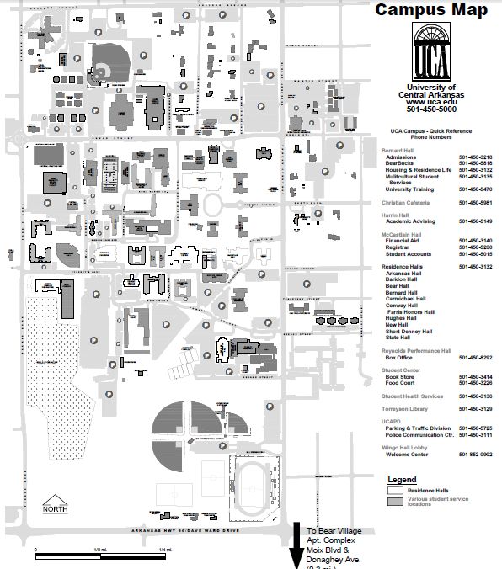

**McCastlain Hall**

* Banquet



**Old Main Hall**

* Awards Ceremony

(Ida Waldron Auditorium)

**2014 Southwestern Energy Arkansas State Science Fair**

**http://www.arsciencefair.org**