From the UCA Archives XXXIII
UCA’s First Homecoming
By
Jimmy Bryant

Homecoming is always a special time at a university; when alumni return to their alma mater to renew old friendships, visit with former professors, tour the familiar campus and attend the football game, which is usually seen as the most important event of the day. But, when did homecoming begin in this country?

The history of homecoming in the United States is not totally clear. According to a Missouri newspaper, the Columbia Missourian, “The University of Missouri celebrated the nation’s first homecoming in 1911. One year earlier, the University of Illinois celebrated the nation’s first homecoming. Also, Baylor, in 1909, celebrated the nation’s first homecoming.” Other universities that had early homecomings include Northern Illinois University, Indiana University and the University of Michigan. One thing is certain; they can’t all be the first.

According to the Columbia Missourian, the National Collegiate Athletic Association (NCAA) recognizes the University of Missouri as being the university that observed the nation’s first homecoming in 1911. But, as one can imagine, not all universities are in agreement.

According to the University of Missouri Archives website, “The 1911 University of Missouri football game against the University of Kansas began an enduring Tiger tradition. Before that year, the MU versus KU game had always been played in Kansas City. The 1911 season, however, saw a change in conference regulations. All intercollegiate football games were required to be played on campus. Fearing that game attendance would be low, the new MU coach, C.L. Brewer, appealed with great success for the “Old Grads” to “Come Back Home” to boost attendance and help dedicate MU’s new football field.”

Whether the University of Missouri was actually the first or just had the best documented account is up for debate. For the record, the University of Central Arkansas (UCA) celebrated its first homecoming that was called a homecoming on Thanksgiving Day, November 24, 1927.

The idea for UCA’s first homecoming actually grew out of its annual Thanksgiving Day football game. For several years, UCA participated in Thanksgiving Day football games. According to the Log Cabin Democrat, “The introduction of home coming day on A.T.C. campus is new, this being the first year to announce such an occasion. For several years many former students from all over the state have been returning for the Thanksgiving game, and although not formally announced, as such they have spoken of that day as Home Coming day.”

Apparently, the process of bringing former students together for the Thanksgiving Day game happened prior to giving that day the moniker of homecoming. This is a similar situation in which the other universities mentioned above were involved. They observed all the festivities of the now traditional homecoming, but most failed to call it by that name until later.

According to The Echo, the following is the schedule of events for UCA’s first homecoming; “8:00-9:00 – Thanksgiving service: 9:00-10:30 – Free for visits and observation of Buildings and Exhibits: 10:30-12:00 – Program of welcome: 12:00 – Organization of Luncheons: 1:00 – Parade: 2:00 – Coronation of Football Queen: 2:30 – Game: 6:00-9:00 – Banquet: and a Pageant was scheduled for 9 p.m.”

Since UCA’s first homecoming also fell on Thanksgiving Day, there was a dual reason for celebration. According to The Echo, “Thursday, Holiday, Thanksgiving and Home Coming Day! We, the present student body of A.T.C. have lots for which to be thankful on this day. We can be thankful that we are to establish and celebrate the first Home Coming as an annual event at the Arkansas State Teachers College. We can be thankful that we have a football team strong enough to defeat College of the Ozarks.”

The Echo went on to explain that ASTC had not done enough for its alumni and needed to do more to attract the alumni back to campus. According to The Echo, “In former years students have been returning for the Thanksgiving game, but the day has lost some of its charm because there have been no preparations whatever for their entertainment. Nothing has really drawn them to their Alma Mater to make them feel that the school has an interest in them and really desires to keep in touch with all its children. It is the purpose of the coming event to do these things. The old students will have a chance to make new acquaintances, because, with the rapid growth of the school, the student body changes much from year to year.”

Mildred Robinson, of Western Grove, Arkansas in Newton County, was UCA’s first homecoming queen and her maids were Virginia Deal, Margaret Watson, Opal Horn, Bertie Cassidy, Marie McBride and Pauline Kirby. The homecoming queen and her court were chosen not by the student body, but by the football team.

The biggest event for UCA’s first homecoming was the football game with the College of the Ozarks. It was a much-anticipated affair, owing to the fact that UCA had only won one game all year, lost four games and tied three and the homecoming game was the Bears last game of the season. However, the sports writers for the Log Cabin Democrat and The Echo both looked at the positive things that had happened during the season. According to the Log Cabin Democrat, “The Bears have outgained every opponent met this season with the exception of Hendrix and Henderson-Brown and the locals made more first downs on the Reddies last week than has been made on the Arkadelphians this year. An attempt will be made the first three days of this week to get the team in the spirit it met Hendrix with and to give the Ozarks a severe licking.”

The Bears won their first homecoming game by beating College of The Ozarks 12 to 7. According to The Echo, “The Bears made Homecoming day doubly pleasing for the alumni when they defeated the College of The Ozarks Thursday by a score of 12 to 7. It was the last game of the season and was one which gave the fans of the Teachers College assurance that the Teachers have a strong team and a good squad of men with an excellent coach.”

An editorial in The Echo, summed up UCA’s first homecoming, “As Home Coming Day the day is one in which we welcome many of our old friends and acquaintances; in which we meet again people who have been students of the Arkansas Teachers College. They have come home, to their Alma Mater, they have taken advantage of this opportunity to return to the scene of their college life. They come with the expectation of meeting many of their old friends and associates. They come to the State Teachers College, where they once went to school, where they once enjoyed the many organizations, institutions, traditions, and customs that we are now enjoying. And they come on Thanksgiving day, a day when they may be thankful that they once enjoyed and benefited from these items of our everyday life. These alumni realize more than we the advantages of the college which are ours; they have experienced them and have experienced others since. And they are able to give thanks that they were once able to partake of these advantages.”

In an interesting case of déjà vu: twenty-four years later, on November 22, 1951, on another Thanksgiving Day, the Bears again beat College of the Ozarks in the last football game of the season by an identical score of 12 to7. That year Ken Stephens, who later returned to his alma mater as head football coach, intercepted five passes (a UCA record that still stands – later tied by Mark Turner) and also scored the game’s winning touchdown.

Author’s Note: Sources for this article include The Echo, Log Cabin Democrat, Columbia Missourian, University of Missouri Archives website, University of Illinois Archives website, Baylor University Archives website, UCAsports.com Football Record Book maintained by Steve East, and The Scroll.

A PHOTOGRAPH OF UCA’S FIRST HOMECOMING QUEEN, MILDRED ROBINSON, IS ON THE NEXT PAGE.

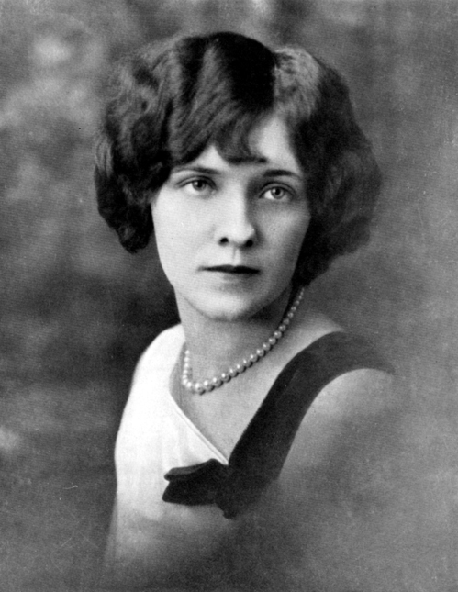

Mildred Robinson, UCA’s First Homecoming Queen, 1927

PHOTOGRPAH COURTESY OF THE SCROLL - 1928

