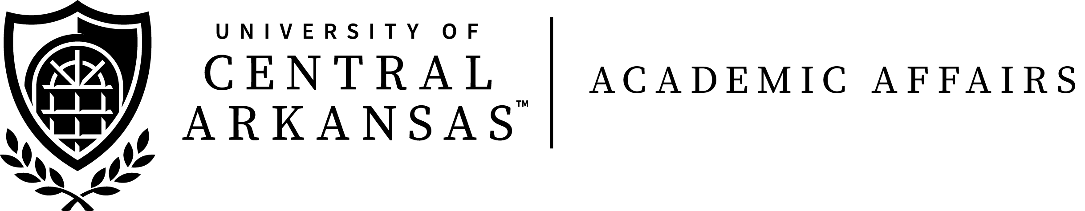

**ANNUAL FACULTY AWARDS**

**2019 NOMINATION FORM**

**Nominations are being accepted for the annual faculty excellence awards. Finalists will be honored at the Faculty Convocation in August. Nominees must have taught full-time at UCA for at least five years; previous winners may be nominated for a different award at any time. Previous winners are eligible to win the same award after a period of ten years. Students, faculty, staff, and alumni are encouraged to submit nominations. A list of past winners and additional information may be found on-line at:**

[**http://uca.edu/academicaffairs/academic-information/**](http://uca.edu/academicaffairs/academic-information/)**.**

Nomination for *(please checkmark appropriate award)*:

**□ Public Service Award**

**□ Research, Scholarship, and Creative Activity Award**

**□ Teaching Excellence Award**

Nominee: ________________________________________________________

Department: ______________________________________________________

Reason for Nomination (additional sheets may be attached):

Submitted by:

□ Student □ Faculty □ Alumnus □ Staff □ Other (please define)__________________________________



*Send completed nomination form by* ***February 28, 2019*** *to the appropriate selection committee chair as listed below.*

|  |  |  |
| --- | --- | --- |
| **Public Service Award** | **Research, Scholarship,**  **and Creative Activity Award** | **Teaching Excellence Award** |
| Send nomination to:  Dr. Taine Duncan  Philosophy & Religion  Irby 118D  [tduncan@uca.edu](mailto:tduncan@uca.edu) | Dr. Charlotte Yates  Physical Therapy  PT Center 321  [cyates@uca.edu](mailto:cyates@uca.edu) | Dr. Melissa Kelley  Chemistry  Laney-Manion 201A  [mkelley@uca.edu](mailto:mkelley@uca.edu) |

**Eligibility will be verified by the Office of the Executive Vice President and Provost, Academic Affairs, Wingo Hall 213**

**University of Central Arkansas, Conway, AR 72035**

**(501) 450-5073,** [**provost@uca.edu**](mailto:provost@uca.edu)